CURRICULUM VITAE  APPLICATION FORM |  |  |  | 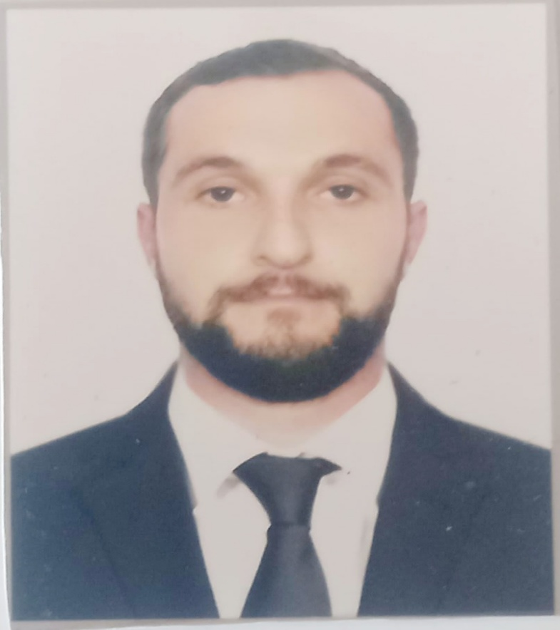
Main information
Full Name: | TOLIK ATAKHANOV | Date of birth: | 01.12.1996
Citizenship: | AZERBAIJAN | Place of birth: | GUSAR
Phones: | +994706451616 | Country of residence: | AZERBAIJAN
 |  | City: | GUSAR

Passports / Smbk | № | Date of issue | Place of issue | Date of expire
Seaman's book | DQK 020431 | 04.06.2022 | SMA, BAKU | 04.06.2027
International passport | C02369053 | 30.04.2019 | AZERBAIJAN | 29.04.2029
Diplomas | № | Date of issue | Place of issue | Valid up
Rank | Able Seafarer-Deck
Professional license | RP08121 | 01.06.2023 | SMA, BAKU | 01.06.2033
Certificates | № | Date of issue | Place of issue | Valid up
Training for seafarers with designated security duties | SH-0728-22 | 13.05.2022 | SMA,BAKU | 13.05.2027
Personal survival techniques, fire prevention and fire fighting , elementary first aid, personal safety and social responsibilities | SO-1931-22 | 11.05.2022 | SMA,BAKU | 11.05.2027
Proficieney in survival craft and boats other than fast rescue boats | SL-1044-22 | 10.05.2022 | SMA,BAKU | 10.05.2027
International Safety Management Code | SP-1215-22 | 12.05.2022 | SMA,BAKU | 12.05.2027
Ship Security-related familiarization security-awareness training | SI-1005-22 | 06.05.2022 | SMA,BAKU | 06.05.2027

Sea service
Position | Name of Ship | Type of Ship | Date | Employer
ABLE SEAMEN | M/V 'LAUD' | IYEM ASYA SHIPPING | 06.09.2017 | 06.06.2018
ABLE SEAMEN | M/V 'AKIN' | DENTAŞ SHIPPING | 24.08.2018 | 24.02.2019
ABLE SEAMEN | M/V 'MUZAFFER BEY' | BEK SHIPPING | 26.06.2019 | 26.01.2020
SAILOR | M/V 'ALOPO' | AKAR GROUP | 09.12.2020 | 13.11.2021
SAILOR | M/V 'EVEREST' | FOUR GROUP | 01.08.2022 | 30.05.2023

Additional info ,
Specialty: ABLE SEAFERER DECK  SAILOR | Knowledge of other languages: I know Russian and Turkish perfectly
Biometrical data
Sex: MAN | Height: 1.70
Eyes color: BROWN | Weight: 80
Education Specialty
Azerbaijan Marine College of the Azerbaijan State Marine Academy  Crystal Training Center | ABLE SEAFERER DECK  SAILOR

