KİŞİSEL BİLGİLER |  |  |  |  |  |  |  |  |  | 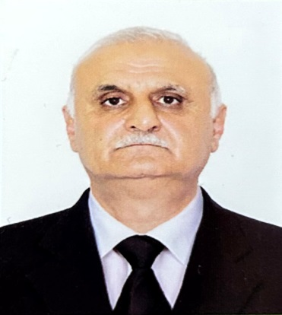
ADI SOYADI: | BAKHSHIYEV JASARAT
DOĞUM TARİHİ: | 20.06.1961
DOĞUM YERİ: | AZERBAIJAN – MASSALLI
ASKERLİK | YAPILDI
SİCİL NO | 22ZV9LZ / BAKU
MEDENİ DURUM | EVLİ
İLETİŞİM BİLGİLERİ
ADRES: | AZERBAIJAN, BAKU , NAKHICHIVANSKI 106/103
TELEFON: | +99 450 427 7581 |  |  |  | EPOSTA |  | baxsiyevcesaret@gmail.com
EĞİTİM BİLGİLERİ
Mezuniyet Tarihi | ODESSA ALI DENİZ MÜHENDİSLERİ ÜNİVERSİTESİ - 1988
İŞ TECRÜBESİ
1982 - 1996 | 4. çarkçi – 3. çarkçi – 2. Çarkçi - Çarkçı başı –- AZERBAIJAN DEVLET HAZAR DENİZ İŞLETMECİLİĞİ
1996 - 2001 | 2 .carkçı – Çarkçı başı H.I. KAPTANOGLU DENIZCILIK GRUBU – ZEYNEP KAPTANOGLU 26500 DWT,  CENGİZ K. 55300 DWT, ŞADAN KAPTANOGLU 37600 DWT, PINAR KAPTANOGLU 42400 DWT
2001 - 2002 | ÇARKÇI BAŞI – KIRAN DENİZÇİLİK – M/V T.K. BREMEN - 6500 DWT
2002 - 2018 | TEXNİK MÜDÜR – MONOLİT LTD
2018 - 2019 | ÇARKÇI BAŞI CMS DENİZCİLİK – M/T ORAL - 13000 DWT , M/T AKTOBE 13000 DWTM/T  ATIRAU – 13000 DWT
2019 - 2020 | ÇARKÇI BAŞI - UNİTED MARİNE – M/V GAZİBEY - 17000 DWT
2020 - 2022 | ÇARKÇI BAŞI - KIRAN DENİZCİLİK – M/V KIRAN AMERİKA – 57000 DWT, KIRAN ISTANBUL – 64000 DWT
2023 | ÇARKÇI BAŞI – FEYZ GROUP DENİZCİLİK M/V OCEAN SKY – 19000 DWT
SERTİFİKA BİLGİLERİ
Engine resource management |  |  | 21.02.2028 |  |  | International Safety Management Code |  |  |  |  | 15.02.2028
Ship Security-related Familiarization |  |  | 23.04.2026 |  |  | Updating |  |  |  |  | 07.08.2028
Training for Seafarers with designated sec.duties |  |  | 14.08.2028 |  |  | Proficiency in Survival Craft and Boats Other Than Fast Rescue Boats |  |  |  |  | 13.02.2028
Training in Advanced Fire-Fighting |  |  | 23.02.2028 |  |  | Dangerous Hazardous and Harmful Cargoes |  |  |  |  | 16.02.2028
Leadership and Teamwork |  |  | 22.02.2028 |  |  | Advanced traning for oil tanker cargo operat. |  |  |  |  | 29.09.2028
Personel Survival Tecniques ,fire Prevention and fire fighting, elementary first aid, personel safety and social pesponsibilities |  |  | 04.08.2028 |  |  | Safe operation and maintenance of hige voltage systems 1000 volts or more |  |  |  |  | 09.12.2027
Advanced training for chemical tanker cargo oprations |  |  | 05.11.2027 |  |  | Medical First Aid |  |  |  |  | 27.02.2028
GEMİ ADAM EVRAK BİLGİLERİ
Pasaport Numarası |  | C 02804610 |  |  |  | Pasaport Geçerlilik Tarihi |  |  |  |  | 08.08.2030
Gemiadamı Cüzdan No |  | AZE 030019 / DQK 025146 |  |  |  | S /B |  |  |  |  | 22.09.2028
Yeterlik |  | CHIF ENGINER |  |  |  | III/2 Chif eng. of ships powered by main propulsion machinery of 3000 kW propulsion power or more |  |  |  |  | 07.08.2028
YABANCI DİL BİLGİSİ
İNGİLİZCE | OKUMA |  | yeterli | KONUŞMA |  |  |  | yeterli | ANLAMA |  |  | yeterli
GEMİ ADAMLARI SAĞLIK YOKLAMA BELGESİ
Geçerlilik Tarihi |  |  | 25.09.2024 |  |  | Yellow Fever
REFERANSLAR

