PERSONAL DETAILS
Family name |  | Pashayev |  |  | 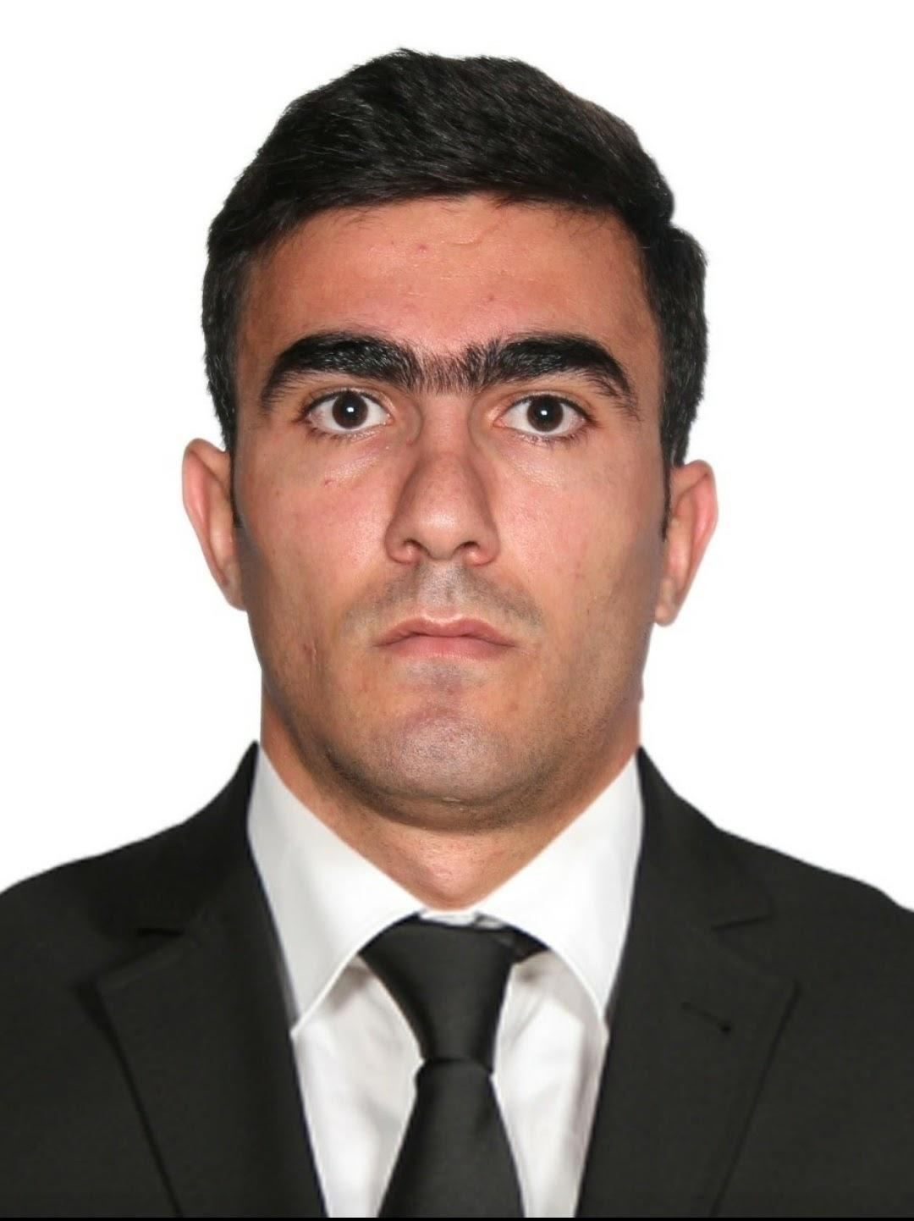
First name |  | Vasif
Father’s name |  | Fakhreddin
Date and place of birth |  | 24 December 1992 / Azerbaijan, Baku
Nationality |  | Azerbaijanian
Marital status |  | Single
Permanent address |  | Azerbaijan, Baku city G.Shıklinski 37.
Nearest airport |  | Haydar Aliyev Airport/Baku, Azerbaijan
Height (cm) | Weight (kg) | Eyes color | Hair color | Size of safety shoes |  | Size of coveralls
175 | 75 | Brown | Black | 42 |  | L
CONTACT DETAILS
Mobile | E-mail address
+994 51 528 88 91  +994 70 228 88 91 WhatsApp | Pashayev763@gmail.com
NEXT OF KIN IN CASE OF EMERGENCY
Next of kin | Pashayev Fakhreddin | Relationship | Father
Address | Azerbaijan, Baku G.Shıklinski 37.
Mobile phone | +994 51 326 83 42
TRAVEL PASSPORT DETAILS
Document | Number | Place of Issue | Issued | Valid
National Travelling Passport | C 03098131 | Ministry of Internal Affairs of Azerbaijan Republic | 04.08.2020 | 03.08.2030
SEAMAN’S BOOK DETAILS
Document | Number | Place of Issue | Issued | Valid
National Seaman’s Book | DQK  015889 | Azerbaijan State Maritime Administration | 22.02.2020 | 22.02.2025
COMPUTER SKILLS
Windows | Microsoft Office | Internet | Autocad
Excellent | Excellent | + | Excellent

EDUCATION
Full name of School | Place of Issue | Grade/Class | From | To
Azerbaijan State  Marine Academy | Azerbaijan, Baku | Shipbuilding  and ship repair | 2010 | 2014
Azerbaijan State  Marine Academy | Azerbaijan, Baku | Ship power plant  Operation engineer  (Bachelory degree) | 2017 | 2020
KNOWLEDGE OF LANGUAGES
Languages | Speaking | Reading | Writing
Azerbaijan | Native | Native | Native
Turkish | Good | Good | Good
English | Good | Good | Good
Russian | Medium | Medium | Medium
MEDICAL INFORMATION
Document | Grade | Place of issue | Last exam | Next exam
Seaman’s Medical Certificate | Health Certificate | Azerbaijan State Maritime Administration | 25.04.23 | 25.04.25
CERTIFICATE OF COMPETENCY
Class/Grade | Issuing country | Certificate No. | Date issued | Valid until
Second Engineer Officer of ship powered by main propulsion machinery of 3000kW propulsion power or more | Azerbaijan State Maritime Administration | 001274/23 | 28.11.23 | 28.11.2028
Endorsement | Marina mercante de panama | PA0426622 | 05.06.2023 | 19.08.2027
STCW AND OTHER CERTIFICATES
Name of course/Certificate | Institute | Place | Date of issue | Cert.No | Date of expiry
Basic safety training | STCW | Azerbaijan | 08.07.2019 | № SO- 1795-19 | 05.07.2024
Ship Security-related familiarization security-awareness training | STCW | Azerbaijan | 16.08.2019 | № SI- 1990-19 | 15.08.2024
Proficiency in survival craft and boats other than fast rescue boats | STCW | Azerbaijan | 11.07.2019 | №SL 0881-19 | 11.07.2024
Training for seafarers with designated security duties | STCW | Azerbaijan | 26.07.2019 | № SH- 1084-19 | 26.07.2024
International Safety Management Code | STCW | Azerbaijan | 01.08.2019 | № SP 1151-19 | 31.07.2024
Training in Advanced Fire Fighting | STCW | Azerbaijan | 21.05.2021 | № SJ-0398-21 | 21.05.2026
Leadership and Team w  Work | STCW | Azerbaijan | 19.05.2021 | № DL-0449-21 | 08.05.2026
Engine Resource Management | STCW | Azerbaijan | 16.05.2021 | № ER-0202-21 | 16.05.2026
Medical First Aid | STCW | Azerbaijan | 20.05.2021 | № SN-0353-21 | 03.05.2026

SEA EXPERIENCE (MOST RECENT EXPERIENCE ON TOP LINE)
Vessel | Company | Flag | Rank | Sign on |  | Sign off
M/V “SUADİYE” | CUNDA SHİPPİNG | PANAMA | OİLER | 26.08.2020 |  | 21.04.2021
M/V “RHONE RİVER” | GN GRUP CORPORATİON | PANAMA | OİLER |  | 20.08.21 |  | 17.07.22
M/V  “RİVER QUEEN” | CUNDA  SHİPPİNG | PALAU | 3rd Enginer |  | 14.09.2022 |  | 24.03.2023
M/V  “MEDKON SAMSUN” | OCEAN AEGEAN SHİPPİNG | Panama | 3rd  Enginer |  | 30.04.23 |  | 08.11.23

