APPLICATION FORM

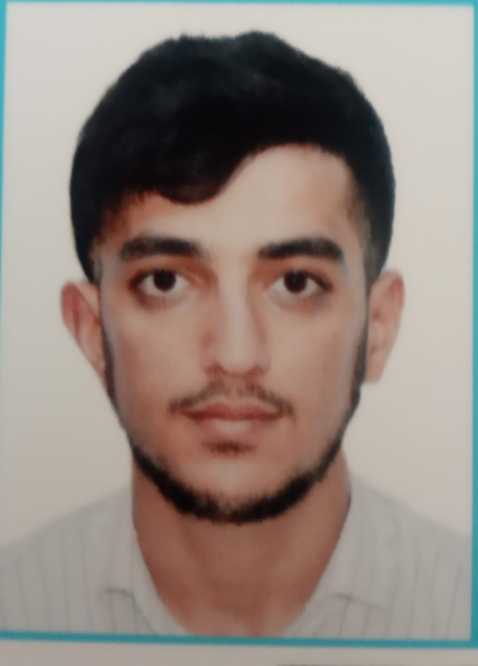

 |  |  |  |  | 6 | L | E | 7 | 7 | Q | 2
Personal ID Number

Position Applied for: Electrican (III/6) | Date Available from:ANY TIME

1. PersonalData
Family Name: Hamidov | First Name: Eltac | Middle Name: Elshan
Date of Birth: 30.09.1998 | Place of Birth:Azerbaijan/Mingachevir | Citizenship: Azerbaijani
Permanent Address: Azerbaijan/Mingachevir |  | Phone (Home): 050-728-15-01  Whatshapp +99455-363-09-89  E-mail: eltac.hemidov@mail.ru

2. MaritimeEducation
Nameofschool | Town | Country | From | To | Type of degree or diploma
Azerbaijan State Marine Academy | Baku | Azerbaijan | 2016 | 2020 | Bachelor

3. ProfessionalTest
EnglishTest Date | Nameof Test | Score
Professional TestDate | Nameof Test | Score
Professional Interview Date | Result

4. FamilyDetails
Civil Status (Single, Married, Separated, Divorced, Widowed) : Married

Next of Kin (the first emergency contact) : | Relationship /Father
Address of Residence:  Azerbaijan/Shirvan | (050) 728-15-01

5. IdentityDocuments
Document | Country | Number | PlaceofIssue | IssueDate | ExpiryDate
Seaman'sBook | Azerbaijan | DQK 020816 | State Maritime Adminstration | 21.07.2022 | 21.07.2027
TravelPassport | Azerbaijan | C03857941 | Ministry of Internal Affairs | 11.07.2022 | 10.07.2032

6. ValidVisa
CountryorUnion | Type | ValidUntil

7. Courses Attended and Certificates Obtained
Document | Number | Dates |  | Place
Document | Number | Issue | Expiry | Place

CertificateofCompetency | RP-10761 | 20.12.2021 | 20.12.2031 | State Maritime Administration
MalteseEndorsementof COC
OilTankerEndorsement
ChemicalTankerEndorsement
GasTankerEndorsement
OilTankerFamiliarizationTraining
ChemicalTankerFamiliarizationTraining
GasTankerFamiliarizationTraining
OilTankersSpecializedTraining
ChemicalTankerSpecializedTraining
GasTankerSpecializedTraining
BasicTrainings | SO-3229-22 | 19.07.2022 | 18.07.2027 | State Maritime Administration
Proficiency in Survival Craft and Rescue Boats | SL-2059-22 | 22.07.2022 | 22.07.2027 | State Maritime Administration
AdvancedFireFighting
MedicalFirstAidTraining
Medical First Aid Training and Medical Care
GMDSS
GMDSS Endorsement
RadarObservation&Plotting
Automatic Radar Plotting Aids Simulator (ARPA)
BridgeTeamManagement
Shiphandling&Maneuvering
Ship Security-related familiarization security-awareness training | SI-1822-22 | 28.07.2022 | 28.07.2027 | State Maritime Administration
MalteseEndorsementof SSO
ISM Code | SP-2218-22 | 25.07.2022 | 25.07.2027 | State Maritime Administration
SafetyOfficer
ECDISTrainingCourse
RiskAssessmentCourse
C.O.W./ I.G.S
FirePracticeonTankers
VapourRecoverySystem
UnmannedMachinerySpace
FRAMO FamiliarizationCourse
Cargo Ballast Operations on Oil/Chemical Tankers
HazardousMaterials
Welder
Turner
Risk Management And Incident Investigation
Training of seafarers with designated security duties
Dangerous hazardous and harmfull cargoes | SH-0779-21 | 03.09.2021 | 03.09.2026 | State Maritime Administration
BasicTraining and qualifications on oil and chemical tanker cargo operations
Crowd management training

8. PhysicalData
Height | 162 sm
Weight | 60
ColourofHair | Black
ColourofEyes | Brown
BoilersuitSize | M
ShoesSize | 41

9. MedicalHistory | Yes | No
Have you ever signed off a ship due to medical reasons?
Did you undergo any medical operation in the past?
Have you consulted a doctor during the last 12 months for an illness/accident?
Do you have any health or disability problems now?

If yes, please give full details:

 | Passed: | Validtill:
International Medical Examination | 16.11.2023 | 16.11.2025
Vaccination Against YellowFiver
Vaccination Against Diphtheria

10. References (please give name and address of your current or past employer) | Officeremarks

NameofCompany
Name of person to contact
Address
Phone

NameofCompany
Name of person to contact
Address
Phone

11. Bank address forallotments
Beneficiary
AccountNo.
NameofBank
BankAddress

12. Knowledgeandexperience | Yes | No
OCIMF vetting experience:
ISGOT knowledge:

13. I hereby declare that the above, including Medical History, is true
Place

14. ForOfficeuseonly

15. SeagoingExperience

Nameofvessel | Flag | Vessel’sType | DWT | EngType | HP | Manageror Owner | Rank | From d/m/y | Tod/m/y | Total  m/d
Ak. Topçubaşov | Azerbaijan | Ro-Ro cargo | 3982 | Diesel |  | Azerbaijan Caspian Shipping Closed Joint-Stock Company | practitioner | 18.06.2017 | 28.09.2017 | 3 m, 9d.
River Gra | Panama | Dry cargo | 5091 | Diesel |  | Cunda denizcilik | Elecrician | 01.05.2018 | 28.09.2018 | 4 m, 6d.
Palmali Voyager | Malta | Dry cargo | 6900 | Wartsila |  | Palmali Shipping Com. | Elecrician | 01.06.2019 | 03.11.2019 | 5 m
Zöhrab Vəliyev | Azerbaijan | passenger | 313 | Diesel |  | Azerbaijan Caspian Shipping Com. | Electrician | 19.01.2020 | 25.05.2020 | 4 m, 5 d
M/V Barda | Azerbaijan | Ro-ro ship | 3750 | Man 6s50mc |  | Azerbaijan Caspian Shipping Com. | Electrician | 27.10.2021 | 18.05.2022 | 6m,21d
Aysu | KKTC | Ro-ro | 4177 | 5700Hp  at600 |  | Altindag Denizçilik | Elektrician | 13.04.2023 | 30.10.2023 | 5,5m

Total rank sea service: Total type of vessel sea service:
Rank | Years |  | Typeofvessel | Years
Elektrician | 1 |  | OIL TANKER
 |  |  | LPG
 |  |  | DRY CARGO
 |  |  | TANKER ICE
 |  |  | OIL /CHEMICAL TANKER
 |  |  | FERRY
Total |  |  | Total:

