C c |  |  |  |  |  |  |  |  |  |  |  |  |  |  |  |  |  |  |  | 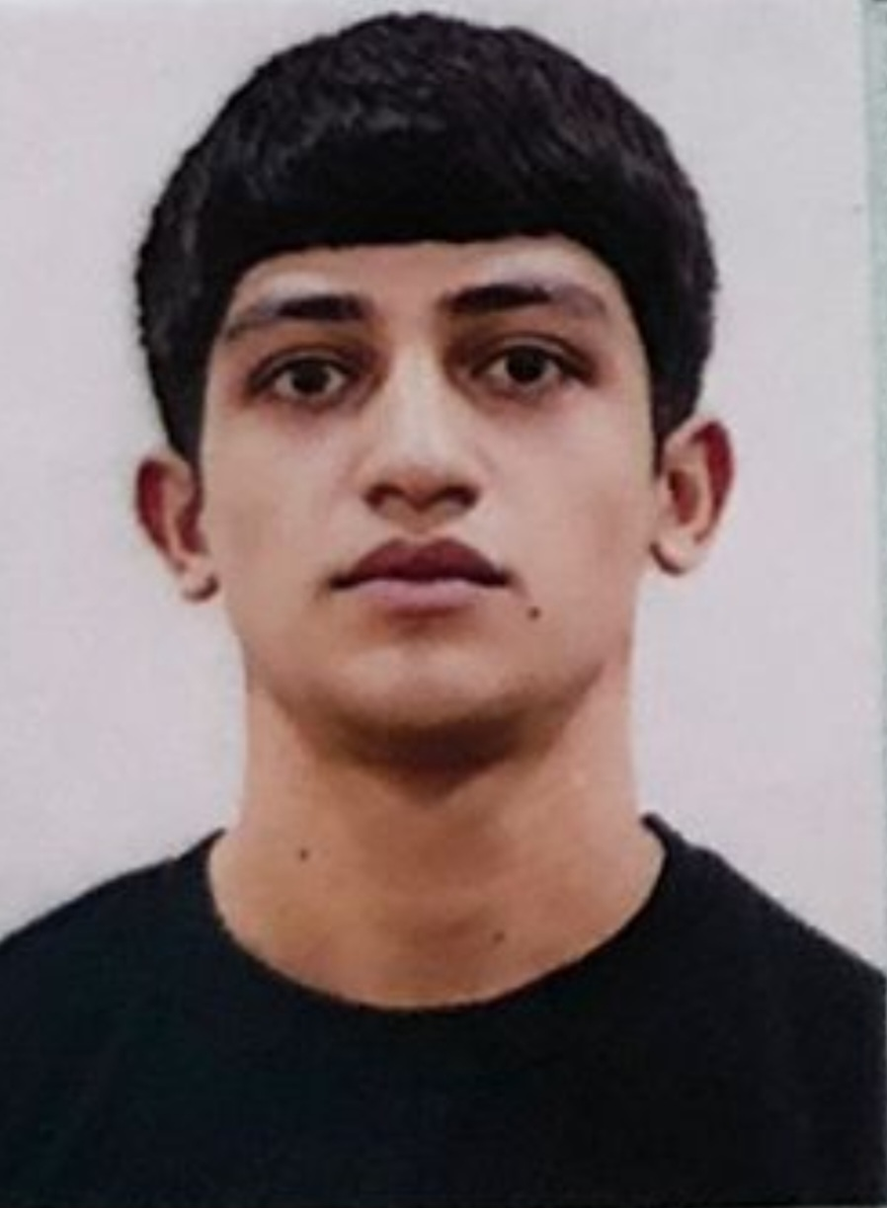

Application Form
Section 1 |  |  |  |  |  | Navigation Officer
Position Applied for |  |  |  |  |  | ABLE SEAMAN
Lowest Position Acceptable |  |  |  |  |  | ABLE SEAMAN
Date of Availability |  |  |  |  |  | Any time
Section 2 |  |  |  |  |  | Personal Details
Family name / Surname |  |  |  |  |  | ISMAYILOV
First Name / Given Name |  |  |  |  |  | ELGUN
Date & Place of Birth |  |  |  |  |  | Date: 23.12.2002 Place:Sabirabad , Azerbaijan
Nationality |  |  |  |  |  | Azerbaijan
Permanent Address |  |  |  |  |  | Azerbaijan, Sabirabad
Present Address |  |  |  |  |  | Azerbaijan, Sabirabad
PPE information |  |  |  |  |  | SAFETY SHOES SIZE |  |  |  |  |  | 42 |  |  |  | COVERALL SIZE |  |  |  |  |  |  |  | L
Present Contact Number |  |  |  |  |  | +994 55 593 10 59
Mobile Number
SKYPE ADDRESS |  |  |  |  |  | N/A
Email Address |  |  |  |  |  | elgunismayilov2222@gmail.com
Nearest Airport (and Distance) |  |  |  |  |  | Haydar Aliyev Baku International (GYD)
Section 3 |  |  |  |  |  | Passport and VISA details
Country of Issue |  |  |  |  |  | Azerbaijan / Baku |  |  |  |  |  |  | USA Visa - Type
Date Issued |  |  |  |  |  | 17.11.2023 |  |  |  |  |  |  | USA VISA Expires
Place Issued |  |  |  |  |  | Azerbaijan |  |  |  |  |  |  | USA Visa - Type
Passport Number |  |  |  |  |  | C04079958 |  |  |  |  |  |  | USA VISA Expires
Passport –Expires |  |  |  |  |  | 16.11.2033 |  |  |  |  |  |  | Other Country Visa
Secondary passport or Dual nationality |  |  |  |  |  | N/A |  |  |  |  |  |  | Visa Expiry
Section 4 ( hi-light as required ) |  |  |  |  |  | Seaman book / Discharge book / Seaman Record Book / CDC
Issuing Country & Place |  |  |  |  |  | Azerbaijan |  |  |  |  |  |  | Date Issued |  |  |  |  |  |  |  |  | 14.12.2023
Number |  |  |  |  |  | DQK 026088 |  |  |  |  |  |  | Expiry Date (if any) |  |  |  |  |  |  |  |  | 14.12.2028
Section 5 |  |  |  |  |  | Next of Kin – this is important information we require- Don’t ignore it
Full Name / Relationship |  |  |  |  |  | Ismayilov Elgun , Father
Any dependents / Children (incl age ) |  |  |  |  |  | Not any
NOMER |  |  |  |  |  | +994 55 815 34 27
Address |  |  |  |  |  | Baku Azerbaijan
+994515234994 +994515234994++994515234994+994515234994+994515234994
 | Section 6 STCW95 Highest Certificate of Competency / Licence Held ( also list Flag State Endorsements)
 | Class / Grade/Capacity |  | Issuing Country |  |  |  |  | Certificate No. | Date Issued |  |  |  | Expiry |  |  |  |  |  | Details of Limitations
 | ABLE SEAFERER DECK |  | Azerbaijan, Baku |  |  |  |  | 2612/23 | 05.12.2023 |  |  |  | ____________ |  |  |  |  |  | A-II/5
 | ALSO ENTER ABOVE DETAILS OF ANY OTHER FLAG STATE CERTIFICATES HELD
 | Section 7 STCW95 Dangerous Cargo Endorsements
 | Petroleum…………….  Liquefied Gas……….  Liquid Chemicals……. |  |  |  | Certificate No. |  |  |  |  | Date Issued |  |  |  | Expires |  |  | Details of Limitations/ Grade
 | Section 8 STCW95 related Courses Attended and Certificates Obtained
 | Name of Course / Certificate |  |  |  |  | STCW Code |  |  | Place |  |  |  | Issue Date |  |  |  |  |  | Cert No |  |  |  |  | Expiry Date
 | Mandatory minimum requirements for familiarization, basic safety training and instruction for all seafarers |  |  |  |  | A-VI/1-1,  A-VI/1-2, A-VI/1-3, A-VI/1-4 |  |  | Baku,  Azerbaijan |  |  |  | 23.01.2023 |  |  |  |  |  | SO-0249-23 |  |  |  |  | 19.01.2028
 | Proficiency in survival craft and boats oter than fast rescue boats |  |  |  |  | А-VI/2-1,2,3,4 |  |  | Baku,  Azerbaijan |  |  |  | 18.09.2023 |  |  |  |  |  | SL-3497-23 |  |  |  |  | 06.09.2028
 | International safety Management Code |  |  |  |  | SOLAS IX |  |  | Baku,  Azerbaijan |  |  |  | 24.01.2023 |  |  |  |  |  | SP-0179-23 |  |  |  |  | 24.01.2028
 | Ship Security-related training and instructing |  |  |  |  | А-IV/6, 1-4 |  |  | Baku,  Azerbaijan |  |  |  | 23.01.2023 |  |  |  |  |  | SI-0204-23 |  |  |  |  | 23.01.2028
 | Training for seafarers with designated security duties |  |  |  |  | А-IV/6-2 |  |  | Baku,  Azerbaijan |  |  |  | 19.09.2023 |  |  |  |  |  | SH-2529-23 |  |  |  |  | 12.09.2028
 | Section 9 OFFSHORE INDUSTRY COURSES
 | Please enter below any other certificates held or courses done, ie offshore, DP certs etc or Any other not already mentioned
 | Name of Course / Certificate |  |  |  |  | APPROVALS |  |  |  |  | Place |  |  |  | Issue Date |  |  | Cert No |  |  |  |  | Expiry
 | OFFSHORE MEDICALS  ( UK, NORWAY or NETHERLAND ) |  |  |  |  | ARDGH |  |  |  |  | Baku,Azerbajan |  |  |  | 05.09.2023 |  |  | N/A |  |  |  |  | 05.09.2025
 | LANGUAGES |  |  |  |  | Speaking |  |  |  |  | Reading |  |  |  | Writing
 | Azerbaijan |  |  |  |  | Excellent |  |  |  |  | Excellent |  |  |  | Excellent
 | Turkish |  |  |  |  | Good |  |  |  |  | Good |  |  |  | Good
 | Russian |  |  |  |  | Pre-intermediate |  |  |  |  | Pre-intermediate |  |  |  | Pre-intermediate
Section 10 References (Last Two Recent Employers)
 | Name of company
 | Name Person to be contacted
 | Address
 | Tel No |  |  |  |  |  |  |  |  |  | Fax
 | Email
 | Name of company
 | Name Person to be contacted
 | Address
 | Tel No |  |  |  |  |  |  |  |  |  | Fax
 | Email

Vessel | Company | Type of vessel | Flag | GRT | Rank | Sign on | Sign off
M/V SABIT ORUCOV | ASCO | PASANGER SHIP | AZERBAIJAN | 2621 | SALIOR ( STUDENT) | 22.06.2021 | 09.08.2021
M/V SABIT ORUCOV | ASCO | PASANGER SHIP | AZERBAIJAN | 2621 | SALIOR (STUDENT) | 09.02.2022 | 23.08.2022
M/V SABIT ORUCOV | ASCO | PASANGER SHIP | AZERBAIJAN | 2621 | SALIOR (STUDENT) | 01.03 2023 | 03.05.2023
M/V SABIT ORUCOV | ASCO | PASANGER SHIP | AZERBAIJAN | 2621 | SALIOR (STUDENT) | 09.02.2023 | 28.02.2023

