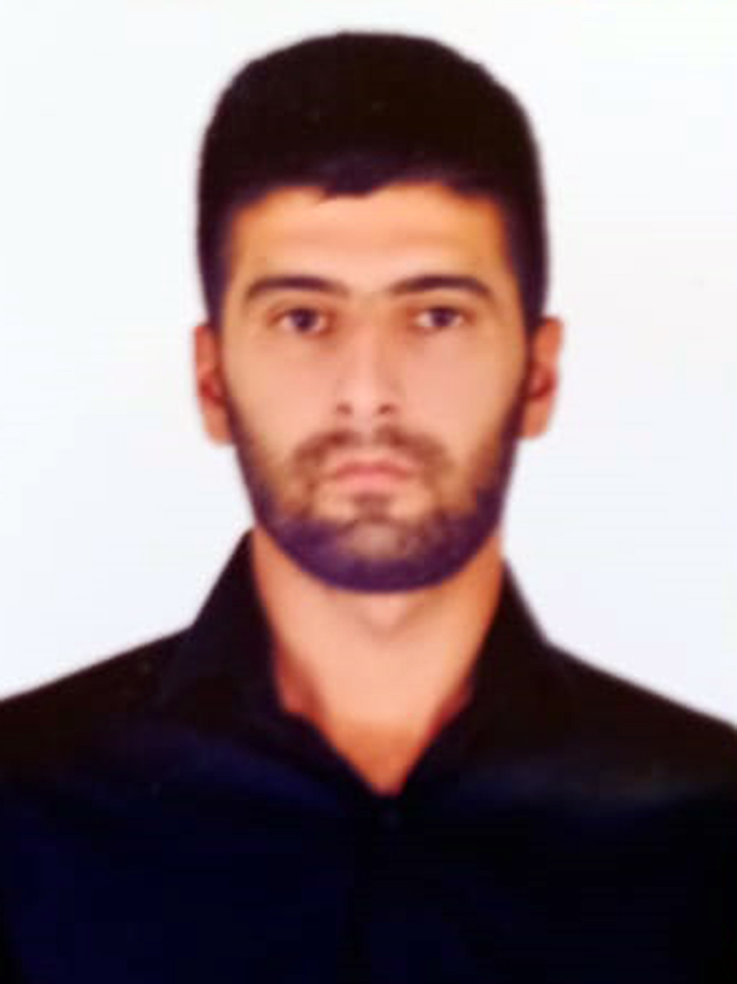

APPLICATION FORM

 |  |  |  |  | 6 | J | 3 | N | D | R | G
Personal ID Number

Position Applied for: Officer in Charge of a Navigational Watch | Date Available from: 28.10.2022

1. Personal Data
Family Name: Azizov | First Name: Ahmedaga | Middle Name: Miraga
Date of Birth: 25.03.1999 | Place of Birth (City and Country):  Azerbaijan, Khachmaz | Citizenship: AZERBAIJANIAN
Permanent Address: Baku, Azerbaijan |  | Phone Mobile: +994515763774  E-mail: ehmed.ezizov99@gmail.com

2. Maritime Education
Name of school | Town | Country | From | To | Type of degree or diploma
Azerbaijan State Marine Academy | Baku | Azerbaijan | 07.09.2016 | 16.07.2020 | Bachelor’s degree

3. Family Details
Civil Status(Single, Married, Separated, Divorced, Widowed) : Single
Next of Kin (the first emergency contact) Azizov Miraga Agamurad |  |  |  |  |  |  | Relationship: Father
Address of Residence Baku, Azerbaijan |  |  |  |  |  |  | Phone: +994507209510
4. Identity Documents
Document | Country | Number |  | Place of Issue |  |  |  |  | Issue Date |  | Expiry Date
Seaman's Book | Azerbaijan | AZE023627 |  | Azerbaijan State Maritime Agency |  |  |  |  | 11.11.2021 |  | 11.11.2026
Travel Passport | Azerbaijan | C02605155 |  | Azerbaijan Ministry of Internal Affairs |  |  |  |  | 12.05.2019 |  | 11.05.2029
Civil Passport | Azerbaijan | AZE15589993 |  | Azerbaijan |  |  |  |  | 14.12.2023 |  | 14.12.2033
5. Courses Attended and Certificates Obtained
Document |  |  | Number |  | Dates |  |  |  |  | Place
 |  |  |  |  | Issue |  |  | Expiry
Officer in Charge Of a Navigational Watch Certificate of Competency |  |  | 001772/22 |  |  | 28.10.2022 |  | - |  | Azerbaijan State Maritime and Port Agency
Endorsement of Sertificate ( officer in charge of a navigational watch on ships of 500 gross tonnage or more ) |  |  | 001772/22 |  |  | 28.10.2022 |  | - |  | Azerbaijan State Maritime andPort Agency
Proficiency in Survival Craft and Boats other than fast rescue boats (STCW Code A-6/2 Pa.1, Pa.2, Pa.3 and Pa.4) |  |  | SL-2006-21 |  |  | 29.11.2021 |  | 16.11.2026 |  | Azerbaijan State Maritime and Port Agency
Medical First Aid |  |  | SN-1262-22 |  |  | 29.09.2022 |  | 29.09.2027 |  | Azerbaijan State Maritime and Port Agency
Bridge Resource Management |  |  | SW-0481-22 |  |  | 15.09.2022 |  | 15.09.2027 |  | Azerbaifan State Maritime and Port Agency
Leadership and Teamwork |  |  | DL-1533-22 |  |  | 22.09.2022 |  | 22.09.2027 |  | Azerbaijan State Maritime and Port Agency
Training in advanced fire-fighting |  |  | SJ-1230-22 |  |  | 08.09.2022 |  | 08.09.2027 |  | Azerbaijan State Maritime and Port Agency
GMDSS General Operator |  |  | DQ-0290-19 |  |  | 11.07.2019 |  | 11.07.2024 |  | Azerbaijan State Maritime and Port Agency
Radar Navigation, Radar Plotting And use of ARPA (Operational level) |  |  | SR-0060-20 |  |  | 25.02.2020 |  | 07.01.2025 |  | Azerbaijan State Maritime and Port Agency
Ship Security-related familiarization security-awareness Training (STCW Code A-6/6, Pa.1 to Pa.4) |  |  | SI-1490-21 |  |  | 02.12.2021 |  | 30.11.2026 |  | Azerbaijan State Maritime and Port Agency
Operational Use of Electronik Chart Display and information Systems |  |  | SZ-0147-20 |  |  | 04.05.2020 |  | 21.01.2025 |  | Azerbaijan State Maritime and Port Agency
International Safety Management Code |  |  | SP-2153-21 |  |  | 29.11.2021 |  | 25.11.2026 |  | Azerbaijan State Maritime and Port Agency
-personal survival techniques –fire prevention avdfire fighting –elementary first aid –personal safety and social responsibilities |  |  | SO-3218-21 |  |  | 29.11.2021 |  | 23.11.2026 |  | Azerbaijan State Maritime and Port Agency
Training for seafarers with designated security duties ( STCW Code, A-VI/6,Pa.6 to Pa.8.; IMO Model Course 3.26 ) |  |  | SH-0898-21 |  |  | 24.09.2021 |  | 22.09.2026 |  | Azerbaijan State Maritime and Port Agency
Advanced training for oil tanker cargo operations ( STCW Code, A-V/1-1 Pa.2.1 and Pa.2.2; IMO Model Course1.02 ) |  |  | SB-0141-21 |  |  | 24.09.2021 |  | 24.09.2026 |  | Azerbaijan State Maritime and Port Agency
Extract From Seafarers Medical Sertificate |  |  |  |  |  | 14.03.2023 |  | 14.03.2025 |  | Azerbaijan State Maritime and Port Agency

6. Physical Data
Height | 180
Weight | 64
Colour of Hair | dark
Colour of Eyes | chestnut
Boilersuit Size | M
Shoes Size | 42

7. Medical History | Yes | No
Have you ever signed off a ship due to medical reasons? |  | +
Did you undergo any medical operation in the past? |  | +
Have you consulted a doctor during the last 12 months for an illness/accident? |  | +
Do you have any health or disability problems now? |  | +

8. Language knowledge
English – pre

Name of vessel | Flag | Vessel’s Type | DWT | Rank | From d/m/y | To  d/m/y
Mir Jalal Phashayev | Malta | Dry cargo | 5684 | AB | 27.07.19 | 10.09.19
Caspian  Endeavour | Azerbaijan | Off-shore | 3107 | AB | 19.01.20 | 25.05.20
T-Moon | Panama | Dry cargo | 5000 | AB | 24.12.21 | 02.03.22
Doa Glory | Panama | Dry cargo | 5000 | AB | 24.03.22 | 21.08.22
Delfin-1 | Azerbaijan | General cargo | 2235 | 2nd officer | 14.12.22 | 03.02.23
Odessa-1 | Comoros | General cargo | 3227 | 2nd officer | 29.03.2023 | 22.09.2023

