CURRICULUM VITAE
PERSONAL DETAILS
Family name |  | DADASHZADE |  |  | 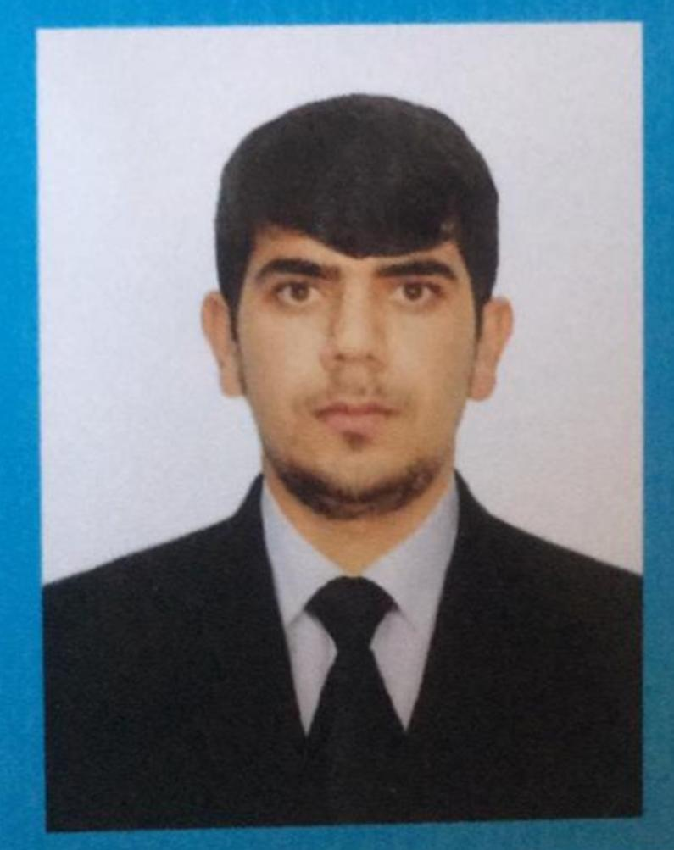
First name |  | TELMAN
Father’s name |  | SHAMIL
Date and place of birth |  | 15.06.2001
Nationality |  | Azerbaijan
Marital status |  | Singl
Permanent address |  | Azerbaijan, Lankaran
Nearest airport |  | Heydar Aliyev International Airport Baku, Azerbaijan
Height (cm) | Weight (kg) | Eyes color | Hair color | Size of safety shoes | Size of coveralls
1.70 cm | 75 kg | BROWN | BLACK | 42 | XL
CONTACT DETAILS
Mobile | E-mail address
+99455 797 61 42  Watcaap | dadash78@icloud.com
NEXT OF KIN (FOR EMERGENCY)
Next of kin | DADASHZADE SHAMIL | Relationship | FATHER
Phone | +99450 553 83 60 | Address | Azerbaijan Lankaran Ashadi Nuvadi settl
TRAVEL PASSPORT DETAILS
Document | Number | Place of Issue | Issued | Valid
PASSPORT | C03830962 | Azerbaijan | 28.04.2022 | 27.04.2032
SEAMAN’S BOOK DETAILS
Document | Number | Place of Issue | Issued | Valid
Seaman book | DGK020042 | Azerbaijan ,Baku | 29.04.2022 | 29.04.2027
SEAARERS IDENTITY | AZE024908 | Azerbaijan ,Baku | 29.04.2022 | 29.04.2027
EDUCATION
Full name of School | Place of Issue | Grade/Class | From | To
Azerbaycan Dovlet Deniz Akademiyasin Denizcilik kolleci | Azerbaijan , Baku | AA-144355 | 15.09.2016 | 30.06.2020
KNOWLEDGE OF LANGUAGE
Languages | Speaking | Reading | Writing
Azerbaijan | Excellent | excellent | Excellent
English | Excellent | excellent | Excellent
Turkish | Excellent | excellent | Excellent
COMPUTER SKILLS
Windows | Microsoft Office | Internet
Excellent | Excellent | Excellent
MEDICAL INFORMATION
Document | Grade | Place of issue | Date of issue | Date of expiry
Medical Sertificate | Electro techical officer | Azerbaijan | 28.08.2023 | 28.08.2025
CERTIFICATE OF COMPETENCY
Class/Grade | Issuing country | Certificate  No.-000871-23 | Date issued | Expires | Details of Limitations
Electro technical officer | Azerbaijan Marine Administration | ID N-0007926 | 18.08.2023 | No limit | A-3/6
STCW AND OTHER CERTIFICATES
Name of course/Certificate | Institute | Place | Date of issue | Cert.No | Date of expiry
International Safety Managemen | Azerbaijan Marine Adminstration | Azerbaijan Baku | 18.02.2022 | SP-0448-22 | 25.01.2027
Proficiency in survival craft and boats other than fast rescue boats | Azerbaijan Marine Adminstration | Azerbaijan Baku | 08.02.2022 | SL-0275-22 | 08.02.2027
Trainig and advanced fire-fighting | Azerbaijan Marine Adminstration | Azerbaijan Baku | 06.07.2023 | SJ-0890-23 | 06.07.2028
Training for seafarers with designated security duties | Azerbaijan Marine Adminstration | Azerbaijan Baku | 04.03.2022 | SH-0287-22 | 24.02.2027
Basic safety trainig | Azerbaijan Marine Adminstration | Azerbaijan Baku | 22.02.2022 | S0-0704-22 | 21.01.2027
Ship Security-related familization security-awareness | Azerbaijan Marine Adminstration | Azerbaijan Baku | 24.02.2022 | SI-0333-22 | 27.01.2027
Medical first aid | Azerbaijan Marine Adminstration | Azerbaijan Baku | 10.07.2023 | SN-1065-23 | 10.07.2028
Leadrship and teamwork | Azerbaijan Marine Adminstation | Azerbaijan Baku | 14.07.2023 | DL-0586-23 | 12.07.2028
SEA EXPERIENCE (LAST 5 YEARS – MOST RECENT EXPERIENCE ON TOP LINE)
Vessel | Company | Type of vessel | Flag | DWT | GRT | Rank | Sign on | Sign off
M/V SUADIYE | CUNDA SHIPPING | GENERAL CARGO | PANAMA | 979 | 2463 | Electro techical rating | 28.05.2022 | 30.05.2023

