CURRICULUM VITAE
PERSONAL DETAILS

Family name |  | Garibov |  |  | 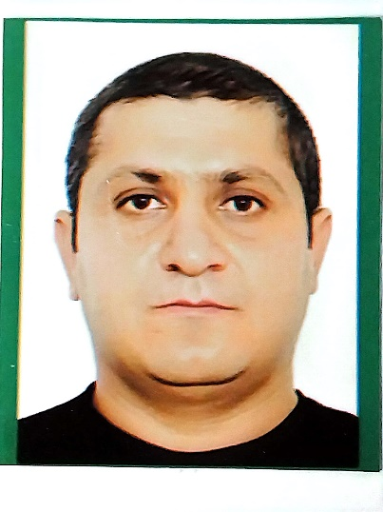
First name |  | Parvin
Father’s name |  | Matlab
Date and place of birth |  | 12.08.1986
Nationality |  | Azerbaijan
Marital status |  | Married
Permanent address |  | Azerbaijan Lankaran
Nearest airport |  | Heydar Aliyev International Airport Baku, Azerbaijan
Height (cm) | Weight (kg) | Eyes color | Hair color | Size of  safety shoes | Size of coveralls
1.60 cm | 70 kg | BROWN | BLACK | 41 | XL

CONTACT DETAILS

Mobile | E-mail address
+99450 565 60 69  Whatcaap | pervinqeribov915@gmail.com

NEXT OF KIN (FOR EMERGENCY)

Next of kin | Garibov Matlab | Relationship | FATHER
Phone | +99450 346 07 02 | Address | AZERBAIJAN Lankaran Balıgchılar settl

TRAVEL PASSPORT DETAILS

Document | Number | Place of Issue | Issued | Valid
PASSPORT | C02711107 | Azerbaijan | 21.11.2019 | 20.11.2029

SEAMAN’S BOOK DETAILS

Document | Number | Place of Issue | Issued | Valid
Seaman book | DGK021346 | Azerbaijan ,Baku | 14.09.2022 | 14.09.2027
SEAARERS IDENTITY | AZE026210 | Azerbaijan ,Baku | 14.09.2022 | 14.09.2027

KNOWLEDGE OF LANGUAGE

Languages | Speaking | Reading | Writing
Azerbaijan | Excellent | excellent | Excellent
Turkish | Excellent | excellent | Excellent
English | N\G | N\G | N\G

MEDICAL INFORMATION

Document | Grade | Place of issue | Date of issue | Date of expiry
Medical Sertificate | Rating forming part of a Navigational  watch | Azerbaijan Baku | 30.11..2023 | 30.11.2024

CERTIFICATE OF COMPETENCY

Class/Grade | Issuing country | Certifikate | Date issued | Expires | Details of Limitations
BOATSWAIN | Azerbaijan Marine Administration | No 0736/21  RP-02683 | 08.09.2021 | No limit | A-II/5

STCW AND OTHER CERTIFICATES

Name of course/Certificate | Institute | Place | RANK | Date of issue | Cert.No | Date of expiry
International Safety Managemen | Azerbaijan Marine Adminstration | Azerbaijan Baku | BOATSWAIN | 27.11.2020 | SP-1170-20 | 27.11.2025
Proficiency in survival craft and boats other than fast rescue boats | Azerbaijan Marine Adminstration | Azerbaijan Baku | BOATSWAIN | 16.03.2023 | SL-1027- 23 | 16.03.2028
Training for seafarers with designated security duties | Azerbaijan Marine Adminstration | Azerbaijan Baku | BOATSWAIN | 27.05.2021 | SH-0400- 21 | 27.05.2026
Basic safety trainig | Azerbaijan Marine Adminstration | Azerbaijan Baku | BOATSWAIN | 31.10.2020 | S0-1429- 20 | 29.10.2025
Ship Security- related familization security-awareness | Azerbaijan Marine Adminstration | Azerbaijan Baku | BOATSWAIN | 20.09.2019 | SI-2195- 19 | 20.09.2024
Training in advanced fire-fighting | Azerbaijan Marine Adminstration | Azerbaijan Baku | BOATSWAIN | 29.07.2021 | SJ-0634-21 | 29.07.2026
Medical First Aid | Azerbaijan Marine Adminstration | Azerbaijan Baku | BOATSWAIN | 10.06.2021 | SN-0418-21 | 10.06.2026

SEA EXPERIENCE (LAST 5 YEARS – MOST RECENT EXPERIENCE ON TOP LINE)

Vessel | Company | Type of vessel | Flag | DWT | GRT | Rank | Sign on | Sign off
M/V Ural | Alestra | Ro Ro | Cameroon | 3550 | 4994 | SEAMEN | 06.09.2023 | 14.12.2023

