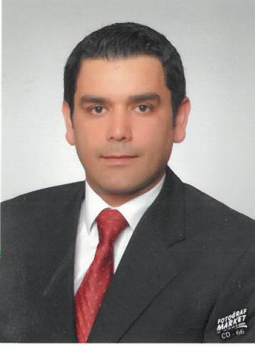
GÖKHAN YILDIZ
PERSONAL İNFORMATİON
Nationaly : Turkey Republic Place of Birth : Adana
Marital Status : Married Birth Date : 23/08/1975
Gender : Male Driving License : E +G
Address :Yeşilyurt mh.70159 sk Er apt 6/11 Seyhan/ADANA/TURKEY
Phone&mail :+90 0531 9017318 2019adana@gmail.com
EDUCATİON İNFORMATİON
High Scool : Adana Borsa Lisesi
Üniversity :Eskişehir Anadolu Üniversity
WORK EXPERİENCE
01,06,2021 -30,07,2021 Yacht Charter Gulet Marmaris Cruise( Esinti Guleti 32m ) Cook
15.08.2020- 07.12.2020 :Nismar Denizcilik (m\v janine) Cook
15.03.2020- 15.07.2020 :VGO Yatching Fethiye ( Nortwint Guleti 32m) Cook
18.04.2019- 18.09.2019 :Almar shipping Ulubey1 Tug Multicat OFFSHORE Cook
05.01.2019 -07.04.2019 :İSTANBULLİNES (BirdenizN RORO Ship) Chef Cook
01.05.2018 10.10.2018 : Sabahattin Şensoy Yat transferleri Cook\Seaman
QUALİFİCATİON
COOK+SEAMAN
PASSPORT:10 Years
CERTİFİCATİONS(MARİNE CERTİFİCATİONS):
1-Cruise Ships(RoRo) Working Edu.Cert. 2-Petroleum and Chemical Tanker Edu. Cert. 3-Liquefield Gas Ships work Edu.Cert 4-Dry Cargo Ships Edu.Cert.
5-10 piece STCW Document 6-Combined ship Security Edu.Cert. 7-Seaman healt Cert.
CERTİFİCATİONS(TAKEN FROM İN OVERLAND CERTİFİCATİONS):
1-Cookery (Provincial National Education Directorate)
2-Cook Journeyman (Adana Governorship Çukurova Education Directorate)
3-Hygiene Certifacate ( Provincial National Education Directorate)
FOREİGN LANGUAGE :ENGLISH (TURKISH AMERİCAN ASSOCİATİON CERTİFİCATE)
Reading-Writing-Understanding-(İntermediate)
REFERANSLAR
1-)Cengiz ÖKSÜZ Türkiye Yat Kaptanları Derneği Yön.Krl.Başkanı 05324515024
2-)Hamit GAZİ İSTANBULLINES Personel Manager 0544 3949734 – 0850 3007676
3-)Murat YAKAR ALMAR SHIPPING Pers.Manager 0530 6008266 – 0216 3948686
4-)Sabahattin Şensoy kaptan uluslar arası yat transferleri 0536 2628997
5-)Ahmet Bilici VGO yatching 05455622298
6-)Recep Odabaş Nismar denizcilik Personel Müdürü 05455490930\02164106147
7-)Emma Deketelaere Yacht Charter Marmaris +44 7509 753570
REQUESTED JOB: Cook/Assistant Cook(Hot and Cold Appetizer/Grille kebab watery foods)
İN THE FORM OF APPLY WAS EXPECTED DOCUMENTS : SCHENGEN VİSA

