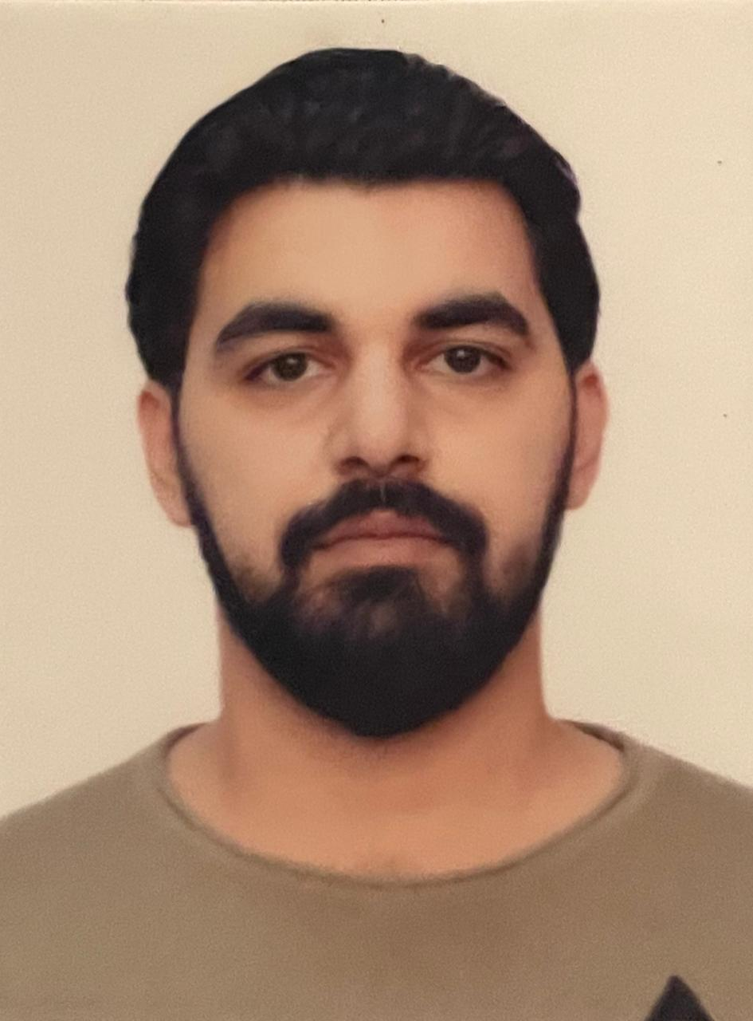

APPLICATION FOR POSITION AS | AB SEAMAN | OTHER POSITION (IF ANY) | AB SEAMAN

1. PERSONAL DETAILS
TITLE MR/MRS/MISS |  |  |  |  | MR |  |  |  |  |  | SEX |  |  |  |  | MALE X |  |  |  |  |  |  |  | FEMALE
SURNAME |  |  |  |  | AGHAYEV
FIRST NAME |  |  |  |  | FARAHIM |  |  |  |  |  | OTHERS NAMES |  |  |  |  | N/A
DATE OF BIRTH |  |  |  |  | 12.01.1994 |  |  |  |  |  | PLACE OF BIRTH |  |  |  |  | AZERBAIJAN
NATIONALITY |  |  |  |  | AZERBAIJANIAN |  |  |  |  |  | MARITAL STATUS |  |  |  |  | MARRIED
COLOUR OF EYES |  |  |  |  | BROWN |  |  |  |  |  | COLOUR OF HAIR |  |  |  |  | BLACK
MOTHER’S NAME |  |  |  |  | GULCOHRA |  |  |  |  |  | FATHER’S NAME |  |  |  |  | AZAR
MOTHER’S MAIDEN NAME |  |  |  |  | AGHAYEVA
HEIGHT (CM) |  |  |  |  | 185 |  |  |  |  |  | WEIGHT (KG) |  |  |  |  | 102
NEAREST INTERNATIONAL AIRPORT: |  |  |  |  |  |  | H.ALIYEV INTERNATIONAL AIRPORT
2. ADDRESS |  |  |  |  |  |  |  |  | ADDRESS (TEMP.) FROM/TO:
NO & STREET | BILAJARI DISTRICT, XAQANI ST, HOME 31A |  |  |  |  |  |  |  | NO & STREET |  |  |  | N/A
CITY | BAKU |  |  |  |  |  |  |  | CITY |  |  |  | N/A
POST CODE | AZ1124 |  |  |  |  |  |  |  | POST CODE |  |  |  | N/A
COUNTRY | AZERBAIJAN |  |  |  |  |  |  |  | COUNTRY |  |  |  | N/A
TEL. NO. | +994556176234 |  |  |  |  |  |  |  | TEL. NO. |  |  |  | N/A
MOBILE | +994556176234 |  |  |  |  |  |  |  | MOBILE |  |  |  | N/A
E-MAIL | ferahim.agayev94@icloud.com |  |  |  |  |  |  |  | E-MAIL |  |  |  | N/A
FAX | N/A |  |  |  |  |  |  |  | FAX |  |  |  | N/A
3. NEXT OF KIN
FULL NAME |  | GULCOHRA AGHAYEVA |  |  |  |  |  |  |  |  |  | RELATIONSHIP |  |  |  |  |  |  | MOTHER
ADDRESS |  | BILAJARI DISTRICT, XAQANI ST, HOME 31A
CITY |  | BAKU |  |  |  |  |  |  |  |  |  | COUNTRY |  |  |  |  |  |  | AZERBAIJAN
TEL. NO. |  |  |  |  |  | MOBILE |  |  |  | +994558596805 |  |  |  |  |  |  | FAX NO. |  |  |  | N/A
4. TRAVEL DOCUMENTS
TYPE |  |  |  | DOCUMENT NO. |  |  |  | ISS.DATE |  |  | EXP. DATE |  |  | ISS. BY (AUTHORITY) |  |  |  |  |  |  |  | PLACE OF ISSUE
PASSPORT |  |  |  | C04083632 |  |  |  | 05.09.2023 |  |  | 04.09.2023 |  |  | MINISTRY OF INTERNAL AFFAIRS |  |  |  |  |  |  |  | AZERBAIJAN
SEAMAN BOOK |  |  |  | DQK 024882 |  |  |  | 05.09.2023 |  |  | 05.09.2028 |  |  | AZERBAIJAN STATE MARITIME ADMINISTRATION |  |  |  |  |  |  |  | AZERBAIJAN
5. EDUCATION
SCHOOL NAME |  |  | AZERBAIJAN MARINE FISHIG INDUSTRIAL COLLEGE |  |  |  |  |  |  |  |  |  |  |  | FROM |  |  | 2010 |  |  |  |  | TO |  | 2011

6. PROFESSIONAL QUALIFICATION / CERTIFICATE OF COMPETENCY
CERTIFICATE NAME |  |  |  | NUMBER |  |  | ISSUE DATE |  |  | EXPIRY DATE |  |  | ISSUED BY (AUTHORITY) |  |  |  |  | ISSUED AT
ABLE SEAFARER DECK |  |  |  | 1273/18 |  |  | 07.09.2018 |  |  | 07.09.2028 |  |  | AZERBAIJAN STATE MARITIME ADMINISTRATION |  |  |  |  | AZERBAIJAN
7. LANGUAGES
ENGLISH | FLUENT |  |  |  | GOOD |  |  |  | X |  | FAIR |  |  |  |  | POOR
TURKISH | FLUENT |  |  | X | GOOD |  |  |  |  |  | FAIR |  |  |  |  | POOR
RUSSIAN | FLUENT |  |  |  | GOOD |  |  |  | X |  | FAIR |  |  |  |  | POOR
8. HEALTH CERTIFICATES & VACCINATIONS
FLAGE STATE | NUMBER |  |  |  |  | ISSUE DATE |  |  | EXPIRY DATE |  |  | ISSUED BY (AUTHORITY) |  |  |  |  | ISSUED AT
Yellow fever | MM0011-PEOZCU |  |  |  |  | 04.09.2023
9. SAFETY CLOTHING
BOILERSUIT SIZE |  | XXL |  |  |  |  |  | BOOTS SIZE |  |  |  |  |  |  | 44
10. MARINE COURSES
COURSE NAME |  |  | NUMBER |  |  | ISSUE DATE |  |  | EXPIRY DATE |  |  | ISSUED BY (AUTHORITY) |  |  |  |  | ISSUED AT
SHIP SECURITY-RELATED FAMILIARIZATION SECURITY-AWARENESS TRAINING |  |  | SI-1338-21 |  |  | 05.11.2021 |  |  | 28.10.2026 |  |  | AZERBAIJAN STATE MARITIME ADMINISTRATION |  |  |  |  | AZERBAIJAN
STCW-78 |  |  | SO-3149-23 |  |  | 05.07.2023 |  |  | 16.06.2028 |  |  | AZERBAIJAN STATE MARITIME ADMINISTRATION |  |  |  |  | AZERBAIJAN
INTERNATIONAL SAFETY MANAGEMENT CODE |  |  | SP-2013-23 |  |  | 22.06.2023 |  |  | 21.06.2028 |  |  | AZERBAIJAN STATE MARITIME ADMINISTRATION |  |  |  |  | AZERBAIJAN
PROFICIENCY IN SURVIVAL CRAFT AND BOATS OTHER THAN FAST RESCUE BOATS |  |  | SL-2295-23 |  |  | 12.07.2023 |  |  | 08.06.2028 |  |  | AZERBAIJAN STATE MARITIME ADMINISTRATION |  |  |  |  | AZERBAIJAN
PROFICIENCY IN FAST RESCUE BOATS |  |  | SU-0359-22 |  |  | 16.12.2022 |  |  | 16.12.2027 |  |  | AZERBAIJAN STATE MARITIME ADMINISTRATION |  |  |  |  | AZERBAIJAN
TRAINING FOR SEAFARERS WITH DESIGNATED SECURITY DUTIES |  |  | SH-2467-23 |  |  | 11.09.2023 |  |  | 11.09.2028 |  |  | AZERBAIJAN STATE MARITIME ADMINISTRATION |  |  |  |  | AZERBAIJAN
EXTRACT FROM SEAFARES MEDICAL CERTIFICATE |  |  |  |  |  | 13.02.2026 |  |  | 13.02.2026 |  |  | UNICLINIC |  |  |  |  | AZERBAIJAN

COMPLETE SEA – SERVICE DETAILS
( LAST VESSELS FIRST )
NAME: FARAHIM AGHAYEV
RANK: ABLE SEAMAN

COMPANY NAME |  | RANK | VESSEL NAME |  | SIGNED ON | SIGNED OFF | TYPE OF VESSEL | D.W.T. | ENGINE TYPE  ( ENGINEERS ONLY) | KW
P/0 |  | AB | TOPAZ KAMA |  | 06.10.2023 | 28.12.2023 | GENERAL CARGO | 3183 | CATERPILLAR – C32 | 3X994
BUE CASPIAN |  | AB | TOPAZ TRIUMPH |  | 22.07.2016 | 05.09.2023 | AHTS | 2148 | MAN | 2X2720
BUE CASPIAN |  | AB | CITADEL |  | 08.05.21 | 01.06.21 | SUPPLY SHIP  PSV DP2 | 2300 | R.R  BERGEN | 2X2160
BUE CASPIAN |  | AB | TOPAZ DIGNTY |  | 28.01.21 | 12.04.21 | AHTS | 2148 | MAN | 2X2720
BUE CASPIAN |  | AB | CASPIAN CHALENGER |  | 22.07.2016 | 05.09.2023 | AHTS | 3060 | R.R  BERGEN | 2X6000
TOPAZ MARINE |  | AB | CASPIAN VOYAGER |  | 05.07.2016 | 19.09.2016 | PSV | 2560 | MAN | 2X2200

