APPLICATION FORM

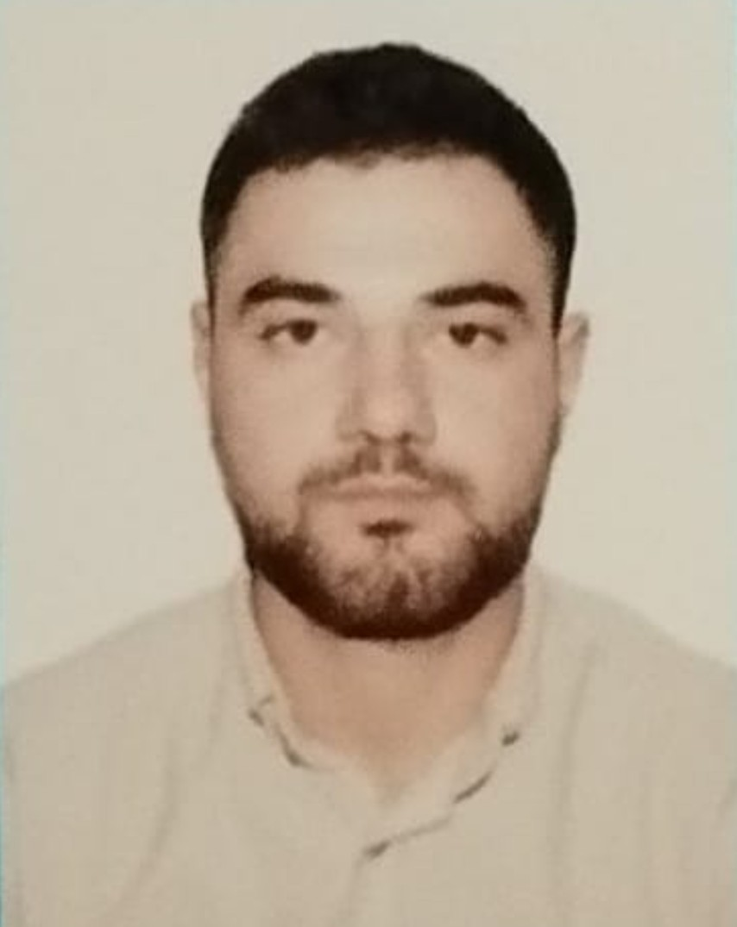

 |  |  |  |  | 7 | C | 7 | A | S | 7 | 8
Personal ID Number

Position Applied for: OILER | Date Available from:ANY TIME

1. PersonalData
Family Name. MAMMADOV | First Name: SAMIR | Middle Name: CALIL
Date of Birth: 28.12.2001 | Place of Birth: AZERBAIJAN,SALYAN | Citizenship: AZEBAIJANIAN
Permanent Address: AZERBAIJAN,SALYAN region. |  | Phone (Home): NO  Phone (Business/ Mobile): +994507821455 E-mail: sm0877780@gmail.com

2. MaritimeEducation
Nameofschool | Country | Town | From | To | Type of degree or diploma
AZERBAIJAN IST.SERVICES | AZERBAIJAN | BAKU | 05.07.2023 | 08.01.2024 | 6 Month

3. ProfessionalTest
EnglishTestDate | NameofTest | Score
ProfessionalTestDate | NameofTest | Score
ProfessionalInterviewDate | Result

4. FamilyDetails
Civil Status(Single, Married, Separated, Divorced, Widowed) : SINGLE

Next of Kin (the first emergency contact) : MAMMADOV CALIL | Relationship / FATHER
Address of Residence: AZERBAIJAN,ASTARA | Phone :+994056459552

 | Doughter | Son
FamilyName
FirstName
DateofBirth
Cityofliving
PhoneNumbers

5. IdentityDocuments
Document | Country | Number | PlaceofIssue | IssueDate | ExpiryDate
Seaman'sBook | AZERBAIJAN | AZE031676 | State Maritime Administration | 16.02.2024 | 16.02.2029
TravelPassport | AZERBAIJAN | C03516180 | AZERBAIJAN LANKARAN | 24.01.2024 | 23.01.2034

6. ValidVisa
CountryorUnion | Type | ValidUntil

7. Courses Attended and Certificates Obtained
Document | Number | Dates |  | Place
Document | Number | Issue | Expiry | Place

CertificateofCompetency | RP14433 | 08.02.2024 |  | State Maritime Administration
MalteseEndorsementof COC
OilTankerEndorsement
ChemicalTankerEndorsement
GasTankerEndorsement
Advanced training for oil tanker cargo operations
ChemicalTankerFamiliarizationTraining
GasTankerFamiliarizationTraining
OilTankersSpecializedTraining
ChemicalTankerSpecializedTraining
GasTankerSpecializedTraining
BasicTrainings | SO-5151-23 | 30.10.2023 | 27.10.2028 | State Maritime Administration
Proficiency in Survival Craft and Rescue Boats | SL-4018-23 | 07.11.2023 | 04.11.2028 | State Maritime Administration
AdvancedFireFighting
MedicalFirstAidTraining
Medical First Aid Training and Medical Care
RO-ro
Crisis management and human behavior training
RadarObservation&Plotting
Automatic Radar Plotting Aids Simulator (ARPA)
BridgeTeamManagement
Shiphandling&Maneuvering
Ship Security-related familiarization security-awareness training | SI-3356-23 | 07.11.2023 | 30.10.2028 | State Maritime Administration
MalteseEndorsementof SSO
ISM Code | SP-3614-23 | 14.11.2023 | 14.11.2028 | State Maritime Administration
SafetyOfficer
ECDISTrainingCourse
RiskAssessmentCourse
C.O.W./ I.G.S
FirePracticeonTankers
VapourRecoverySystem
UnmannedMachinerySpace
FRAMO FamiliarizationCourse
Cargo Ballast Operations on Oil/Chemical Tankers
Engine resoursce management
Leadership and Teamwork
High woltage
Risk Management And Incident Investigation
Training of seafarers with designated security duties | SH-2098-23 | 07.11.2023 | 07.11.2028 | State Maritime Administration
Dangerous hazardous and harmfull cargoes
BasicTraining and qualifications on oil and chemical tanker cargo operations

8. PhysicalData
Height | 175
Weight | 67
ColourofHair | Black
ColourofEyes | Chestnut
BoilersuitSize | 42
ShoesSize | XL

9. MedicalHistory | Yes | No
Have you ever signed off a ship due to medical reasons? |  | +
Did you undergo any medical operation in the past? |  | +
Have you consulted a doctor during the last 12 months for an illness/accident? |  | +
Do you have any health or disability problems now? |  | +

If yes, please give full details:

 | Passed: | Validtill:
InternationalMedicalExamination | 29.07.2023 | 29.07.2025
VaccinationAgainstYellowFiver
VaccinationAgainstDiphtheria

10. References (please give name and address of your current or past employer) | Officeremarks

NameofCompany
Name of person to contact
Address
Phone

NameofCompany
Name of person to contact
Address
Phone

11. Bankaddressforallotments
Beneficiary
AccountNo.
NameofBank
BankAddress

12. Knowledgeandexperience | Yes | No
OCIMF vettingexperience:
ISGOT knowledge:

13. I hereby declare that the above, including Medical History, is true
Place

14. ForOfficeuseonly

15. SeagoingExperience

Nameofvessel | Flag | Vessel’s Type | DWT | EngType | HP | ManagerorOwner | Rank | From d/m/y | To d/m/y | Total  m/d
MORNOVA | AZE | Dry cargo | 2500 | Wartsila  6L20 |  | Azerbaijan company | cadet | 08.10.2023 | 06.01.2024 | 3 month

Total rank sea service: Total type of vessel sea service:
Rank | Years |  | Typeofvessel | Years
 |  |  | OIL TANKER
 |  |  | LPG
 |  |  | DRY CARGO
 |  |  | TANKER ICE
 |  |  | OIL /CHEMICAL TANKER
 |  |  | FERRY
Total |  |  | Total:

