ALİ KOÇ  OCEANGOING MASTER |  |  |  |  |  |  |  |  |  | 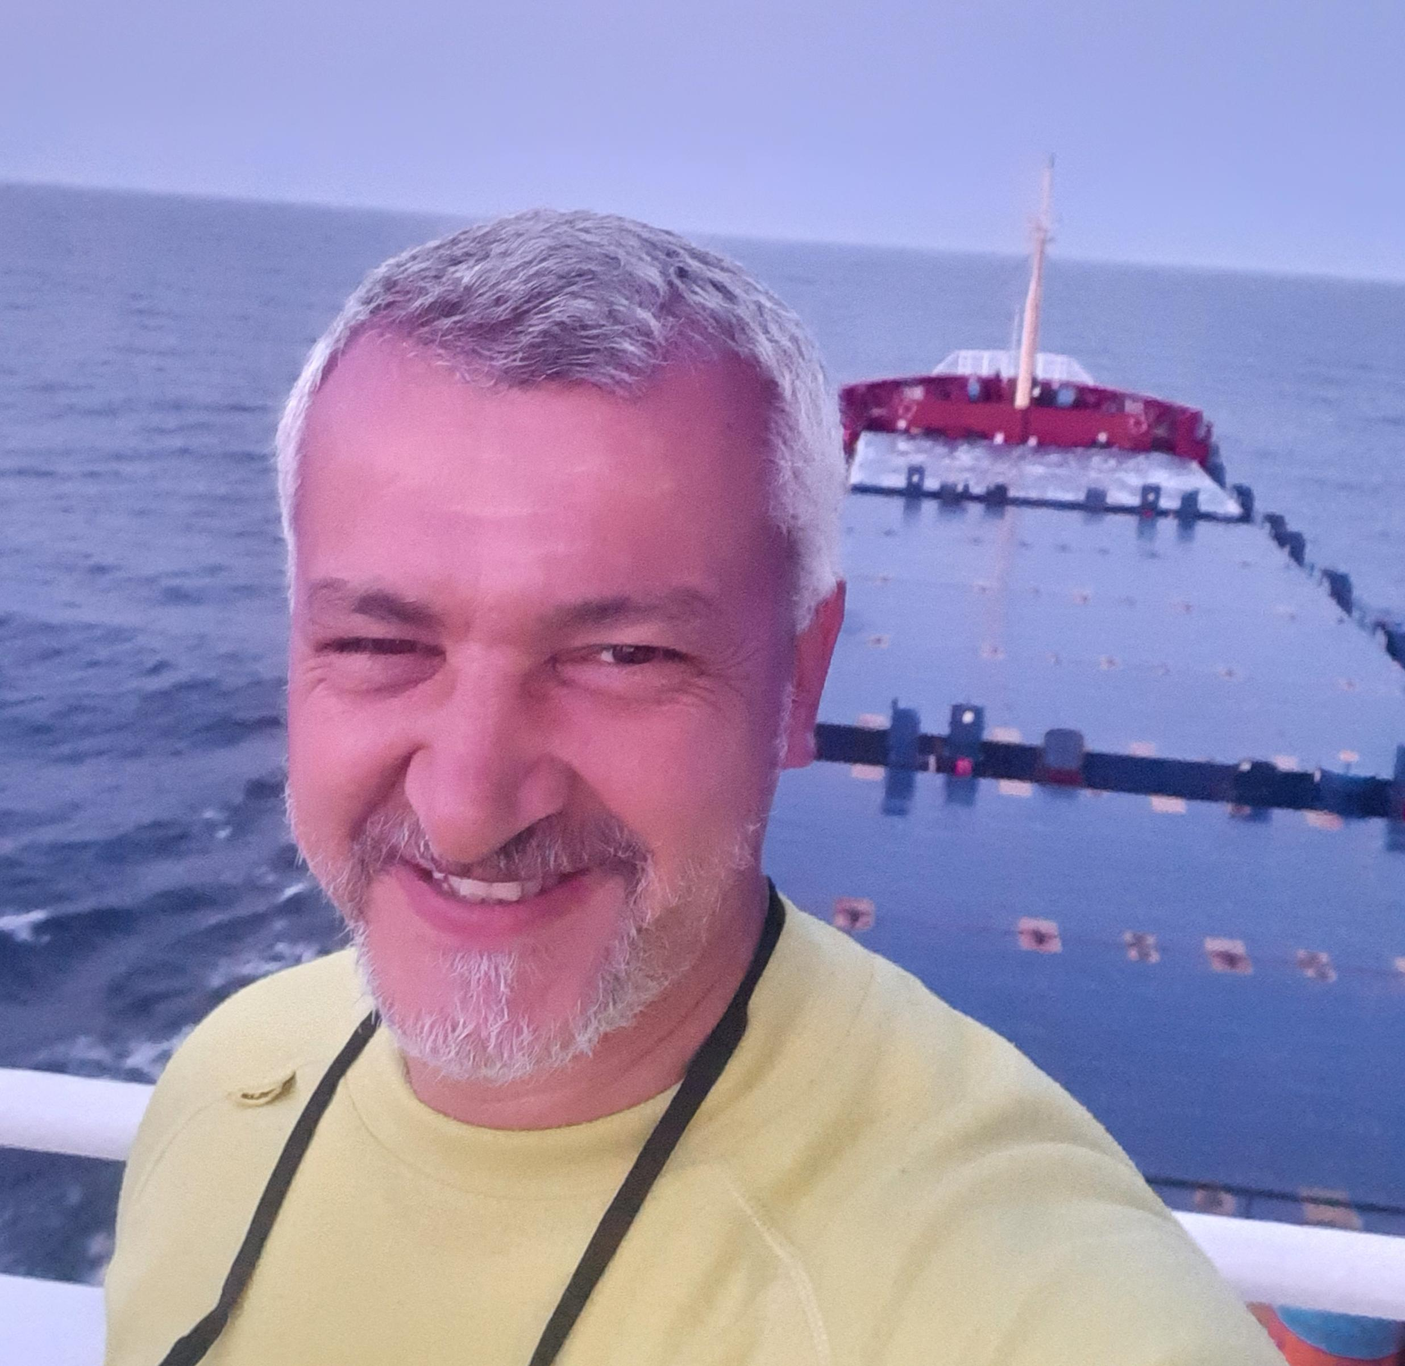
A. Personal
Family Name |  |  | Given Name |  |  |  |  | Middle Name |  | Sex
KOÇ |  |  | ALİ |  |  |  |  | - |  | M
Birth Date  (dd MM yy) |  |  | Place of Birth |  |  | Nationality |  | National Reg. No. |  | Religion
11 APR 1971 |  |  | KANDIRA |  |  | TURKISH |  | 56569161942 |  | MUSLIM
Address |  |  |  |  |  |  |  | Contact No. |  | Email
KARTEPE / KOCAELİ |  |  |  |  |  |  |  | + 90 553 833 04 11 |  | emrec2012@ gmail.com
Passport No. (Special) |  | Place of Issue |  |  |  | Date of Issue |  | Expiry Date |  | Civil Status
S20666981 |  | ISTANBUL |  |  |  | 25 NOV 2019 |  | 25 NOV 2024 |  | MARRIED
University |  |  |  |  | Highest Education |  |  |  | Year
TURKISH NAVAL ACADEMY |  |  |  |  | - |  |  |  | 1992
Next of Kin
Family / Given Name |  |  | Address |  |  |  |  | Tel/Cell/Fax |  | Relationship
KOC/ MARYNA |  |  | KARTEPE / KOCAELİ |  |  |  |  | +380 68 890 41 13 |  | SPOUSE
KOC/MUSERREF |  |  | MERKEZ MAH. KUBILAY SK. NO:5 D:3 GAZIOSMANPASA/ISTANBUL |  |  |  |  | +90 555 04 41 962 |  | ELDER SISTER
B. National Certification
Seaman’s Book No. |  |  | Issued Date |  |  | Expiry Date |  | Medical Expiry Date |  | Vaccination Date
S00421714 |  |  | 04.04.2024 |  |  | 04.04.2029 |  | 26 AGU 2024 |  | 07 OCT 2019
National Certificate No. |  |  |  |  | Issued Date |  | Expiry Date |  | Issuing Country
TURKEY / 4EBDA38C (YACHT MASTER) |  |  |  |  | 04 APR 2024 |  | 04 APR 2029 |  | TURKEY
TURKEY / 58B10DAF  (OCEANGOING MASTER) |  |  |  |  | 04 APR 2024 |  | 04 APR 2029 |  | TURKEY
C. Certificates and Qualifications
Documents Held |  |  |  | STCW’95 |  |  | Flag State | Number | Issued  (DDMMYY) | Expiry  (DDMMYY)
GMDSS GENERAL RADIO OPERATOR (GOC) |  |  |  |  |  |  | TURKEY | 4378DB4C | 04 APR 2024 | 04 APR 2024
D. Sea Service Record
Rank | Vessel |  | Flag |  | IMO Type | GRT/DWT | BHP/  KW | Period (DD/MM/YY) |  | Management
 |  |  |  |  |  |  |  | From | To | Management
1st OFF. | M/V AYA |  | PANAMA |  | GENERAL CARGO | 4339/  6511 | 2574 KW | 24.11.2023 | 03.01.2024 | MILESTONE SHIPPING
1st OFF. | M/V SUN S |  | PANAMA |  | GENERAL CARGO | 3798/  5418 | 2060 KW | 07.05.2023 | 08.08.2023 | MILESTONE SHIPPING
1st OFF. | M/V KALKANDERE |  | ISTANBUL / TURKEY |  | GENERAL CARGO | 3379/  5225 | 2250 KW | 19.10.2022 | 23.01.2023 | BEK SHIPPING
1st OFF. | M/V DANCING QUEEN |  | PANAMA |  | GENERAL CARGO | 2810/4631 | 2200 KW | 03.09.2022 | 15.09.2022 | BEK SHIPPING
1st OFF. | M/V MUZAFFER BEY |  | ISTANBUL / TURKEY |  | GENERAL CARGO | 3796/  5583 | 2207 KW | 21.04.2022 | 20.06.2022 | BEK SHIPPING
1st OFF. | M/V KALKANDERE |  | ISTANBUL / TURKEY |  | GENERAL CARGO | 33795225 | 2250 KW | 14.08.2021 | 23.12.2021 | BEK SHIPPING
1st OFF. | M/V DANCING QUEEN |  | PANAMA |  | GENERAL CARGO | 2810/ 4631 | 2200 KW | 27.05.2021 | 10.08.2021 | BEK SHIPPING
1st OFF. | M/V SKYMOON2 |  | MOLDOVA |  | GENERAL CARGO | 23313262 | 749 KW | 10.01.2021 | 03.04.2021 | STARON SHIPPING
1st OFF. | M/V KARADERE |  | ISTANBUL / TURKEY |  | GENERAL CARGO | 28804586 | 1865 KW | 02.08.2020 | 10.10.2020 | BEK SHIPPING
CAPT. | M/T SELAY |  | ISTANBUL / TURKEY |  | TANKER | 1584 | 970 KW | 30.05.2015 | 01.07.2015 | SELAY SHIPPING
CAPT. | TCSG 90 |  | TURKEY |  | TURKISH COAST GUARD | 195 | 5384 KW | 28.07.2003 | 07.01.2006 | TURKISH COAST GUARD COMMAND
1st OFF. | TCG TAŞKIZAK |  | TURKEY |  | WAR SHIP | 1484 | 790 KW | 02.04.2001 | 27.07.2003 | TURKISH NAVAL FLEET
2nd OFF. | TCG ATILAY |  | TURKEY |  | WAR SHIP | 1200 | 4600 HP | 26.06.2000 | 02.01.2001 | TURKISH NAVAL FLEET
2nd OFF. | TCG DOĞANAY |  | TURKEY |  | WAR SHIP | 1200 | 4600 HP | 01.09.1999 | 10.03.2000 | TURKISH NAVAL FLEET
2nd OFF. | TCG BATIRAY |  | TURKEY |  | WAR SHIP | 1200 | 4600 HP | 15.03.1999 | 16.07.1999 | TURKISH NAVAL FLEET
2nd OFF. | TCG DOĞANAY |  | TURKEY |  | WAR SHIP | 1200 | 4600 HP | 14.07.1997 | 15.03.1999 | TURKISH NAVAL FLEET
2nd OFF. | TCG DOĞANAY |  | TURKEY |  | WAR SHIP | 1200 | 4600 HP | 18.11.1996 | 14.07.1997 | TURKISH NAVAL FLEET

E. COURSES
Course |  |  |  |  | Certificate No. | Date of Issue / Expiry
CERTIFICATE OF PROFICIENCY IN BASIC TRAINING FOR OIL AND CHEMICAL TANKER CARGO OPERATIONS |  |  |  |  | 11333709 | 26.11.2019 / 31.10.2024
FIRE PREVENTION AND FIRE FIGHTING TRAINING CERTIFICATE  YANGIN ÖNLEME VE YANGINLA MÜCADELE EĞİTİMİ BELGESİ |  |  |  |  | 02D969F0 | 04.04.2024 / 04.04.2029
ELEMENTARY FIRST AID TRAINING CERTIFICATE  TEMEL ILK YARDIM EĞİTİMİ BELGESİ |  |  |  |  | 21D4A025 | 04.04.2024 / 04.04.2029
PERSONAL SAFETY AND SOCIAL RESPONSIBILITY TRAINING CERTIFICATE  PERSONEL GÜVENLİĞİ VE SOSYAL SORUMLULUK EĞİTİMİ BELGESİ |  |  |  |  | 49A96C8E | 04.04.2024 / 04.04.2029
PERSONAL SURVIVAL TECHNIQUES TRAINING CERTIFICATE  DENIZDE KİŞİSEL CAN KURTARMA TEKNİKLERİ EĞİTİMİ BELGESİ |  |  |  |  | 3FC8A330 | 04.04.2024 / 04.04.2029
PROFICIENCY IN SURVIVAL CRAFT AND RESCUE BOATS (OTHER THAN FAST RESCUE BOATS) CERTIFICATE  CAN KURTARMA ARAÇLARINI KULLANMA YETERLİLİĞİ EĞİTİMİ BELGESİ |  |  |  |  | 56E6447C | 04.04.2024 / 04.04.2029
SHIP SECURITY OFFICER  GEMİ GÜVENLİK ZABITI |  |  |  |  | 569DA91A | 04.04.2024 / 04.04.2029
PROFICIENCY IN FAST RESCUE BOATS CERTIFICATE  HIZLI CAN KURTARMA BOTU KULLANMA YETERLİLİĞİ BELGESİ |  |  |  |  | 11272172 | 15.08.2019 / 24.05.2024
ADVANCED FIRE FIGHTING TRAINING CERTIFICATE  ILERİ YANGINLA MÜCADELE BELGESİ |  |  |  |  | 657A6069 | 04.04.2024 / 04.04.2029
SECURITY RELATED FAMILIARIZATION CERTIFICATE  GÜVENLİK İLE İLGİLİ TANITIM BELGESİ |  |  |  |  | 5E48BC59 | 04.04.2024 / 04.04.2029
F. Other Qualifications / STCW 95 Courses
Course |  |  |  |  | Certificate No. | Date of Issue / Expiry
SECURITY AWARENESS CERTIFICATE  GÜVENLİK FARKINDALIK BELGESİ |  |  |  |  | 0D5020DE | 04.04.2024 / 04.04.2029
DESIGNATED SECURITY DUTIES CERTIFICATE  BELİRLENMİŞ GÜVENLİK GÖREVLERİ EĞİTİMİ |  |  |  |  | 7330EBC6 | 04.04.2024 / 04.04.2029
BRIDGE RESOURCES MANAGEMENT (BRM)  KÖPRÜÜSTÜ KAYNAK YÖNETIMİ |  |  |  |  | 10225114 | 28.04.2014 / UNLIMITED
ELECTRONIC CHART DISPLAY INFORMATION SYSTEM (ECDIS)  ELEKTRONİK HARİTA GÖSTERİMİ VE BİLGİ SİSTEMİ |  |  |  |  | 10225113 | 28.04.2014 / UNLIMITED
MEDICAL CARE TRAINING CERTIFICATE  TIBBI BAKIM EĞİTİMİ BELGESİ |  |  |  |  | 11531903 | 07.12.2020 / UNLIMITED
MEDICAL FIRST AID TRAINING CERTIFICATE  ILK YARDIM EĞİTİMİ BELGESİ |  |  |  |  | 11531902 | 07.12.2020 / UNLIMITED
THE OPERATIONAL USE OF AUTOMATIC RADAR PLOTTING AIDS (ARPA) TRAINING CERTIFICATE  OTOMATİK RADAR PLOTLAMA AYGITLARINI (ARPA) KULLANMA |  |  |  |  | 10225109 | 28.04.2014 / UNLIMITED
RADAR OBSERVATION AND PLOTTING TRAINING CERTIFICATE  RADAR GÖZLEM VE PLOTLAMA EĞITIMI BELGESİ |  |  |  |  | 10225108 | 28.04.2014 / UNLIMITED
G. Bio Data
Height |  |  | Weight |  | Colour of Eyes | Colour of Hair
1.72 | Centimetres |  | 85 | Kilograms | BROWN | GRAY
Boiler Suit Size |  |  | Safety Shoe Size
M/L |  |  | 42
H. Language Skills
ENGLISH |  | INTERMEDIATE ( SPOKEN, WRITTEN )
RUSSIAN |  | INTERMEDIATE (SPOKEN, WRITTEN )

I. Reference(s) from Previous Employment
No. | Company / FUNCTION | Name of Contact Person | Tel/Fax
1. | BEK SHIPPING/ DPA | Kayhan TEKIN | +90 533 291 31 40
2. | BEK SHIPPING/ MV KALKANDERE MASTER | Murat ŞAHİN | +90 532 695 14 26
3. | İNCE DENİZCİLİK/OCEANGOING MASTER | Ali Haydar UÇAN | +90 530 596 09 20
4. | DEKAMAR DENİZCİLİK/OCEANGOING MASTER | Ayhan BURHAN | +90 536 816 17 83
5. | OLDENDORFF SHIPPING / 3 OFF | İsmail Ünsal KONURALP | +90 533 454 91 28
6. | TANGO SHIPPING / MASTER | Alper ARABACI | +90 553 456 96 34
7. | OCEANGOING MASTER | Cengiz ÖZYOLDAŞ | +90 532 615 17 33  czyoldas@yahoo.com
8. | PSV ALTAN / OCEANGOING MASTER | Serdar ÇELEBİ | +90 532 778 69 20

