CURRICULUM VITAE
PERSONAL DETAILS
Family name |  | MUSTAFAZADE |  |  | 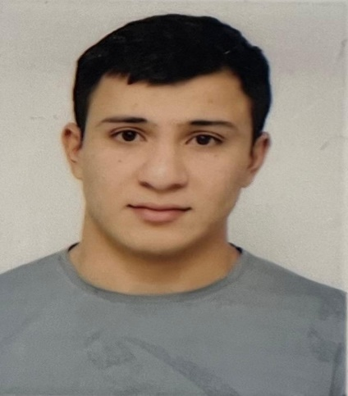
First name |  | GURUR
Father’s name |  | OKTAY
Date and place of birth |  | 29.04.2003 Azerbaijan
Nationality |  | Azerbaijani
Marital status |  | No
Permanent address |  | Azerbaijan, BAKU
Nearest airport |  | Heydar Aliyev International Airport Baku, Azerbaijan
Height (cm) | Weight (kg) | Eyes color | Hair color | Size of safety shoes | Size of coveralls
1.80 cm | 76 kg | BROWN | BLACK | 42 | 52
CONTACT DETAILS
Mobile | E-mail address
+994552183837
NEXT OF KIN (FOR EMERGENCY)
Next of kin |  | Relationship | Brother
Date of birth |  | Address | Baku,Azerbaijan
Phone |  | Mobile phone
TRAVEL PASSPORT DETAILS
Document | Number | Place of Issue | Issued | Valid
PASSPORT | C04021934 | Azerbaijan | 08.02.2024 | 07.02.2034
SEAMAN’S BOOK DETAILS
Document | Number | Place of Issue | Issued | Valid
Seaman book | DGK027546 | Azerbaijan ,Baku | 09.04.2024 | 09.04.2029
SEAARERS IDENTITY | AZE032422 | Azerbaijan ,Baku | 09.04.2024 | 09.04.2029
EDUCATION
Full name of School | Place of Issue | Grade/Class | From | To
Azerbajan Marine Akademiy | Azerbaijan , Baku | 0629/24 | 19.03.2024

Languages | Speaking | Reading | Writing
Azerbaijan | Excellent | Excellent | Excellent
Russian | Excellent | Excellent | Excellent
Turkish | Excellent | Excellent | Excellent
COMPUTER SKILLS
Windows | Microsoft Office | Internet
Excellent | Excellent | Excellent
MEDICAL INFORMATION
Document | Grade | Place of issue | Date of issue | Date of expiry
Med.Sertificate | A/B | Azerbaijan | 06.12.2023 | 06.12.2025
CERTIFICATE OF COMPETENCY
Class/Grade | Issuing country | Certificate No. | Date issued | Expires | Details of Limitations
SEAMAN | Azerbaijan Marine Administration | 0629/24 | 19.03.2024 |  | A-II/4
STCW AND OTHER CERTIFICATES
Name of course/Certificate | Institute | Place | Date of issue | Cert.No | Date of expiry
Basic training and qualifications on oil and chemical tanker cargo operations | Azerbaijan Marine Adminstration | Azerbaijan Baku | 19.12.2023 | SA-1054-23 | 14.12.2028
International Safety Management | Azerbaijan Marine Adminstration | Azerbaijan Baku | 01.03.2024 | SP-0484-24 | 26.02.2029
Proficiency in survival craft and boats other than fast rescue boats | Azerbaijan Marine Adminstration | Azerbaijan Baku | 01.02.2024 | SL-0239-24 | 26.01.2029
Training for seafarers with designated security duties | Azerbaijan Marine Adminstration | Azerbaijan Baku | 21.12.2023 | SH-3466-23 | 15.12.2028
Basic safety trainig | Azerbaijan Marine Adminstration | Azerbaijan Baku | 16.02.2024 | S0-0427-24 | 16.02.2029
Ship Security-related familization security-awareness | Azerbaijan Marine Adminstration | Azerbaijan Baku | 19.01.2024 | SI-0164-24 | 19.01.2029
SEA EXPERIENCE (LAST 5 YEARS – MOST RECENT EXPERIENCE ON TOP LINE)
Vessel | Company | Type of vessel | Flag | DWT | GRT | BHP | Rank | Sign on | Sign off
AMUR 2528 | NR GORUP | GEN CARGO | Russia [RU] | 3332 | 3086 | 116.03 x 13.43 | SEAMAN | 30.04.2023 | 25.07.2023
ALI MUSTAFAYEV | ASCO | TANKER | AZERBAIJAN | 4056 | 4510 | 113 x 17 | SEAMAN | 15.09.2023 | 18.04.2024

