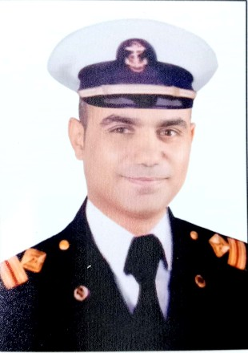  Contact  Seaman’s passport : S00035835 ends 19/6/2028  Profession : 3rd Eng  Date of birth : 25 / 9 / 1984  Nationality : Egyptian  Religion : Muslim  Gender : Male  Marital status : Married  Address :  El-Mahala El-Kobra Egypt  Tel no. +201061919420  E- Mail address :  Mohamedsharf235@gmail.com | Curriculum Vitae  MOHAMED IBRAHIM MOHAMED SHARAF  3RD MARINE ENGINEER  Education :  3rd Marine Engineer 25/10/2023 certificate no.3846,Exp  ( 19/6/2028  - The industrial technical institute for maritime facilities and maritime transport economics (the branch of ships building and maintenance )  Language :  Arabic : ( mother tongue )  English : good  ALL STCW certificates from ARAB REPUBLIC OF EGYPT NAVAL POST-GRADUATE STUDIES INSTITUTE :  1- Prevention and combating of marine pollution .  2- Personal safety and social responsibilities .  3- Advanced fire prevention and fire fighting .  4- Medical first care .  5- Proficiency in personal survival techniques.  6- Proficiency for security awareness training for seafarers with designed Security Duties .  7- Proficiency in survival crafts and rescue boats .  8- Engine room resource management .

Experiences :
Vessel name | Vessel type | Position | M/E | Duration
El-Dawlia 102 | Splet barge | 3rd engineer | CAT | From 23 /2/2011 to 16/5/2012
Prince 5 | general Cargo | 3rd engineer | MAN  4 stroke | From 1/6/2012 to 23/7/2013
Comondanty Gee | Marine service of shore | 3rd engineer | B & W | From 25/8/2013 to 10/11/2013
El-Dawlia 102 | Splet barge | 3rd engineer | CAT | From 9/11/2014 to 30/3/2016
AL Baraka -5 | Ro-Ro Car carrier | 4th engineer | Bazan M.A.N  4 stroke | From 1/5/2016 to 10/2/2017
AL Baraka -5 | Ro-Ro Car carrier | 3rd engineer | Bazan M.A.N  4 stroke | From 13/3/2017 to 3/1/2018
Yosor | Life stock | 4th engineer | DUETZ  4 stroke | From 7/4/2018 to 25/1/2019
Yosor | Life stock | 3rd engineer | DUETZ  4 stroke | From 21/2/2019 to 23/12/2019
Yosor | Life stock | 3rd engineer | DUETZ  4 stroke | From 7/6/2020 to 1/4/2021
Sallizar Forte | Bulk carrier | 3rd engineer | Mitsu-MAN B&W  2 stroke | From 19/10/2021 to 27/7/2022
Sallizar Forte | Bulk carrier | 3rd engineer | Mitsu-MAN B&W  2 stroke | From 10/10/2022 to 15/5/2023

