





PERSONAL DETAILS
CONTACT DETAILS
NEXT OF KIN (FOR EMERGENCY)
TRAVEL PASSPORT DETAILS
SEAMAN’S BOOK DETAILS
EDUCATION
COMPUTER SKILLS

 |  | AZIZLI |  |  | 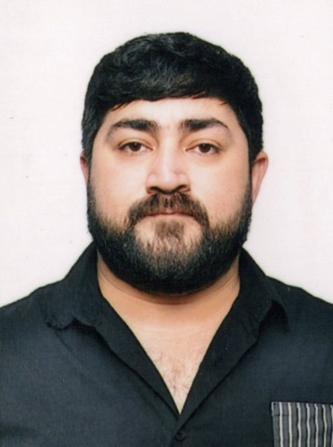
 |  | ELMAR
 |  | RASIM
 |  | 22.11.1995 Azerbaijan
 |  | Azerbaijani
 |  | SİNGLE
 |  | Azerbaijan, BAKU
 |  | Heydar Aliyev International Airport Baku, Azerbaijan
Height (cm) | Weight (kg) | Eyes color | Hair color | Size of safety shoes | Size of coveralls
1.70cm | 90 kg | BROWN | BLACK | 41 | XL

Mobile | E-mail address
+994 558662261 | ezizlielmar749@gmail.com

Next of kin | UNCLE | Relationship | YES
Date of birth | 02.12.1971 | Address | AZERBAIJAN., SHIRVAN SITY., M.RASULZADE STREET 17/43
Phone | +994 553344381 | Mobile phone

Document | Number | Place of Issue | Issued | Valid
PASSPORT | C03620170 | Azerbaijan | 26.05.2023 | 25.05.2033

Document | Number | Place of Issue | Issued | Valid
Seaman book | DQK028095 | Azerbaijan ,Baku | 16.05.2024 | 16.05.2029
SEAARERS IDENTITY | AA2969484 | Azerbaijan ,Baku | 30.11.2019 | 30.11.2030

Full name of School | Place of Issue | Grade/Class | From | To
“ Kaspian Education Center” MMC | Azerbaijan , Baku | PS-000760 | 27.09.2022 | 30.03.2023

Languages | Speaking | Reading | Writing
Azerbaijan | Excellent | Excellent | Excellent
English | Middle | Middle | Middle
Russian | Middle | Middle | Middle
Turkish | Excellent | Excellent | Excellent



CERTIFICATE OF COMPETENCY
STCW AND OTHER CERTIFICATES
SEA EXPERIENCE (LAST 5 YEARS – MOST RECENT EXPERIENCE ON TOP LINE)
Windows | Microsoft Office | Internet
Excellent | Excellent | Excellent
MEDICAL INFORMATION

Document | Grade | Place of issue | Date of issue | Date of expiry
Med.Sertificate | Rating forming part of a Navigational watch | Azerbaijan | 05.03.2024 | 05.03.2026

Class/Grade | Issuing country | Certificate No. İD | Date issued | Expires | Details of Limitations
O/S | Azerbaijan Marine  Administration | RP-14954 | 02.05.2024 | No limit | A-II/4

 |  |  |  |  | 
International Safety Management | Azerbaijan  Marine Adminstration | Azerbaijan Baku | 29.03.2024 | SP-0849-24 | 29.03.2029
Proficiency in survival craft and boats other than fast  rescue boats | Azerbaijan Marine  Adminstration | Azerbaijan Baku | 18.03.2024 | SL-0614-24 | 14.03.2029
Training for seafarers with designated security duties | Azerbaijan Marine  Adminstration | Azerbaijan Baku | 29.03.2024 | SH-0791-24 | No limit
Basic safety trainig | Azerbaijan  Marine Adminstration | Azerbaijan Baku | 06.04.2024 | S0-1144-24 | 05.04.2029
Ship Security-related  familization securityawareness | Azerbaijan  Marine Adminstration | Azerbaijan Baku | 29.03.2024 | SI-1068-24 | No limit

Vessel | Company | Type of vessel | Flag | DWT | GRT | BHP | Rank | Sign on | Sign off

