

Position applied for: 3RD ENGINER |  |  | Date: 13/10/2022
Surname: TETEMADZE |  |  | First Name: BESIK | 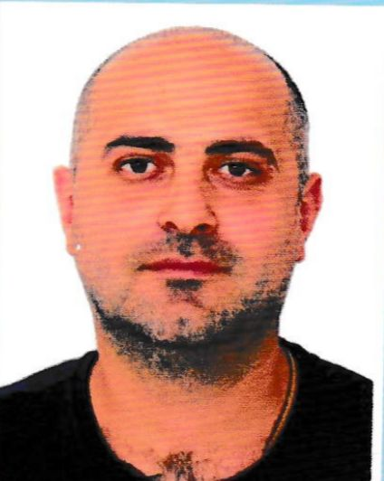
Date of Birth: 17/08/1987 |  |  | Place of birth: BATUMI
Nationality: GEORGIA |  |  | Departure airport: BATUMI
Home address: TBEL ABUSERIDZE STR 61A
Tel / Mob: 995 557 59 05 37 |  |  | Other Tel:995 557 30 44 30
E-mail: tetemadzebesik@gmail.com |  |  | Marital status: MARRIED
Number of children under the age of 18: 2
Next of Kin / Relationship / Address: |  | TBEL ABUSERIDZE STR 61A
Marine college: | Academy | UNIVERSITY
PHYSICAL DATA:
Height | 183 | Color of Eyes | HAZEL
Weight | 90 | Boiler suit Size | XL
Color of Hair | BLACK | Shoes Size | 44

CERTIFICATES:
DESCRIPTION | Number | Issue | Expiry | Place
Certificate of Competency : | 20G06-20-006169 | 03/12/2020 | 03/12/2025 | GEORGIA
Passport: Alien  Citizen  of GEO |  |  |  | GEORGIA
Seaman’s book | GE018639 | 08/12/2020 | 08/12/2025 | GEORGIA
Seaman’s ID Card |  |  |  | GEORGIA
Basic Safety Training | BST01-161089 | 11/05/2022 | 07/05/2027 | GEORGIA
Advanced Fire Fighting | AFT03-130198 | 04/11/2020 | 01/10/2025 | GEORGIA
Proficiency in Survival Craft and Rescue Boats Other Then Fast Rescue Boats | FRB01-161088 | 11/05/2022 | 11/05/2027 | GEORGIA
Profiency In Crisis Management & Human Behavior |  |  |  | GEORGIA
Security Awareness Training | SEC03-130199 | 04/11/2020 | 25/09/2025 | GEORGIA
Designated Security Duties |  |  |  | GEORGIA
Passenger Safety, Cargo Safety & Hull Integrity Training | PSS03-130194 | 04/11/2020 | 24/10/2025 | GEORGIA
Safety Training For Personnel Providing Direct Service Passengers In Passengers Space |  |  |  | GEORGIA
COVID 19 Vaccine |  | 04/06/2022 |  | GEORGIA
Crowd Management Training |  |  |  | GEORGIA
Vaccinations / Yellow fever / | M 51861-V | 07/12/2017 | 07/12/2017 | GEORGIA
National Medical Certificate |  | 21/06/2022 | 21/06/2024 | GEORGIA

VISA:
USA: | 21/01/2023
Other:

LANGUAGES:
English: | GOOD
Russian | GOOD
Other: Turkish | NO

PREVIOUS SEA SERVICE:
FROM | UNTIL | RANK | SHIP GRT/DWT | FLAG | TYPE | COMPANY
07/08/2016 | 11/12/2016 | Sr enginer | carnival breeze  128052/10250 | PAN | passenger | CARNIVAL CRUISE LINE
11/02/2017 | 16/09/2017 | Sr enginer | Carnival glory  110239/11100 | PAN | passenger | CARNIVAL CRUISE LINE
13/01/2018 | 21/07/2018 | Sr enginer | Carnival freedom  110320/12870 | PAN | passenger | CARNIVAL CRUISE LINE
18/10/2018 | 30/03/2019 | Sr enginer | Carnival paradise  70390/6894 | PAN | passenger | CARNIVAL CRUISE LINE
21/06/2019 | 29/11/2019 | Sr enginer | Carnival victory | PAN | passenger | CARNIVAL CRUISE LINE
17/06/2020 | 05/06/2020 | Sr enginer | carnival | PAN | passenger | CARNIVAL CRUISE LINE
17/06/2021 | 11/09/2021 | Sr enginer | Yasa southern cross | MARSHAL IS | Vlcc | YASA LTD
23/11/2021 | 04/04/2022 | 3rd enginer | Mariner | ISRAEL | Psv dp 2 | INTERGLOBAL 33 LTD
06/06/2022 | 20/06/2022 | 3rd enginer | Aqua solution  8893/1845 | COMOROS | Roro PAX | AQUA SHIPPING
24/06/2022 | 22/07/2022 | 3rd enginer | Spirit of britan  47592/9500 | CYPRUS | RORO PAX | P&O INTERNATION AL FERRY MANAGMENT
24/08/2022 | 22/09/2022 | 3rd enginer | Spirit of britan  47592/9500 | CYPRUS | RORO PAX | P&O INTERNATION AL FERRY MANAGMENT

