APPLICATION FORM  Position applied for: Motorman  Minimum acceptable salary: 2100 $ |  |  |  |  |  | 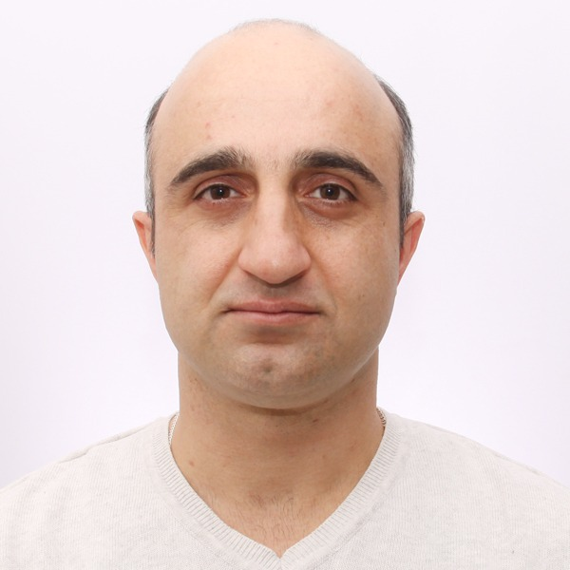
Date available |  |  |  | 01.06.2024
SURNAME |  | Beridze
NAME |  | Gela
FATHER'S NAME |  | Levani
Date and place of birth: |  | 19.03.1985. Batumi
Address: Georgia |  | City: Batumi |  | Str : Ivane Javaxishvili 3a
Personal civil code: Georgia |  | Flat : 24 |  | Mob +995 557 025888  Whatsapp: +995 557 025888
E-Mail : gela.beridze1985@mail.ru
TITLE OF THE DOCUMENT |  | Country | City | CERT.NO | DATE  ISSUED |  | VALID  UNTILL
Civil Passport |  | Georgia | Batumi | 12IC03574 | 29.01.2013 |  | 29.01.2023
Travel. Passport |  | Georgia | Batumi | 18AD50744 | 23.10.2019 |  | 23.10.2029
Seaman’s Book |  | Georgia | Batumi | S000344 | 05.04.2021 |  | 01.04.2031
Seafarer’s Identity Document |  | Georgia | Batumi | GE000350 | 05.04.2021 |  | 01.04.2026
Training for Seafarers designated security duties. A-VI/6-2 |  | Georgia | Batumi | SEC04-138797 | 06.04.2021 |  | 22.03.2026
Competent to perform Function specified by capacity of ABLE SEAFARER ENGINE |  | Georgia | Batumi | MTA-00-019548 | 04.05.2024 |  | 30.04.2029
Personal Survival Techniques. A-VI/1-1 |  | Georgia | Batumi | BST04-138796 | 06.04.2021 |  | 04.04.2026
Fire Prevention And Firefighting. A-VI1-2 |  | Georgia | Batumi | BST04-138796 | 06.04.2021 |  | 04.04.2026
Elementary First Aid. A-VI/1-3 |  | Georgia | Batumi | BST04-138796 | 06.04.2021 |  | 04.04.2026
Personal Safety And Social Responsibilities |  | Georgia | Batumi | BST04-138796 | 06.04.2021 |  | 04.04.2026
Basic Training For Oil And Chemical Tanker. A-V/I-1-1 |  | Georgia | Batumi | OCG04-138798 | 06.04.2021 |  | 28.03.2026
Proficiency In Survival Craft And Rescue Boats Other Then Fast Rescue Boats. A-VI/2-1 |  | Georgia | Batumi | FRB09-215260 | 30.04.2024 |  | 28.04.2029
Basic Training For Liquefied Gas Tanker. A-V/1-2-1 |  | Georgia | Batumi | LPG01-152890 | 30.12.2021 |  | 30.12.2026
Seaman’s Identification And Record Book / Republic Of Liberia |  | U.S.A | Virginia | 1601620 | 27.05.2021 |  | 27.05.2026
Experience With Mixed Nationality Crew |  | Greeks, Indians, Turk, Georgian, Russian, Philippines, Ukranian.
Knowledge Languages |  | English, Georgian, Russian.
Valid USA Visa | Until 02.11.2027

ADDITIONAL INFORMATION

Marital status: Married/Single |  |  | Married
Children under the age of 18 (names, date of birth ) |  |  | Elene – 18.11.2013
 |  |  | Anano – 07.12.2016
Next of kin (Name, date of birth, address, phone #) |  |  | Wife – Shorena Dolidze
 |  |  | +995 593 756379
Physical details: | Height: 1.75 | Weight: 83 |  | Overall: XL - 56 | Shoes: 43

PREVIOUS SEA EXPERIENCE (FOR LAST 10 YEARS):
RANK | NAME OF THE VESSEL | TYPE VESSEL | YEAR OF BUILD |  | GRT | TYPE OF THE MAIN ENGINE | FROM | TILL | Owner COMPANY
RANK | NAME OF THE VESSEL | FLAG |  |  | HP
WIPER | M/V UNDINE | OIL TANKER |  |  | 28799  MT |  | 28.12.2017 | 09.09.2018 | PRODUCT SHIPPING AND TRADING S.A
WIPER | M/V UNDINE | MARSHALL ISLANDS |  |  | 9480
Motorman | M/V JOYCE | OIL TANKER |  |  | 26900  MT |  | 22.12.2018 | 01.10.2019 | PRODUCT SHIPPING AND TRADING S.A
Motorman | M/V JOYCE | MARSHALL ISLANDS |  |  | 8580 KW
Motorman | M/V NORTHERN LIGHT | OIL TANKER |  |  | 30053  MT |  | 22.03.2020 | 23.01.2021 | PRODUCT SHIPPING AND TRADING S.A
Motorman | M/V NORTHERN LIGHT | MARSHALL ISLANDS |  |  | 13540 KW
Motorman | M/V FPMC P HERO | DOUBLE HULL OIL TANKER |  |  | 59174  MT | B&W 6S50MC-C, POWER 11700 KW, RPM 95 | 12.05.2020 | 22.10.2021 | FPMC HERO MARINE CORPORATION
Motorman | M/V FPMC P HERO | LIBERIA |  |  | 11700 KW
Motorman | M/V GOLAR SEAL | LNG/C |  |  | 102,100 | Wartsila Dual Fuel Diesel Electric 25,400 KW @ 85.1 rpm | 26.03.2022 | 23.09.2022 | GOLAR HULL M2021 CORP
Motorman | M/V GOLAR SEAL | MARSHALL ISLANDS
Motorman | GSP PEGASUS PSV/DP2 | PSV/DP2 |  |  | 5448 | 2X MAK 6M25 / 2X MAK 8M25 | 13.12.2022 | 21.05.2023
Motorman | GSP PEGASUS PSV/DP2 | PANAMA |  |  | 1800-2320  KW

MARINE EDUCATION RECEIVED

 | FROM | TILL
BATUMI FIGH MARITIME ENGINEERING SCHOOL ANRI | 2015 | 2016

BERIDZE.G

