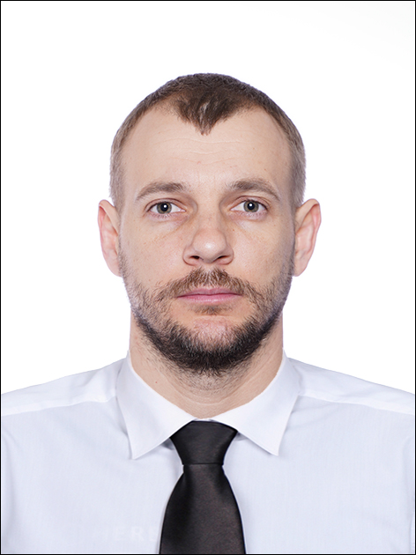

Andrienko Oleh
Citizenship:  UKRAINE | Country of origin: UKRAINE |  | Date of Birth:  11.02.1990 |  |  |  |  | Place / City of Birth: Ukraine, Kherson reg. Novovorontsovka
Rank applied for: AB |  |  |  | Available From (date): Today |  |  |  | Marital Status: Married |  | Gender : Male
Permanent Address (Street): Moldova Chicinau |  |  |  |  |  | Nearest Airport: Chicinau airport Moldova
English - good |  | Hair Color : Dark blond |  |  | Eyes Color : Green |  |  |  | Overall size - 52, Shoes size - 43
Mob.number: +380978728567 – Calls, Viber, WhatsApp |  |  |  |  |  |  | Email: olegandriienko1990@gmail.com

Andrienko Svitlana | Relationship - Mother |  | Gender : Female
Permanent Address: Ukraine, Kherson reg. Novovorontsovka |  | Mob.number: +380966421919

Company | Ship’s Name | Type | DWT | Rank | Date From  (DD/MM/YYYY) | Date To  (DD/MM/YYYY)
Ukrvodshliah | AYDAR | Tug | 1040 | OS | 16.03. 2015 | 16.05. 2015
Mintaca Shipping Co LTD | ALTENAVI | GC | 4891 | OS | 20.11.2016 | 06.05.2017
Belstar Shipping Co LTD | ALTRANY | GC | 6002 | OS | 10.09.2017 | 25.04.2018
Mintaca Shipping Co LTD | ALTENAVI | GC | 4891 | OS | 19.01.2019 | 03.08.2019
Premius Maritime Co LTD. | EVALUNA | GC | 7450 | OS | 08.12.2019 | 25.05.2020
Premius Maritime Co LTD | EVALUNA | GC | 7450 | OS | 07.09.2020 | 13.03.2021
Gala Shipping LTD | GALA | Multi purpose | 9990 | OS | 02.07.2021 | 23.02.2022
Glomar Offshore | Glomar Arctic | OSV | 407.4 | AB | 07.04.2022 | 19.09.2022
Glomar Offshore | Situla | OSV | 466 | AB | 27.10.2022 | 05.12.2022
GSP Holding SA | Bigfoot 1 | Pipe Layer barge | 11171 | AB | 15.01.2023 | 31.08.2023
GEOxyz offshore B.V. | GEO OCEAN III | MPSV | 3722 | AB | 25.09.2023 | 21.11.2023
GEOxyz offshore B.V. | GEO OCEAN III | MPSV | 3722 | AB | 16.01.2024 | 13.03.2024
GEOxyz offshore B.V. | GEO OCEAN lll | MPSV | 3722 | AB | 08.05.2024 | 05.07.2023

Type of Document / ID | Country  of Issue | No. | Date of Issue  (DD/MM/YYYY) | Valid Until  (DD/MM/YYYY)
Seagoing Service Record Book | Ukraine | 00050/2015/26 | 28.01.2015 | -
Int. Passport | Ukraine | FG872417 | 10.07.2017 | 10.07.2027
Seaman’s Book | Ukraine | AB 553437 | 11.06.2015 | 16.03.2025
Liberian Seaman’s Book | USA | 1614393 | 22.07.2021 | 22.07.2026
Panama Seaman’s Book | Panama | PA0249246 | 10.05.2022 | 12.04.2027
LUXEMBOURG Seaman’s Book | Luxembourg | C60754 | 26.09.2023 | 25.09.2028
Int. Physical examination | Ukraine | 822162233 | 11.12.2023 | 11.12.2025
Drug/Alco Test | Ukraine | 822162233 | 11.12.2023 | 11.12.2025
Yellow Fever | Ukraine | 006613 | 18.05.2015 | 18.05.2025

Maritime Educational Institution ( MEI )
Name of MEI | Country, City | Grade | Year of Graduation
Training centre of seafarers «AVANT» | Ukraine | Able Seaman | 2023

Certificate of Competency: | Country of Issue | Number | Date of Issue  (DD/MM/YYYY) | Date of Expiry  (DD/MM/YYYY) | Place of Issue
Able Seaman ll/5 | Ukraine | 05567/2024 | 25.04.2024 | - | Odessa Seaport

STCW-1978 ( amended 1995) Compliant Certificates / Courses and Other Qualifications: -

Description of Cert / Course | Country of Issue | Number | Date of Issue  (DD/MM/YYYY) | Date of Expiry  (DD/MM/YYYY) | Place of Issue
Proficiency in Survival Craft & Rescue Boat | Ukraine | 289185 | 30.06.2020 | 30.06.2025 | Nikolaev Centre of Training of Seafarers
Safety Familiarization, Basic Training | Ukraine | 013825 | 30.06.2020 | 30.06.2025 | Nikolaev Centre of Training of Seafarers
Security-related training | Ukraine | 238989 | 30.06.2020 | 30.06.2025 | Nikolaev Centre of Training of Seafarers
Designated Security Duties of Shipboard Personnel | Ukraine | 242510 | 30.06.2020 | 30.06.2025 | Nikolaev Centre of Training of Seafarers
Advanced Fire Fighting | Ukraine | 031877 | 30.06.2020 | 30.06.2025 | Nikolaev Centre of Training of Seafarers
Transport of Dangerous Cargoes | Ukraine | 062154 | 30.06.2020 | 30.06.2025 | Nikolaev Centre of Training of Seafarers
Fast & Rescue Boats | Ukraine | 1457349 | 07.06.2022 | 07.06.2027 | MTC “Whale”
Rating Forming Part of a Navigational Watch | Ukraine | 004880 | 20.05.2015 | - | Odessa Maritime Training Centre Kherson

I have all necessary documents for working.

I have Ukrainian biometrical travel passport. I’m responsible, hard-working and communicative.

Mob.Phone: +380978728567
E-mail: olegandriienko1990@gmail.com

