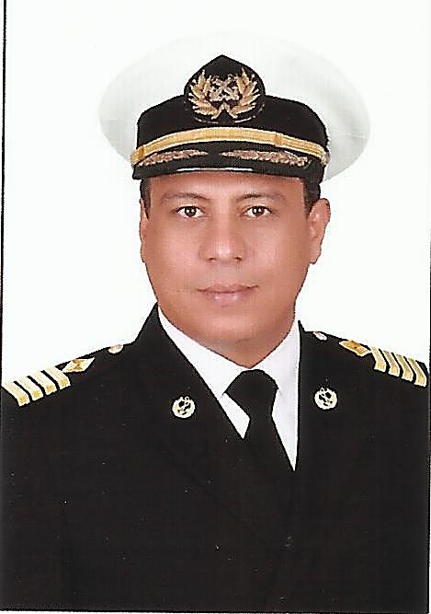

Curriculum Vitae

Personal Information
Name:- Magdy Osman Ali Mohammed
RANK:- Chief mate
University: - Arab Academy for Science, Technology and Maritime Transport
Nationality:- Egyptian
City :- MENIA – Egypt
Mobile: +201002039339
Date of birth:- 30/07/1980
Place of birth:- MENIA – Egypt.
Marital status:- Married.
Seaman’s passport No:- ((S00014484))
date:- ((04/10/2020))- valid ((03/10/2025)) .
Passport No:- (A28100818)-
DATE :- ((22/04/2021))-valid ((21/04/2028)) .
E-Mail:- magdy.chief_officer@yahoo.com
SKILLS

- Computer skills: - Microsoft ((Word-Microsoft Excel –Power Point)) .

- Language skills: - English Good (Speaking, Reading & Writing).

Certificate
Certificate | DATE ISSUED | VALID UNTIL
•CHIEF MATE . | 10/2016 | Extended
• GMDSS . | 08/03/2023 | 24/02/2029
• G.O.C . | 08/03/2023 | 22/02/2029
• Proficiency of Security Awareness Training for Seafarers with Designated Security Duties. | 17/10/2020 | 13/10/2025
• Personal Safety and Social Responsibilities. | 07/10/2020 | 2/10/2025
• Advanced Personal Survival Techniques and Search and Rescue. | 28/10/2020 | 23/10/2025
• Medical Care Studies. | 14/10/2020 | 09/10/2025
• Proficiency in Survival Crafts and Rescue Boats. | 03/10/2020 | 29/10/2025
• Marine Radar and Automatic Radar Plotting Aids. | 13/03/2016 | Extended
• Prevention And Combating of Marine Pollution. | 13/03/2016 | Extended
• Advanced Communication. | 16/03/2016 | Extended
• Proficiency As a Ship Security officer (PSSO). | 17/10/2020 | 16/10/2025
- ECDIS Advanced Simulator (Management Level). | 06/10/2020 | 02/03/2025
- ECDIS Simulator (Operation Level). | 02/03/2016 | Extended
- Advanced Fire Prevention and Fire Fighting. | 04/10/2020 | 30/10/2025
- Radar & ARPA Simulator and Search &Rescue. | 15/03/2016 | Extended
• Furuno Computer Based Type Specific ECDIS Training | 24/01/2023 | Extended
- Marlins (English Language Test) | 28/05/2023 | Extended
- International Medical | 18/01/2023 | 17/01/2025
- Accident Prevention: Managing Risks / Sharing Knowledge | 20/04/2023 | Extended
- Ministry of Health & population (International) | 12/05/2013 | For Life Long

EXPERIENCES

Co. Name |  | Ship Name & G.T |  | Rank | Sign on & Sign Off
ARAB FEEDER’S SERVICES-CO | GLORY  CONTAINER  1700-TEU |  | CHIEF OFFICER |  | 22/06/2023  17/03/2024
MSC (DANAOS SHIPPING .CO) | PUSAN C  CONTAINER (113000) M/T  9000-TEU |  | CHIEF OFFICER |  | 03/11/2022  25/02/2023
IPC SHIPPING | MIRA  ((27763 T ))Bulk career |  | CHIEF OFFICER |  | 04/01/2022  17/05/2022
EL MOEZ MARITIME .CO | M/V: NOUR G.GARGO 9603 M/T  READ SEA |  | CHIEF OFFICER |  | 24-07-2019  07.01.2020
RE D SEA NAVIGATION.CO | LILY OF SEA G.GARGO 11700 M/T |  | CHIEF OFFICER |  | 03-06-2018  24.02.2019
NAMMA LINES .CO | MASARRAH PASSENGER Ro-Ro ( 11495) T  READ SEA |  | CHIEF OFFICER |  | 17-03-2017  19-12-2017
AL-Watania Navigation | GAZALLE Ro-Ro ( 9071) t  MIDDLE SEA |  | 2ndofficer |  | 29/12/2014  21/04/2015
NornaShiping+ CMA.CGM. France | Egyptian Dignity( RoRo contender) & CMA CGM Siwa (container) MIDDLE SEA |  | 2ndofficer |  | 08/06/2011  01/04/2013
EL bahLwanShping | Master Joy , G.Cargo , (8350)t  MIDDLE SEA |  | 2nd Officer |  | 08-03-2010  02-07-2010
Salamis LineRo-Ro Ship | Notos Ro-Ro Container (8188)t |  | 2nd Officer |  | 03-08-2008  10-05-2009
Queen Tower General Cargo | Adriatic Queen G.Cargo& Container (8232)T.. MIDDLE SEA |  | 2nd Officer |  | 27-12-2007  26-06-2008
CleopatraPassenger Ship | Shahd CleopatraRo-Ro Passenger(8120)T |  | 2nd Officer |  | 09-01-2007  24-10-2007

