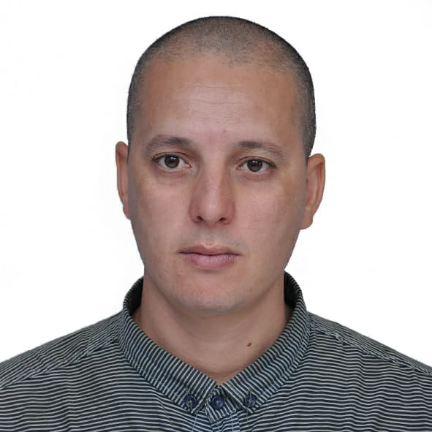
CURRICULUM VITAE
I-CIVIL STATUS:

Mr CHALLAL Makhlouf
Born on: 15/11/1983 in Tizi-Ouzou, and released from military obligations
Postal code: 15004, City EPLF 250 Logt Bt. 1A Draâ Ben Khedda
Telephone: 0658 37 5511
Email: navmodele@yahoo.com
II-DIPLOMAS OBTAINED:

➢July 2014: MAGISTER, in Mechanical Engineering. Option: Energy Conversion, Thesis Theme: Study of Crude Oil Flows in Pipelines. University of Science and Technology of Oran "Mohamed Boudiaf" USTO-MB
➢Aout 2009: Certificate of practical training at the Repair Company naval
➢July 2010: STATE ENGINEERING, Maritime Engineering. Option: Ship equipment. Theme of the dissertation: Study of the turbulent flow in the conduct involves a sudden enlargement University of Sciences and Technology of Oran "Mohamed Boudiaf" USTO-MB
➢July 2007: D.E.U.A. In Marine Engineering. Option: Auxiliary Machines and Installations. Thesis: Study of the viscosity by a falling ball viscometer.
➢ July 2004: BACCALAUREAT, in Mechanical Manufacturing.

III-PROFESSIONAL EXPERIENCE:
o 1 Month: Vessel Assessment Agent at ALE-MARINE
o 13 Months: Engineer in Marine Engineering at the Ship Repair Company, W. of Bejaia
o 3 Months: Teaching temporary work practice Laboratory of Fluid Mechanics.
o 30 months: Temporary teaching at the Ecole Supérieur Navale de Tamenfoust, and supervision of the final project since January 2018.
o Individual work: Tracing and geometric calculation, Industrial technical drawing, Word, Manufacture of boat models and aerodynamic profiles from modeling by ANSYS Drawing, Software, Research ICEM-CFD design software, experimental test on float stability, analytical simulation, .etc.
o University laboratory engineer since January 2018 at Mouloud Mammeri University.

IV-LANGUAGE: French. Arab. English. Levels: TCF B1 Very Good Average

V-QUALITIES:
Serious and generous, motivated at work, Sport, Motivational Naval Modeling and Experimental Research, Follow a theoretical diagram during the transition to practical work, etc.

