APPLICATION FORM |  |  |  |  |  |  |  |  |  |  |  |  |  |  |  |  |  |  |  |  | 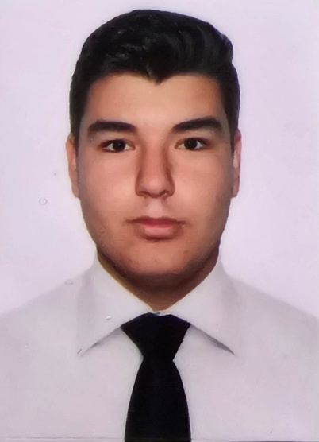
Position Applied for |  |  |  |  |  | ENGINE CADET |  |  | Alternative
Family name |  |  |  |  |  | STAIEV
First name |  |  |  |  |  | MAKSYM |  |  |  |  |  |  | - Single  - Married  - Divorced  - Widowed
Fathers name |  |  |  |  |  | MYKOLA
Date & place of birth |  |  |  |  |  | 02.02.2006 |  |  | National |  |  |  | UKRAINE
Biom travel passport |  |  |  |  |  | FZ807894 |  |  | Religion |  |  |  | 5135
USA Visa valid till |  |  |  |  |  |  | Height 195cm |  |  | Weight 90 kg |  |  |  |  | Overall size 56 |  |  |  |  |  |  |  |  |  | Shoes size 45
Address | Street |  |  |  | KRYMSKAYA
Address | City/Country |  |  |  | ODESA |  |  |  |  |  |  |  |  |  |  |  | Airport(s) |  |  |  |  | Varna
Address | Tel: | +420775427666 |  |  |  |  |  | Mobile | +380688667379 |  |  |  |  |  |  |  | E-mail: |  |  |  |  | maksimstaev@gmail.com
Address | Social Networks: (please fill in your social network profile name)
Address | VIBER |  |  | +380688667379 |  |  |  |  |  |  |  | FACEBOOK
Address | Skype |  |  |  |  |  |  |  |  |  |  | Instagram |  |  |  | Maxstaev_2.0
Next of Kin | Name/Relationship |  |  |  |  | STAIEV MYKOLA / FATHER |  |  |  |  |  |  |  |  |  |  |  | Date of birth |  |  |  |  |  | 26.07.1974
Next of Kin | Street |  |  |  | KRYMSKAYA |  |  |  |  |  |  |  | City/Country |  |  |  |  |  | ODESA
Next of Kin | Tel |  |  |  |  |  |  | Mobile | +380679173295 |  |  |  |  |  |  |  |  | E-mail: |  |  |  |  | nickstaev@gmail.com
Name of School / Academy attended |  |  |  |  |  |  |  | Address |  |  |  |  |  | Dates attended |  |  |  |  |  | Type of Degree & Diploma
 |  |  |  |  |  |  |  |  |  |  |  |  |  | From |  | To |  |  |  | Received upon Graduation
Faculty College of Maritime Transport of the National University "Odessa Maritime Academy" |  |  |  |  |  |  |  | Marazliivska street, 40, Odesa, Odesa region, 65000 |  |  |  |  |  | 2021 |  | 2025 |  |  |  | ENGINEER MECHANIC
SEA SERVICE (from latest to previous)
NAME of VESSEL | Position | Vessel’s type | Engine type | Flag | Company | Period of service
NAME of VESSEL | Position | DWT | HP | Year of built | Crew Agent | Period of service
Mount Olympus | Engine cadet | Oil & Chemical tanker | Mitsubishi 6UEC52LS | Mar | Billingham partners Inc. | S/on 16.02.2024
Mount Olympus | Engine cadet | 40000 | 10800 | 2003 |  | S/off 25.08.2024
 |  |  |  |  |  | S/on
 |  |  |  |  |  | S/off
 |  |  |  |  |  | S/on
 |  |  |  |  |  | S/off
 |  |  |  |  |  | S/on
 |  |  |  |  |  | S/off
 |  |  |  |  |  | S/on
 |  |  |  |  |  | S/off
 |  |  |  |  |  | S/on
 |  |  |  |  |  | S/off
 |  |  |  |  |  | S/on
 |  |  |  |  |  | S/off
 |  |  |  |  |  | S/on
 |  |  |  |  |  | S/off
References: (state last management Company with telephone number and Name of Manager)
Відповідно до закону України «Про захист персональних даних» цим я надаю Компанії свою згоду на оброблення та внесення до спеціальної бази персональних даних інформації, що містяться в цій анкеті чи додається до неї, а також на передачу інформації з такої спеціальної бази персональних даних третім особам у порядку та на умовах, визначених чинним законодавством України.
Above information is to the best of my knowledge and correct. Herewith I allow and appoint Columbia Shipmanagement to verify my sea-service with any of my previous employers and to get information regarding duration of my previous contracts, performance and other possible details.
Date . Signature .

