 | 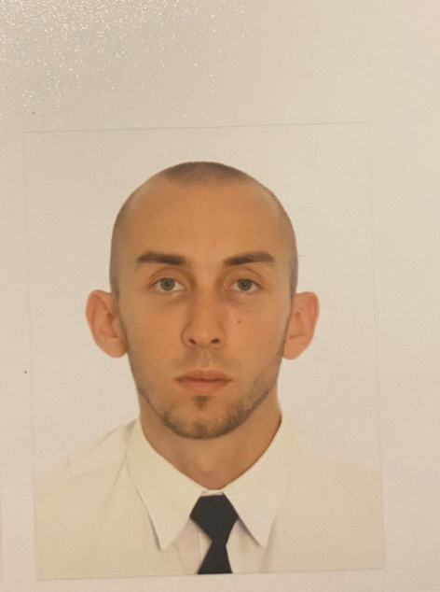
  SEAFARER'S APPLICATION FORM
  Position: | 4th engineer | Readiness: | 15.09.2024
  Position: | 4th engineer | Citizenship: | Russia
  Last name: | Maidaniuk | Marital status | Single
  First name: | Vladimir | Children: | None
  Middle name: | Olegovich | Nationality: | Russian
  Birth date: | 21.04.1998 | Birth place: | Ukraine
  Home address: | Krasnodar, Russia | Phone mobile: | +7(978)6988416
  Home address: | Krasnodar, Russia | Phone home:
  Home address: | Krasnodar, Russia | Email: | mr.maydanyuk@mail.ru
  English level: | Upper Intermediate
  Spanish level: | Beginner
  Russian level: | Native | Ukrainian level: | Fluently

Salary | Minimum: 3000 | Expected:3300 | Last: 1800 | $/month

Education
Educational institution | Speciality | Faculty | Place | Number | From | Till
Sevastopol State University | Engineer-Mechanic | Engineering Ships Power Plants Operation | Sevastopol/RUS | NVS207196381 | 01.09.2015 | 28.02.2022

Passports, Licenses & Certificates
Title |  | Class | Number | Place of issue | Issued | Valid
Passports & Visas
Civil passport |  |  | 3917298818 | Simferopol, RUS | 04.05.2018 | 04.05.2043
Travel passport |  |  | 754276122 | Simferopol, RUS | 10.02.2017 | 10.02.2027
Seaman’s ID |  |  | RUS 0599556 | Novorossiysk, RUS | 27.09.2022 | 27.09.2027
Diplomas & Endorsements
Certificate of Competency | Rating forming part of an engineering watch |  | NVS201934064 | Novorossiysk, RUS | 19.10.2017 | -
Certificate of Competency | Officer in charge of engineering watch |  | NVS207196381 | Novorossiysk, RUS | 29.08.2022
Certificates & Licenses
Proficiency in Survival Craft (VI/2) |  |  | 2022052904 | Novorossiysk, RUS | 09.02.2022 | 09.02.2027
Basic Safety Training (VI/1.1-4) |  |  | 7012062640 | Novorossiysk, RUS | 08.07.2021 | 08.07.2026
Security-related training for seafarers (with designated security duties) (VI/2) |  |  | 2022053078 | Novorossiysk, RUS | 11.02.2022 | 11.02.2027
Advanced training in firefighting |  |  | 2022054430 | Novorossiysk, RUS | 26.02.2022 | 26.02.2027
Medical First Aid |  |  | 2022053456 | Novorossiysk, RUS | 17.02.2022 | 17.02.2027
Basic training for oil and chemical tankers |  |  | OBT 2025098 | Astrakhan, RUS | 18.11.2022 | 18.11.2027

Sea-going experience
 | Vessel’s  name | Flag | Type | Engine | Rank | From | Shipowner
 | Vessel’s  name | Year | DWT | HP | Rank | Till | Crew Agency
6 | EXPRESS ROME | Liberia | Container Carrier (10114 TEU) | Hyundai-Wartsila | Motorman | 05.12.2023 | CELLCONTAINER (№7)
6 | EXPRESS ROME | 2011 | 113973 | 93324 | Motorman | 22.05.2024 | Danaos Shipping Management
5 | TURBA | Cameroon | Crude Oil Tanker | Sulzer | Oiler | 05.12.2022 | Aquamarine
5 | TURBA | 1997 | 106454 | 19300 | Oiler | 15.07.2023 | Aquamarine Ship Management
4 | BALTIC SUMMER | Bahamas | Refrigerator | MAN-B&W | Wiper | 07.03.2022 | Ost-West Handel und Shiffarcht
4 | BALTIC SUMMER | 1988 | 12656 | 18273 | Wiper | 26.05.2022 | Afalina Shipping Management Company
3 | BALTIC LADY | Bahamas | Refrigerator | MAN-B&W | Wiper | 21.02.2021 | Ost-West Handel und Shiffarcht
3 | BALTIC LADY | 2000 | 12913 | 18273 | Wiper | 09.06.2021 | Afalina Shipping Management Company
2 | BALTIC LADY | VCT | Refrigerator | MAN-B&W | Wiper | 07.11.2019 | Ost-West Handel und Shiffarcht
2 | BALTIC LADY | 2000 | 12913 | 18273 | Wiper | 16.09.2020 | Afalina Shipping Management Company
1 | BALTIC PEARL | Bahamas | Refrigerator | B&W | Engine Cadet | 10.10.2018 | Ost-West Handel und Shiffarcht
1 | BALTIC PEARL | 1991 | 10713 | 15300 | Engine Cadet | 24.01.2019 | Afalina Shipping Management Company

Crewing Agencies or Marine Companies
Crew Agency | City | Country
Danaos Shipping Management | Piraeus | Greece
Aquamarine Ship Management | Novorossiysk | Russia
Afalina Shipping Management Company | St. Petersburg | Russia

General Physical State
Height (cm) | Weight (kg) | Shoes | Clothes | Hair color | Eye color
176 | 75 | 43 | M | brown | grey

Date 25.07.2024

