Mob.: +48 575 492 223  +48576427980/+48 575 492 223(Viber)  E-mail: slastuhinvalentin@gmail.com | Ship`s Cook/Baker

APPLICATION FORM

POSITION APPLIED FOR: |  |  |  | Ship`s Cook/Baker |  |  |  |  |  |  |  |  |  |  |  | 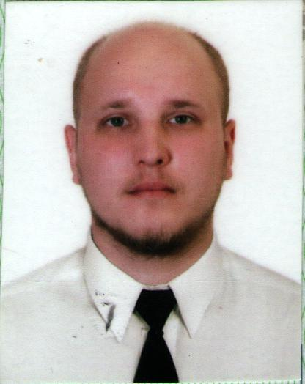
SURNAME |  |  |  |  |  |  | NAME |  |  |  |  | FATHER`S NAME
Slastukhin |  |  |  |  |  |  | Valentyn |  |  |  |  | Dmytro
DАTE OF BIRTH |  |  |  |  |  |  | NEXT OF KIN: |  |  |  |  | MARITAL STATUS
30.09.1992 |  |  |  |  |  |  | Slastukhina Viktoria-wife |  |  |  |  | Married
PLACE OF BIRTH |  |  |  |  |  |  | NATIONALITY |  |  |  |  | ADDRESS NEXT OF KIN:
Russia |  |  |  |  |  |  | Ukraine |  |  |  |  | +38(095) 419 20 79(viber)  +48576427980
ADDRESS : |  | App. 33, bld. 25, 295 Strelkovoi Divizii str., Kherson, Ukraine |  |  |  |  |  |  |  |  |  |  |  |  |  | Visa USA | no
EDUCATION |  | Kherson State Professional College – 2009 – Cook  KSTC “Marine Pro Service” – 2018 – Ship’s Cook |  |  |  |  |  |  |  |  |  |  |  |  |  | English: Basic
PASSPORT |  |  |  |  |  | № |  |  | ISSUED PLACE |  |  |  |  | ISSUED DATE |  | VALID UNTIL
SEAMEN`S PASSPORT |  |  |  |  |  | AB 656262 |  |  | Kherson/Ukraine |  |  |  |  | 20.02.2019 |  | 19.01.2029
BIOMETRIC PASSPORT |  |  |  |  |  | FU 700623 |  |  | Kherson/Ukraine |  |  |  |  | 05.04.2019 |  | 05.04.2029
Height: | 176 |  | Weight: |  | 90 | Shoes: |  | 42-43 | Size: | 52-54 |  |  | Color of eyes: |  | grey | Color of hear: |  | dark
CERTIFICATE of COMPETENCY
CERTIFICATE of COMPETENCY | ISSUED PLACE | ISSUED DATE | CLASS
00336/2019/11 | Kherson/Ukraine | 28.02.2019 | Ship`s Cook
CERTIFICATES
CERTIFICATES | № | ISSUED DATE | VALID UNTIL | ISSUED PLACE
Basic safety training | 32334224/01/0915/023 | 21.09.2023 | 21.09.2028 | Odessa/Ukraine
Proficiency in survival craft and rescue boats | 32334224/02/0712/023 | 21.09.2023 | 21.09.2028 | Odessa/Ukraine
Proficiency in ship security | 32334224/09/0314/024 | 24.01.2024 | 24.01.2029 | Odessa/Ukraine
EXPIRIENCE
Rank | Name of Vessel  IMO | Type of vessel | Flag  YOB | Shipping Company /  Crewing Agency | DWT | From | To
Cook | Restaurant “Troyka”/Kherson/Ukraine |  |  |  |  | 2011 | 2014
Cook | Club “Friends”/Kherson/Ukraine |  |  |  |  | 2015 | 2016
Cook | Restaurant “Basta Pasta”/Kherson/Ukraine |  |  |  |  | 2016 | 2018
Cook | Restaurant “Round About “/Kherson/Ukraine |  |  |  |  | 08.2018 | 02.2019
Cook | Victoria | General cargo | Maroni | Samtex Alliance | 5000 | 08.05.2019 | 04.07.2019
Mass boy | Port Estrela | Bulk Carrier | Liberia | Alpha Navigation | 61530 | 29.08.2019 | 07.12.2019
Cook | Almeria | General Cargo | Ukraine | Multimarine | 4000 | 03.03.2020 | 09.09.2020
Cook | Jarvis | AHTS | Wanuat | Deniz maritime | 2760 | 24.12.2020 | 26.06.2021
Cook | Golden Lion | General cargo | Antique Barbuda | Multimarine | 6000 | 22.08.2021 | 24.03.2022
Cook | Aristona | General cargo | Portugal | COG offshore | 3799 | 02.07.2022 | 28.11.2022
Cook | Baltic moon | General cargo | Isle of Man | COG offshore AS | 3850 | 8.05.2023 | 30.08.2023

