CURRICULUM VITAE  APPLICATION FORM |  |  |  | 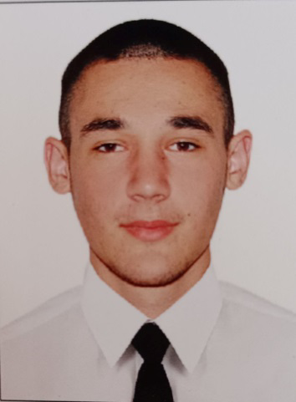
Main information
Position: | Engine Cadet | Desired Type of Ship: | Bulk carrier, Container ship, Tanker
Desired salary: | from 400 $ | Available from: | 18/05/2024
Full Name: | Denys Savenko | Date of birth | 09.01.2006
Citizenship: | Ukrainian | Full Address: | Ukraine/ Odessa reg/ Berezovskyi district / Vynograd village / Vynogradnaya street / house 6
Phones: | +380956746304 | English level: | Intermediate
Gmail: | savenkodenis52@gmail.com | Telephone: | +380956746304

Passports / Smbk | № | Date of issue | Place of issue | Date of expire
Seaman's book | AC 009121 | 13/07/2023 | Ukraine / PORT ODESSA | 13/07/2028
International passport | GС 996192 | 06/02/2023 | Ukraine / 5128 | 06/02/2033
Diplomas | № | Date of issue | Place of issue | Valid up
Rank
Professional license
Endorsement
Certificates | № | Date of issue | Place of issue | Valid up
Basic Safety Traning | 1572581 | 29.06.2023 | IZMAIL MARINE TRAINING CENTER "MARINE PRO SERVICE" | 29.06.2028
Advanced Fire Fighting
Medical First aid
Proficiency in survival craft and rescue boats
Security awareness training for all seafarers | 1576664 | 25.09.2023 | NATIONAL UNIVERSITY "ODESSA MARITIME ACADEMY" SURVIVAL UNDER EXTREME SEA CONDITIONS TRAINING CENTER | 25.09.2028
Designated security duties of shipboard personnel
Carriage of Dangerous and Hazardous Substances
Yellow fever date and centre : | 03 February. Odessa Medical Centre MEDMARIN
Covid-19 Vaccination: №
Last medical examination

Flag Documents and Other Countries Seaman's Books
Country | № | Document type | Date of issue | Date of expire

Sea service
Position | Name of Ship | Type of Ship | Gross Tonnage | From - Till | Employer

Additional info
Education: MARITIME COLLEGE NAMED AFTER MARINESKO |  | Knowledge of languages: Eng.,Rus.,Ukr.
Specialty: Engineering Department |  | Lathe machine skills:
Second (relative) specialty: |  | Welding skills: normal
Next of Kin
Next of kin: mom |  | Phone: +380 96 390 8919
Name, Surname: Natalia Savenko |  | Address: Ukraine/ Odessa reg/ Berezovskyi district / Vynograd village / Vynogradnaya street / house 6
Biometrical data
Sex: the man | Height: 190 |  | Overall size: 54
Eyes color: brown | Weight: 85 |  | Shoe size: 43

