APPLICATION FOR EMPLOYMENT

1. General information & education
Position applied for: | 2nd Officer |  |  |  | 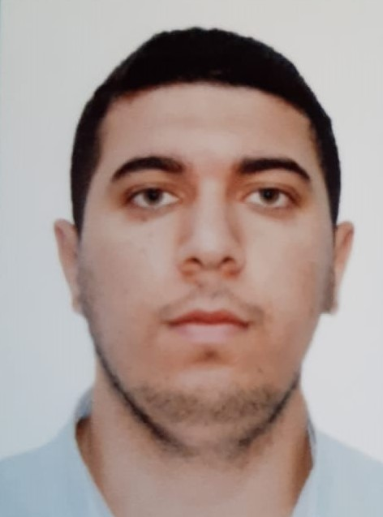
Surname: | Allahverdizade | Marital status: |  | Single
Name: | Elnur | No.of children |  | Married
Date and place of birth: | 22.08.1995 Azerbaijan | Next of kin name:
Nearest Airport: | Baku International Airport | Next of kin Surname:
Nationality: | Azerbaijanian | Relationship:
Knowledge of Computer: | Skilled user
Ability to work with  Windows Programs: | Microsoft Word,  Microsoft Excel,  Microsoft Power Point,  Microsoft Publisher,  Microsoft Access,  Internet Exp.
Size of coverall/Shoes: | L / 44
Height / Weight: | 180 cm / kg | Language assessment:
Address, phone & e-mail:  Keshla village, Baku , Azerbaijan Republic.  +994554029354  allahverdizadeelnur31@gmail.com |  | English: Intermediate, Turkish: Advance,  Azerbaijanian: Native
 |  | Education | Azerbaijan State Marine Academy, Navigation Department, Bachelor degree, Graduated: 2013  http://www.adda.edu.az

2. International Passport & Seaman’s Book, COC
Documents | Number | Date Issue | Place Issued | Valid until
Travel Passport: | C03172767 | 17.07.2022 | Azerbaijan Republic  Ministry of Internal Affairs | 16.07.2032
Seaman’s Book: | DQK No. 020535 | 15.06.2022 | Azerbaijan Republic  State Maritime Administration | 15.06.2027
Seafarer’s Identity Document | AZE 025399 | 15.06.2022 | Azerbaijan Republic  State Maritime Administration | 15.06.2027
Certificate of Competency | ID No. 0007134 | 12.03.2020 | Azerbaijan Republic  State Maritime Administration | 12.03.2025
Endorsement: | 000167/20 | 12.03.2020 | Azerbaijan Republic  State Maritime Administration | 12.03.2025
Seafarer’s Medical Certificate | 0171 | 14.10.2022 | Azerbaijan Republic  Central Seafarer’s Hospital | 14.10.2024

3. Previous experience
Vessel | Company | Type | Gross | Position | From | To | Working  Area
m/v OM  IMO No. 8119077 | Azerbaijan Caspian Shipping Company | Supple Ship | 1585 | Able Seaman | 01.03.2018 | 01.07.2019 | Caspian  Sea
m/v Shuvalan  IMO No. 9416472 | Azerbaijan Caspian Shipping Company | Supple  Ship | 1761 | Able Seaman | 15.07.2019 | 15.08.2019 | Caspian  Sea
m/v Shirvan 3  IMO No. 8207202 | Azerbaijan Caspian Shipping Company | Crane Ship | 2979 | Able Seaman | 01.09.2019 | 01.02.2020 | Caspian  Sea
m/v Zulfi Haciyev  IMO No. 7912161 | Azerbaijan Caspian Shipping Company | Crane Ship | 2971 | Able Seaman | 15.05.2020 | 15.07.2020 | Caspian  Sea
m/v Zulfi Haciyev  IMO No. 7912161 | Azerbaijan Caspian Shipping Company | Crane Ship | 2971 | 3rd Officer | 01.10.2020 | 01.12.2020 | Caspian  Sea
m/v Ehram Xalıqov  IMO No. 8515946 | Azerbaijan Caspian Shipping Company | Supple Ship | 2737 | 2nd Officer | 01.01.2021 | 01.12.2021 | Caspian  Sea
m/v Zulfi Haciyev  IMO No. 7912161 | Azerbaijan Caspian Shipping Company | Crane Ship | 2971 | 2nd Officer | 01.01.2022 | ---------- | Caspian  Sea

4. STCW-78 & Other certificates
Certificate & Document name | Number | Date Issue | Place Issued | Valid until
Radar navigation, radar plotting and use of ARPA (Operational level) | SR-0101-19 | 03.09.2019 | Azerbaijan Republic  State Maritime Administration | 03.09.2024
GMDSS General Operator | DQ-0685-23 | 26.12.2023 | Azerbaijan Republic  State Maritime Administration | 26.12.2028
Bridge Resources Management | SW-0386-19 | 26.12.2019 | Azerbaijan Republic  State Maritime Administration | 26.12.2024
Operational use of electronic chart & information systems (ECDIS) | SZ-0063-24 | 13.02.2024 | Azerbaijan Republic  State Maritime Administration | 09.02.2024
Training for seafarers with designated security duties | SH-0402-24 | 14.02.2024 | Azerbaijan Republic  State Maritime Administration | 14.02.2029
Medical first aid | SN-0143-20 | 21.02.2020 | Azerbaijan Republic  State Maritime Administration | 21.02.2025
Basic safety training | SO-0887-22 | 03.03.2022 | Azerbaijan Republic  State Maritime Administration | 03.03.2027
Proficiency in survival craft & boats other than fast rescue boats | SL-0706-22 | 04.04.2022 | Azerbaijan Republic  State Maritime Administration | 31.03.2027
Advanced Fire Fighting | SJ-0909-19 | 24.10.2019 | Azerbaijan Republic  State Maritime Administration | 24.10.2024
ISM Code | SP-1318-22 | 12.05.2022 | Azerbaijan Republic  State Maritime Administration | 06.05.2027
Leadership and Teamwork | DL-0044-20 | 13.02.2020 | Azerbaijan Republic  State Maritime Administration | 13.02.2025

