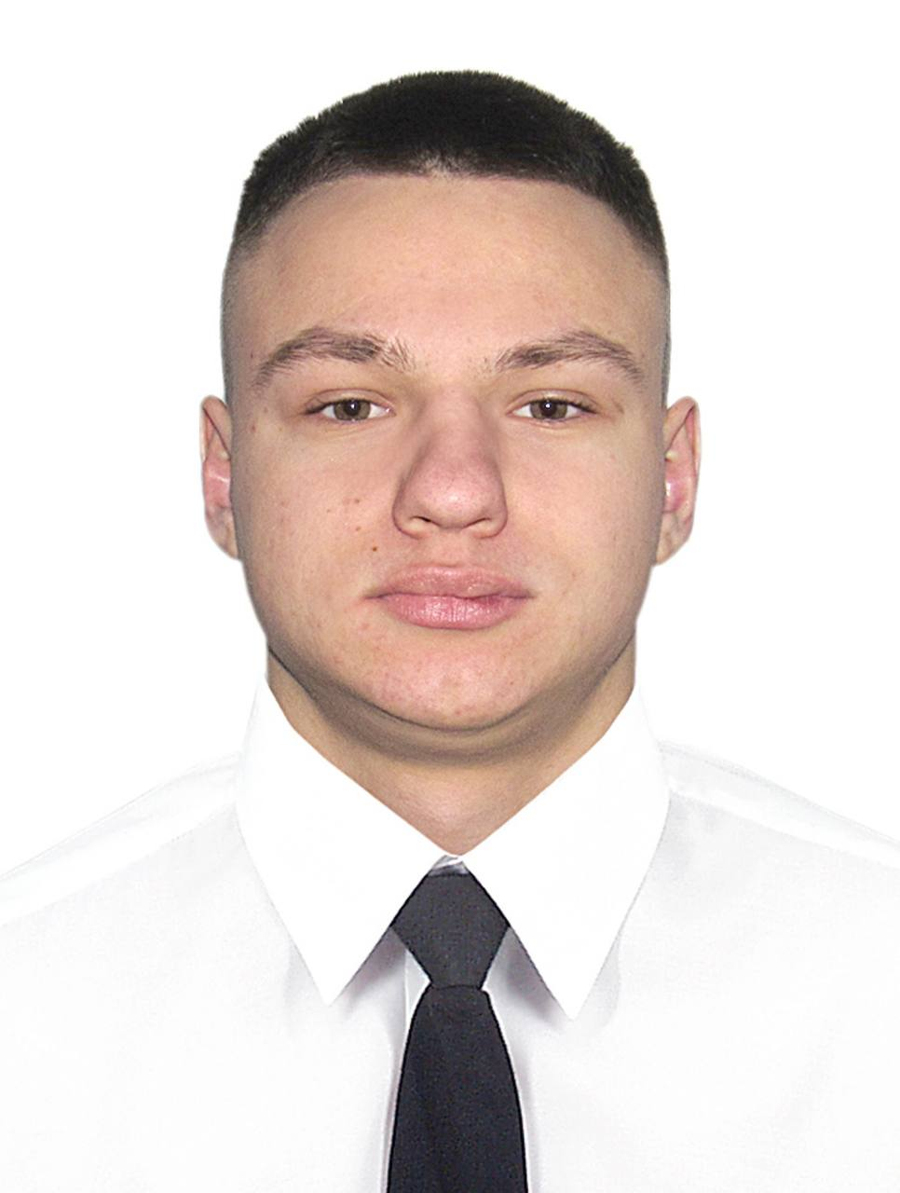
APPLICATION FORM

photo

Position |  | Engine cadet |  |  |  |  |  |  |  |  | Other position (if any)
- Main information
Available from |  |  | 05.08.2024 |  |  |  |  |  |  |  | Desired salary |  |  |  | 600
Name |  |  | Maksym |  |  |  |  |  |  |  | Surname |  |  |  | Vorona
Date of birth |  |  | 20.07.2005 |  |  |  |  |  |  |  | Citizenship |  |  |  | Ukrainian
English level |  |  | good |  |  |  |  |  |  |  | Country / City |  |  |  | Poland/Poznan
E-mail |  |  | maksim.vorona2005@gmail.com |  |  |  |  |  |  |  | Type of ship |  |  |  | Tanker vessel
Phone |  |  | +380668873699 |  |  |  |  |  |  |  | Skype
- Travel documents |  |  |  |  |  |  | № Date of issue Place of issue Date of expire
Passport |  |  |  |  |  |  |  |  |  |  |  |  | 07 May 2022 |  |  |  |  |  |  | 3519 |  |  |  |  | 07 May 2032
Seaman book |  |  |  |  |  |  |  |  |  |  |  |  | 07 March 2023 |  |  |  |  |  |  | Port Odessa |  |  |  |  | 07 March 2028
- Certificates |  |  |  |  |  |  | Date of issue |  |  | Place of issue |  |  |  |  |  | Date of expire
Basic Safety Training |  |  |  |  |  |  | 14.02.2023 |  |  | 42,Kanatna Str.,Odessa/SEAFARERS TRAINING CENTRE |  |  |  |  |  | 14.02.2028
Advanced Fire Fighting |  |  |  |  |  |  | 14.02.2023 |  |  |  |  |  |  |  |  | 14.02.2028
Medical examination |  |  |  |  |  |  | 16.08.2023 |  |  | Dariusz Krasnicki/Wroclaw |  |  |  |  |  | 15.08.2025
Medical First aid |  |  |  |  |  |  | 14.02.2023 |  |  | 42,Kanatna Str.,Odessa/SEAFARERS TRAINING CENTRE |  |  |  |  |  | -
Proficiency in Survival craft |  |  |  |  |  |  | 14.02.2023 |  |  | 42,Kanatna Str.,Odessa/SEAFARERS TRAINING CENTRE |  |  |  |  |  | 14.08.2028
Security Awareness Training |  |  |  |  |  |  | 14.02.2023 |  |  | 42,Kanatna Str.,Odessa/SEAFARERS TRAINING CENTRE |  |  |  |  |  | -
Security training for seafarers with designated security duties |  |  |  |  |  |  | 14.02.2023 |  |  | 42,Kanatna Str.,Odessa/SEAFARERS TRAINING CENTRE |  |  |  |  |  | -
Yellow fever |  |  |  |  |  |  | 08 April 2023 |  |  | Odessa Medical Centre MEDMARIN |  |  |  |  |  | -
- Sea service
Position | Name of Ship |  |  |  |  | Type of Ship |  |  | Owner |  |  |  |  | DWT |  |  |  | ME Type/kW |  |  |  |  | From |  |  | Till
Engine cadet | NORTHERN DEMOCRAT |  |  |  |  | Container vessel |  |  | Schifffahrtsgesellschaft MS NORTHERN DEMOCRAT GmbH&Co.KG |  |  |  |  | 41987 |  |  |  | MAN B&W 7K90MC-C |  |  |  |  | 26.02.2024 |  |  | 27.07.2024
Bio data
Sex |  |  |  | Male |  |  |  | Height |  |  |  | 183 |  |  |  |  | Weight |  |  |  |  |  |  | 78
Eyes |  |  |  | Brown |  |  |  | Overall size |  |  |  | Medium |  |  |  |  | Shoe size |  |  |  |  |  |  | 42
Family information
Marital status |  |  |  |  | Single |  |  |  |  |  |  | Next of kin (name/relation) |  |  |  |  |  |  |  |  | Tertyshna Alina/sister
Number / age of children under 18 y.o. |  |  |  |  |  |  |  |  |  |  |  | Next of kin (phone) |  |  |  |  |  |  |  |  | +380666140786
 |  |  |  |  |  |  |  |  |  |  |  | Next of kin (address) |  |  |  |  |  |  |  |  | Odessa

