
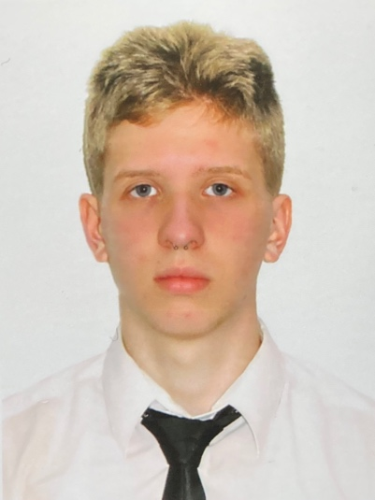
CONTACTS

+380 97 028 6781
nagibatirland@gmail.com
@cadetrull

English
●●●●○ – C1 Above average

Ukrainian
●●●●● – C2 Native speaker

Russian
●●●●● – C2 Native speaker

Stress resistance
Endurance
Responsibility
Diligence
Purposefulness

TITOV KYRYLO

CADET deck

 Kyiv. Ukraine y.o. – 19 years

EDUCATION ——————————————————-

2021 – 2025 SUIT Bachelor(3year)
Navigation

CERTIFICATES —————————————————

2023 SDCM
Maritime Training Center

2023 Fire fight
Maritime Training Center

2023 Life boats
Maritime Training Center

2023 Security 6.1
Maritime Training Center

ABOUT ME ——————————————————

I swim, run, have experience in boxing. On I visit the gym on
a regular basis. Video editing is also my passion.

I am currently in my third year with a bachelor's degree. Looking for
cadet practice. I have never been on a voyage on a cargo ship
from 300 tonnage tons

I stood at the helm of the yacht, I also have experience in driving
a dry cargo ship and container ship on simulators in the academy.
I am in good physical shape.

I want to do something serious. Since childhood, I was drawn to the sea,
I love your profession. The academy is a solid good boy!
QUALITIES
LANGUAGE

