APPLICATION FOR EMPLOYMENT
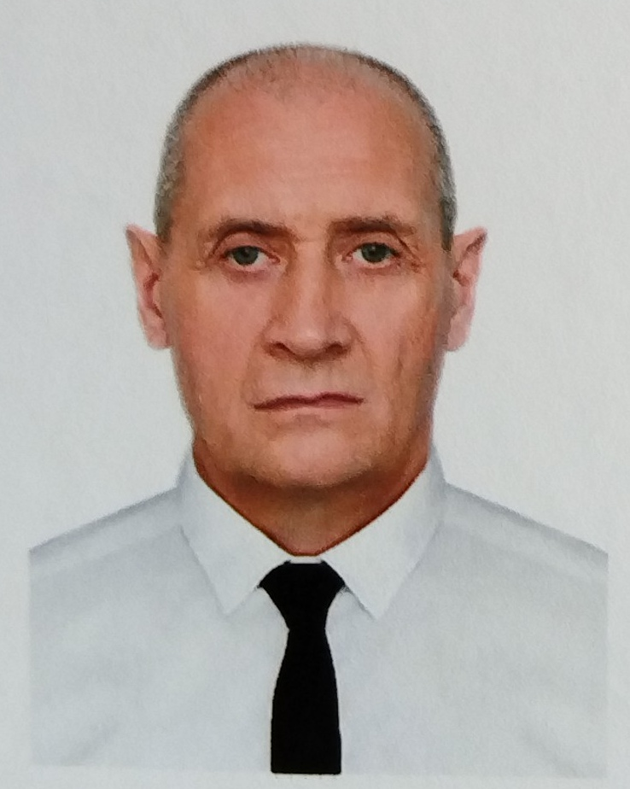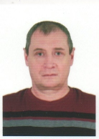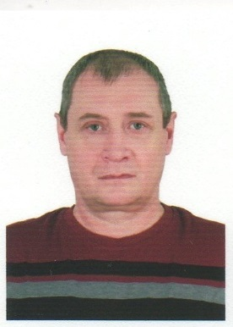
POSITION APPLIED FOR: CHIEF OFFICER

Surname: DYMNIKOV | Name: VLADISLAV | Fathers Name: ALEKSEY
Date of Birth: 04 March 1968 | Place of Birth / City & Country:  Omsk, Russia | Nationality: Russian
Permanent address: 45h/4, Uzhnoe shosee, 186 ap, 192249, S. Peterburg Russia Federation | E/mail: virtusmarine@mail.ru | Phone(mobile): +7 9620340979
Civil Status (married, single, divorced): | Graduate: The Novosibirsk State Academy of Water Transport | Next of kin: Daughter  Ekaterina Dymnikova  Phone(mobile): +79609812080

DOCUMENTS | NUMBER | ISSUED | VALID | COUNTRY
NATIONAL PASSPORT | 769131969 | 27.10.2022 | 27.10.2032 | RUSSIA
NATIONAL SEAMAN’ S BOOK | RUS 0628595 | 26.05.2022 | 25.05.2022 | RUSSIA
LICENSE SHIP OF 3000 CROSS TONNAGE OR MORE | ASF205434725 | 14.03.2022 | 11.01.2027 | RUSSIA
COP ADVANCED TRAINING FOR OIL TANKER | ASF205434730 | 14.03.2022 | 10.02.2027 | RUSSIA
COP ADVANCED TRAINING FOR CHEMICAL TANKER | ASF205434749 | 14.03.2022 | 16.02.2027 | RUSSIA
COP SSO | LED208330867 | 29.06.2024 | UNLIMITED | RUSSIA
GMDSS GENERAL OPERATOR | ASF205434717 | 14.03.2022 | 11.01.2027 | RUSSIA
BASIC SAFETY TRAINING | 1818453 | 11.01.2022 | 11.01.2027 | RUSSIA
PROFICIENCY IN SURVIVAL CRAFT | 1823052 | 28.01.2022 | 28.01.2027 | RUSSIA
ADVANCED FIRE FIGHTING | 1707963 | 27.01.2022 | 27.01.2027 | RUSSIA
MEDICAL FIRST AID | 1831778 | 14.01.2022 | 14.01.2027 | RUSSIA
MEDICAL CARE | 011695 | 24.02.2022 | 24.02.2027 | RUSSIA
ADVANCED OIL TANKER CERTIFICATE | 1343407 | 10.02.2022 | 10.02.2027 | RUSSIA
ADVANCED CHEMICAL TANKER CERTIFICATE | 1615958 | 16.02.2022 | 16.02.2027 | RUSSIA
APRA | 1622811 | 04.02.2022 | 04.02.2027 | RUSSIA
RADAR OBS | 1713705 | 01.02.2022 | 01.02.2027 | RUSSIA
SSO | ISPS-SSO-00877/24 D | 19.06.2024 | 19.06.2029 | RUSSIA
SAFETY OFFICER TRAINING | 1837818 | 21.01.2022 | 21.01.2027 | RUSSIA
ECDIS NAVI-TRAINER PROFESSIONAL 4000 | 1624287 | 26.01.2022 | 26.01.2027 | RUSSIA
MEDICAL EXAMINATION | A01495743 | 12.12.2022 | 12.12.2024 | RUSSIA
DRUG & ALCHOHOL TEST

SEA SERVICE: FIVE YEARS
TYPE OF VESSEL | NAME OF  VESSEL | DWT | ENGINE  TYPE | KWT | FLAG | NAME OF  COMPANY | RANK | PERIOD OF SERVICE  FROM / TO
CHEM/OIL  TANKER | HAJI DAVUD | 6526 | Wartsila | 2240 | RUS | ENEYA LLC | CH/OFF | 06.11.2023 17.05.2024
OIL/  TANKER | ARMADA LEADER | 6477 | Wartsila | 2240 | RUS | ENEYA LLC | CH/OFF | 04.03.2023 04.08.2023
CHEM/OIL  TANKER | HAJI DAVUD | 6526 | Wartsila | 2240 | RUS | ENEYA LLC | CH/OFF | 18.12.2022 03.02.2023
CHEM/OIL  TANKER | KUPAVA | 6500 | Wartsila | 2208 | RUS | SVSK LLC | CH/OFF | 30.06.2022 07.10.2022
CHEM/OIL  TANKER | GLARD 2 | 6119 | Wartsila | 2160 | RUS | SAMARATRASSHIPPING | CH/OFF | 05.01.2020 16.04.2020
OIL TANKER | SERGEY MANYKIN | 2278 | SKL | 1030 | RUS | IRTYSH SHIPPING CO | CH/OFF | 16.05.2019  24.10.2019
CHEM/OIL TANKER | NAVIGER 2 | 6564 | SKL | 2000 | RUS | YARBUNKER LCC | CH/OFF | 20.12.2017  08.05.2018
OIL TANKER | MECHANIC EROKHIN | 5534 | Wartsila | 2400 | RUS | V.F TANKER LCC | SEC/OFF | 23.08.2017  16.10.2017
CHEM/OIL  TANKER | CONSTRUCTOR ZHIVATOVSKY | 6998 | Wartsila | 2600 | RUS | V.F TANKER LCC | SEC/OFF | 06.12.2016  29.05.2017
OIL TANKER | MECHANIC PARAMONOV | 5534 | Wartsila | 2400 | RUS | V.F TANKER LCC | SEC/OFF | 26.02.2016  05.07.2016

DATE: 12 July 2024 SIGNATURE:

