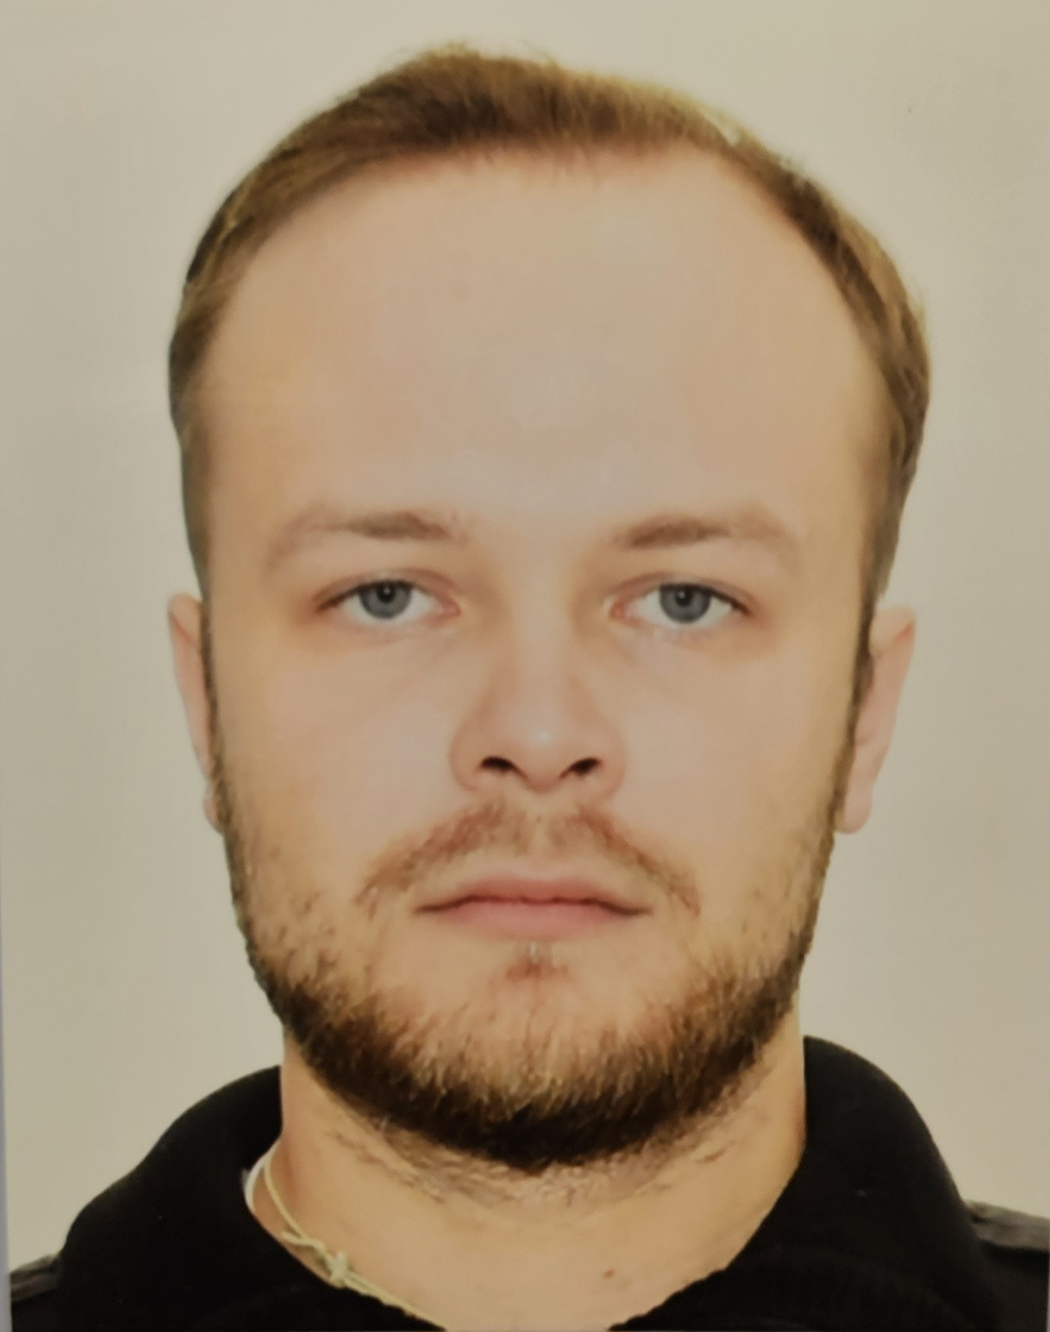
Application Form for Seafarers_General Template

EMPLOYMENT APPLICATION FORM
Rank: 2nd off. | Date Available for Joining: no information
 | Vessel: container and bulk carrier

Personal details
Surname: Pohorletskyi | First name: Dmytro | Photo:
Date of birth: 09.08.1998 | Place of birth: Odessa | Nationality: Ukranian
Home address: Odessa reg. vill. Usatovo, st. Myra №8
Phones: +380671192830;

Nearest airport: Munich | Nearest international airport: MUC

Documents

Passport No. | AB 602245 | Issued on: | 28.11.17 | Expiry date: | 28.11.27
S/book No. | 2683/2016/24 | Issued on: | 17.06.2016 | Expiry date: | ---
Travel paport | FV 843725 | Issued on: | 17.07.19 | Expiry date: | 17.07.29
US visa C1/D |  | Issued on: |  | Expiry date:

CERTIFICATES | Cert No | Date of Issue | Expiry date
COC | 02933/2019/08 | 28.08.19 | -
COC. Endorsement | 02933/2019/08 | 28.08.19 | 19.06.24
G.M.D.S.S. | 20139/2024 | 09.01.24 | -
G.M.D.S.S. Endorsement | 20139/2024 | 09.10.24 | 25.12.28
Proficiency In Survival Craft and rescue boat | 1490900 | 02.09.22 | 02.09.27
Basic Safety Training | 1490898 | 02.09.22 | 02.09.27
Advanced Fire Fighting | 1490897 | 02.09.22 | 02.09.27
RADAR/ARPA | 01792 | 01.12.23 | 01.12.28
Medical First Aid | 02775 | 30.11.23 | --
Securityawarenes training for all seafarers | 03366 | 30.11.23 | --
Designated Security Duties | 0407 | 06.03.20 | 06.03.25
Dangerous cargo | 7/2021/332 | 17.05.21 | 17.05.26
Yellow fever | 001623 | 24.07.20 | -
Bridge resource management (operation level) | 1445977 | 13.04.22 | 13.04.27
ECDIS | 03708 | 20.04.2023 | 20.04.2028
Medical care on board | 02782 | 05.05.2023 | --

Pre-SEA Training / Nautical School / Maritime School | Qualifications | Passed:
MKTF | Junior specialist | 2018
NU “OMA” | Bakhalavr | 2022

SEA SERVICE
Name of Vessel | Year  Built | Flag | Type of Vessel  and Engine (Type) | DWT and HP | Rank | Period of Service |  | Name of Owners
ATLANTIC NORTH | 2002 | SG | Container | 18132 | 2nd off | 24.01.24 | 29.05.24 | Silver maritime Nine PTE.LTD.
Pacific Monaco | 2007 | SG | Container | 8722 | 2nd off | 14.05.23 | 31.11.23 | Silver maritime Nine PTE.LTD.
ELBTRADER | 2008 | Cy | Container | 11000 | 2nd off | 23.10.22 | 28.01.23 | Contagra limited
Breb Xian | 1999 | Cy | MPP | 7500 | 2nd off | 27.04.22 | 17.08.22 | Luptaria Shipping Company LTD
AMUR 2505 | 1984 | Pa | Gen.cargo | 3340 | 2nd off | 03.02.22 | 25.03.22 | Zanetti inc
Ledy Melike | 2005 | Lr | MPP | 10300 | Ab | 21.08.21 | 23.10.21 | MAVERA DENIZCILIK DIS TOCARET
SACURA | 2011 | Lr | Bulk carrier | 12000 | OS | 18.05.21 | 09.07.21 | Sacura Navigation Ltd
ATLANTIS | 2003 | Ag | Container | 8015 | D/Cadet | 27.07.20 | 05.12.20 | Caribbean Shipping Ltd.
River Elbe | 1985 | Pa | General cargo | 3650 | D/Cadet | 08.03.20 | 08.06.20 | River Elbe Shipping Ltd.
Dunay | 1975 | Md | Dredger | 612 | AB | 30.10.19 | 25.12.19
Al Yasra | 2010 | Qa | Container | 12512 | D/Cadet | 19.09.18 | 10.03.19 | Qatar Navigation Ltd
Dunay | 1975 | Ua | Dredger | 612 | D/Cadet | 01.05.18 | 18.09.18
Patriot | 2010 | Ua | Tug | 282 | D/Cadet | 15.05.17 | 31.08.17 | OMTP

References |  |  | Exp. with Multinational Crew: | yes
Name of company: |  |  | Nationalities: | Turkish, Latvish, Egyptian, Ethiopian, Hrvatsko, Philipino, Estonia, Litvanian.
No.
Name of company: |  |  | Level of English | Good
No. |  |  | Marlins Test % | 77%

Next of kin |  |  | Personal data:
Name/Relationship | Kateryna Karpenko |  | Weight, kg: | 78 | Height, cm: | 172
Home address: | Germany, Munich, str. Riesenfeldstraße 70 |  | Eyes: | blue | Hair: | blond
Phones: | +380661979403 / +4901747532812 |  | Overall size: | 50 | Safety shoes: | 43
About you: I’m smart man. I’m hardworking. I am fast learner.

