

APPLICATION FORM

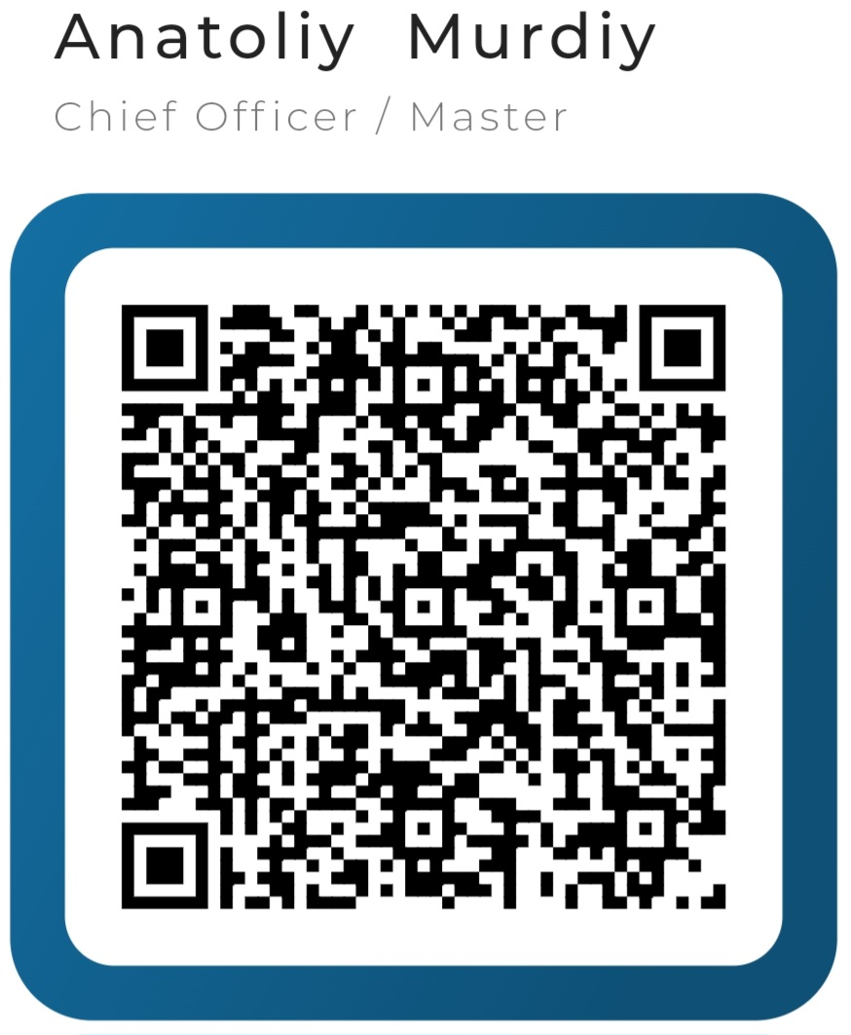
PERSONAL DETAILS
RANK APPLIED | Chief Officer / Master | DATE OF APPLICATION | 20-Aug-2024
RANK APPLIED | Chief Officer / Master | DATE OF AVAILABILITY | August 2024

SURNAME FIRST NAME MIDDLE NAME
NAME |  | Murdiy |  |  |  |  | Anatoliy |  |  |  |  | Anatoliy
Date of Birth |  | 10.04.1985 |  |  | Place of birth |  | Kherson, Ukraine |  |  |  |  | Nationality |  | Ukraine
Permanent Address: App. 3, H. 79, Ushakov Ave. |  |  |  |  |  |  |  |  | Present Address: Slovakia, Europe
City & Pin code: Kherson, Ukraine |  |  |  |  |  |  |  |  | City & Pin code: 927 01
Telephone |  |  |  |  |  |  |  |  | Telephone
  +380506402110
  +380507525288 (wife)
Email 1 |  | murdiy.anatoliy@gmail.com |  |  |  |  |  |  | E-mail 2
Next of Kin (Name) |  | Iryna Murdiy |  |  |  |  |  |  | Relationship |  | Wife
Address of next of kin: SAME AS ABOVE : SAME
Height | 178 |  | Weight | 90 |  | Blood Group |  | 4+ |  | Languages Known |  |  | English, Russian, Ukraine
Marital Status |  |  | Married |  |  | Name of Spouse |  | Iryna Murdiy |  |  |  |  | Number of Children |  | 4
Safety Gear Size |  |  | XL |  |  |  |  | Safety Shoe Size |  |  |  |  | 42

2. LICENSES / DOCUMENTS HELD
ITEM | NUMBER | ISSUED | EXPIRING | ISSUED BY | PLACE OF ISSUE | GRADE
PASSPORT | FJ276508 | 17.10.2017 | 17.10.2027 | Ukraine | Ukraine
SEAMAN'S BOOK (National) | AB658001 | 09.07.2019 | 23.01.2028 | Ukraine | Ukraine | *Extnded
SEAMAN’S BOOK (Other) | PA0278298 | 25.07.2022 | 24.03.2027 | Panama | Panama | Mngmnt
COC | 00682/2017/11 | 25.01.2017 | 24.07.2022 | Harbour Master of Seaport | Kherson, Ukraine | Chief Mate
COE | 00682/2017/11 | 24.03.2022 | 24.03.2027 | Harbour Master of Seaport | Odessa, Ukraine | Chief Mate
COC | 08587/2024 | 07.06.2024 | 02.01.2028 | Shipping Administration | Odessa, Ukraine | Master
COE | 08587/2024 | 07.06.2024 | 02.01.2028 | Shipping Administration | Odessa, Ukraine | Master
GMDSS COC | 41700/2024 | 28.08.2024 | 19.08.2029 | Shipping Administration | Odessa, Ukraine | Operational
GMDSS COE | 41700/2024 | 28.08.2024 | 19.08.2029 | Shipping Administration | Odessa, Ukraine | Operational
U.S. VISA | 20170687850004 | 10.03.2017 | 08.03.2027 | Embassy | Kyiv, Ukraine | R C1/D
YELLOW FEVER VACC. | 20102008 | 20.10.2008 | For Lifetime | Ukraine | Ukraine

3. STCW AND OTHER CERTIFICATES
STCW COURSES | Certificate No. | Date of Issue | Date of Expiry | Place of Issue | Issuing Authority /Institute
BASIC TRAINING - PERSONAL SURVIVAL TECHNIQUES A-VI/1-1 | 1422791 | 22 Oct 2021 | 22 Oct 2026 | Kherson, Ukraine | Seafarers Training Centre
BASIC TRAINING - FIRE PREVENTION & FIRE-FIGHTING A-VI/1-2 | 1422791 | 22 Oct 2021 | 22 Oct 2026 | Kherson, Ukraine | Seafarers Training Centre
BASIC TRAINING - ELEMENTARY FIRST AID A-VI/1-3 | 1422791 | 22 Oct 2021 | 22 Oct 2026 | Kherson, Ukraine | Seafarers Training Centre
BASIC TRAINING - PERS. SAFETY & SOCIAL RESP. A-VI/1-4 | 1422791 | 22 Oct 2021 | 22 Oct 2026 | Kherson, Ukraine | Seafarers Training Centre
PROFICIENCY IN SURVIVAL CRAFT & R.BOATS A-VI/2-1 | 1422794 | 25 Oct 2021 | 25 Oct 2026 | Kherson, Ukraine | Seafarers Training Centre
SECURITY AWARENESS A-VI/6-1 | 1422807 | 01 Nov 2021 | 01 Nov 2026 | Kherson, Ukraine | Seafarers Training Centre
SECURITY TRAINING WITH DESIGNATED SECURITY DUTIES A-VI/6-2 | 1422812 | 02 Nov 2021 | 02 Nov 2026 | Kherson, Ukraine | Seafarers Training Centre
SSO - SHIP SECURITY OFFICER A-VI/5 | 158987 | 30 Jun 2020 | 30 Jun 2025 | Kherson, Ukraine | Seafarers Training Centre
SSO - SHIP SECURITY OFFICER A-VI/5 | 00723/2020/11 | 14 Jul 2020 | 30 Jun 2025 | Kherson, Ukraine | Harbour Master of seaport Kherson
SAFETY OFFICER TRAINING COURSE (INCLUDING RA & AI) | 00485 | 30 Jun 2020 | 30 Jun 2025 | Kherson, Ukraine | Seafarers Training Centre
ADVANCED FIRE FIGHTING A-VI/3 | 1422796 | 26 Oct 2021 | 26 Oct 2026 | Kherson, Ukraine | Seafarers Training Centre
BRIDGE TEAM/RESOURCE MANAGEMENT (IMO 1.22) | 1422821 | 08 Nov 2021 | 08 Nov 2026 | Kherson, Ukraine | Seafarers Training Centre
MEDICAL CARE A-VI/4 | 1422800 | 29 Oct 2021 | 29 Oct 2026 | Kherson, Ukraine | Seafarers Training Centre
MEDICAL FIRST AID A-VI/4 | 1422798 | 27 Oct 2021 | 26 Oct 2026 | Kherson, Ukraine | Seafarers Training Centre

SIMULATOR TRAINING
RADAR, ARPA, BRIDGE TEAM, SEARCH AND RESCUE - MANAGEMENT LEVEL (A-I/12, AII/2) | 1422817 | 04 Nov 2021 | 04 Nov 2026 | Kherson, Ukraine | Seafarers Training Centre
GENERIC ECDIS  (IMO 1.27) | 1422818 | 05 Nov 2021 | 05 Nov 2026 | Kherson, Ukraine | Seafarers Training Centre
ECDIS TRANSAS 4000 | 2016-UA-OMTC-NS40-0078 | 24 May 2016 | Life time | Odessa, Ukraine | Maritime Training Centre

TANKER COURSES
BASIC OIL TANKER CARGO OPERATION A-V/1-1-1 | 1422829 | 09 Nov 2021 | 09 Nov 2026 | Kherson, Ukraine | Seafarers Training Centre
ADVANCED OIL TANKER CARGO OPERATION A-V/1-1-2 | 1422833 | 10 Nov 2021 | 10 Nov 2026 | Kherson, Ukraine | Seafarers Training Centre
ADVANCED TRAINING FOR CARGO OPERATIONS ON TANKERS | 01607/2022/08 | 24 Mar 2022 | 24 Mar 2027 | Odessa, Ukraine | Harbour Master of seaport Odessa
CARRIAGE OF DANGEROUS AND HAZARDOUS SUBSTANCES | 1422814 | 03 Nov 2021 | 03 Dec 2026 | Kherson, Ukraine | Seafarers Training Centre

4. SEAEXPERIENCE:( Most recent first)

COMPANY | VESSEL |  |  |  |  | MAIN ENGINE |  | PERIOD |  | TOTAL DAYS
COMPANY | NAME / FLAG | TYPE | DWT | GRT | RANK | MAKER | BHP/KW | FROM | TO | MONTH
NORD SHIPS MARITIME | BELLA 1 / PANAMA | VLCC CRUDE OIL TANKER | 318518 | 161233 | CHIEF OFFICER | HYUNDAI - B&W | 39,900 | 08.11.2023 | 23.03.2024 | 4.5
NORD SHIPS MARITIME | TIMIMUS / PANAMA  (Ship’s delivery) | VLCC CRUDE OIL TANKER | 318518 | 161233 | CHIEF OFFICER | HYUNDAI - B&W | 39,900 | 22.10.2023 | 07.11.2023 | 0.6
UNAONE  SHIPMANAGEMENT | HORNET/ PANAMA | VLCC CRUDE OIL TANKER | 281050 | 19282 | CHIEF OFFICER | SULZER | 37,000 | 18.03.2023 | 07.07.2023 | 3.7
UNAONE  SHIPMANAGEMENT | LADY SOFIA/ PANAMA | CRUDE OIL  TANKER | 160000 | 83724 | CHIEF  OFFICER | MITSUI MAN B&W  MC-C | 15,480 | 03.06.2022 | 02.12.2022 | 6.0
UNAONE  SHIPMANAGEMENT | SOBAR/ IRAN | CRUDE OIL  TANKER | 160000 | 83723 | CHIEF  OFFICER | MITSUI MAN B&W  MC-C | 15,480 | 13.10.2020 | 19.08.2021 | 10.3
MINERVA MARINE | MINERVA OLYMPIA/ GREEK | CRUDE OIL TANKER | 114,661 | 63485 | CHIEF OFFICER | MITSUI MAN B&W 6G60 ME - C9.5 | 15,948 | 03.09.2019 | 21.06.2020 | 9.7
MINERVA MARINE | MINERVA ZENOBIA/ GREEK | CRUDE OIL TANKER | 114,661 | 63485 | CHIEF OFFICER | MITSUI MAN B&W 6G60 ME - C9.5 | 15,730 | 20.11.2018 | 13.06.2019 | 6.8
MINERVA MARINE | MINERVA ELEFTHERIA/ GREEK | CRUDE OIL TANKER | 114,696 | 63485 | CHIEF OFFICER | MITSUI MAN B&W 6G60 ME-C9.2 | 15,948 | 09.02.2018 | 31.07.2018 | 5.7
MINERVA MARINE | MINERVA INDIANA/ MALTA | CRUDE OIL TANKER | 105,547 | 56285 | 2ND OFFICER | SULZER 6RTA58T | 19,200 | 13.04.2017 | 12.09.2017 | 5.0
MINERVA MARINE | MINERVA CONCERT/ GREEK | CRUDE OIL TANKER | 105,817 | 56477 | 2ND OFFICER | SULZER 7RTA58T | 11,547 | 29.05.2016 | 03.12.2016 | 6.3
THOME OFFSHORE MANAGEMENT PTE LTD | ENERGY SCOUT/ NORWAY | PSV | 3,184 |  | 2ND OFFICER / DPO | BERGEN DIESEL KRMB9 | 5,452 | 29.08.2015 | 31.10.2015 | 2.1
LERUS | DENAR2/ TURKEY | ROV | 2,997 |  | 2ND OFF /JDPO | ALPHA  16V23L-VO | 2,160 | 16.01.2015 | 18.02.2015 | 1.1
SCF SHIP MANAGEMENT | SCF PROGRESS/LIBERIA | CRUDE OIL TANKER | 74,588 | 42208 | 2ND OFFICER | B & W | 14,230 | 26.04.2014 | 26.09.2014 | 5.1
SCF SHIP MANAGEMENT | SCF PROGRESS/ LIBERIA | CRUDE OIL TANKER | 74,588 | 42208 | 2ND OFFICER | B & W | 14,230 | 14.07.2013 | 07.12.2013 | 4.9
SCF SHIP MANAGEMENT | SCF PROGRESS/ LIBERIA | CRUDE OIL TANKER | 74,588 | 42208 | 2ND OFFICER | B & W | 14,230 | 06.10.2012 | 19.02.2013 | 4.5
SCF SHIP MANAGEMENT | SCF PACIFICA/ LIBERIA | CRUDE OIL TANKER | 74,534 | 42208 | 3RD OFFICER | B & W | 14,230 | 20.03.2012 | 17.07.2012 | 4.0
SCF SHIP MANAGEMENT | ANICHKOV BRIDGE/ LIBERIA | OIL / CHEMICAL TANKER | 47,842 | 27829 | 3RD OFFICER | B & W | 10,620 | 22.05.2011 | 04.10.2011 | 4.5

