Curriculum Vitae

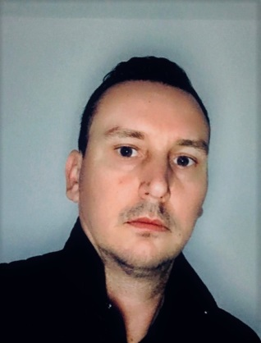

Personal information:
 | Florian Ionescu
Address | Constanta, Romania
Telephone(s) | +40 734 215 904
E-mail | ionescu_32a@yahoo.com
Nationality | Romanian
Occupational field | Master SDPO  STCW REG II/2 / Full DP  ADNOC approval
Work experience | December 2000 onwards
Main activities and responsibilities | Master SDPO:  - Pipe Lay and Derrick Lay - DP2  - Heavy lift Jack-up - DP2  - DSV - DP3  - Wind Farm Installation Vessel - DP 2  - DRILL RIG / drilling semi-submersible - DP 2  - MPSV – DP 2  - Cable lay  - Heavy Lift / Accommodation and Working Barge  - Performing underwater operations / intervention, drilling, pipe lay, ROV & AUV survey, diving operations, jacket construction & installation, heavy Lift, etc.
Name of the employer: | - Zakher Marine International  - Swire Pacific Offshore
Education and training:
Dates | 2000 - 2005
Title of qualification awarded | Diplomat engineer - Ship management and shipping operation  Bachelor of Science Degree in Maritime Transport: Navigation and Naval Transport
Principal subjects/occupational skills covered | Master SDPO
Name and type of organization providing education and training | Constanta Maritime University, Constanta, cod 900663, Romania
Level in national or international classification | ISCED 6
Self-assessment |  | Understanding |  |  |  |  | Speaking |  |  |  |  | Writing
European level (*) |  | Listening |  | Reading |  |  | Spoken interaction |  | Spoken production
English |  | C1 | Proficient user | C1 | Independent user |  | C1 | Independent user | C1 |  | Independent user | C1 | Independent user
 | (*) Common European Framework of Reference for Languages
DP System | KONGSBERG, ROLLS - ROYCE, CONVERTEAM, L3  DP2 / DP3
Other skills and competences | SDPO – UNLIMITED DP  - HLO  - HUET  - BOSIET  - H2S  - FRC  Experience on:  - Heavy lift jack-up / MODU / Wind Farm Installation DP 2  - DRILL RIG DP 2 / MODU  - MPSV – DP 2 / ROV & DIVING support, Construction  - DSV - DP 3  - Cable lay  - Pipe Lay and Derrick Lay – DP 2  - Heavy Lift / Accommodation, Jacket installation  - Working Barge - saturation diving & ROV  - Survey and Seismic Vessel  - PSV

