Positions applied for: |  |  | bosun or |  |  | Date of readiness: |  |  |  |  | 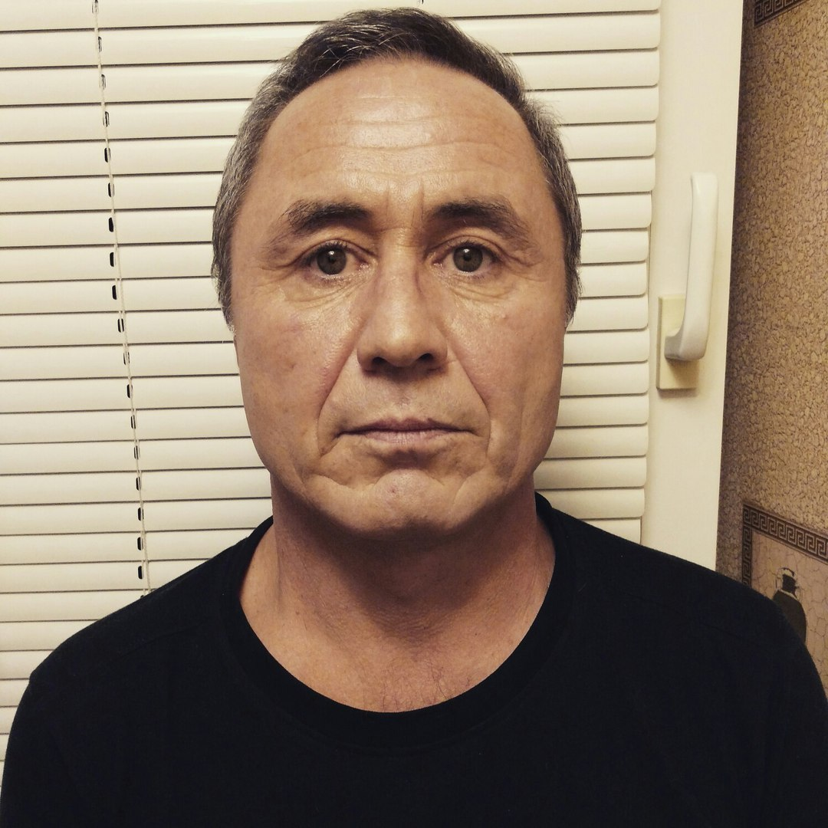  PHOTO
Surname: |  |  | Gromov |  |  | Name: |  |  | Alexander
Father’s name: |  |  | Georgyevich |  |  | Mother’s name:
Date of birth: |  |  | 01.04.1968 |  |  | Nationality: |  |  | Rus
Place of birth: |  |  | USSR Bukharskiy region |  |  | Marital status: |  |  | Mar.
N of children under 18:
Home Address: |  |  | Novorossiysk Suvorovskaia str. 39/49 app.18 |  |  | Contact Phone: |  |  | +79528528617
E-mail: |  |  | gromovag68@mail.ru |  |  | Skype/Telegram:
Next of kin: |  |  | Neskoromnykh Elena |  |  |  |  |  | Relation: |  | Wife
Next of kin’s address: |  |  | Same |  |  |  |  |  | Next of kin’s phone №:
Height (cm): | 173 |  | Weight (kg): | 72 | Size of Overall (EUR): |  |  |  | 48/50 | Shoes (EUR): |  | 42
Eyes Colour: | brown |  | Hair Colour: | grizzle
 |  |  |  | Marine Education
Name of maritime college or academy |  |  |  | Novorossiysk Marine Scool |  |  | From |  |  | 1988
Department |  |  |  | Able seaman |  |  | Till |  |  | 1989
 |  |  |  | PASSPORTS and CERTIFICATES
DOCUMENT |  |  |  | NUMBER |  |  |  | ISSUED DATE |  | VALID UNTIL |  | PLACE
TRAVEL PASSPORT: |  |  |  | 76 6237300 |  |  |  | 23.12.21 |  | 23.12.31 |  | Novorossiysk
SEAMAN’S BOOK: |  |  |  | MK 0075066 |  |  |  | 06.06.2011 |  |  |  | Novorossiysk
CIVIL PASSPORT: |  |  |  | 03 15 098158 |  |  |  | 23.12.2014 |  |  |  | Novorossiysk
U.S. VISA:
OTHER VALID VISA:
CERTIFICATE OF COMPETENCY # 1 |  |  |  | 2014600819 |  |  |  | 09.06.2015 |  |  |  | Novorossiysk
RANK / CAPACITY |  |  | Able seafarer deck
ENDORSEMENT OF CERTIFICATE # 1
CERTIFICATE OF COMPETENCY # 2
RANK / CAPACITY
ENDORSEMENT OF CERTIFICATE # 2
CERTIFICATE |  |  |  | NUMBER |  |  |  | ISSUED DATE |  | VALID UNTIL |  | PLACE
GMDSS CERTIFICATE/ENDORSEMENT
BASIC SAFETY TRAINING |  |  |  | 2191024765 |  |  |  | 10.12.19 |  | 10.12.24 |  | Novorossiysk
PROFICIENCY IN SURVIVAL CRAFT |  |  |  | 2191025055 |  |  |  | 12.12.19 |  | 12.12.24 |  | Novorossiysk
ADVANCED FIRE FIGHTING
MEDICAL FIRST AID / MEDICAL CARE
SHIPS SECURITY OFFICER
DESIGNATED SECURITY DUTIES |  |  |  | 1211392 |  |  |  | 01.03.19 |  | 01.03.24 |  | Novorossiysk
SECURITY AWARENESS
SHIPS SAFETY OFFICER / ISM
RADAR NAVIGATION, RADAR PLOTTING AND USE OF ARPA
DANGEROUS & HAZARDOUS CARGOES
BRIDGE TEAM MNGT/ ENGINE ROOM RESOURCE MNGT
ECDIS GENERIC
BASIC TRAINING FOR OIL & CHEMICAL TANKER CERTIFICATE |  |  |  | 1143606 |  |  |  | 26.12.19 |  | 26.12.24 |  | Novorossiysk
ADV. TRAINING FOR OIL / CHEMICAL TANKER CERTIFICATE
BASIC TRAINING FOR OIL AND CHEMICAL TANKER - ENDORSEMENT
ADV. TRAINING FOR OIL / CHEMICAL TANKER -ENDORSEMENT
BASIC/ADV. TRAINING FOR GAS TANKER ENDO
HIGH VOLTAGE EL. EQUIPMENT
ECDIS SPECIFIC
COOK / MESSMAN (MLC-2006)
YELLOW FEVER CERTIFICATE |  |  |  |  |  |  |  | 15.06.2011 |  |  |  | Novorossiysk
COVID-19 VACCINATION CERTIFICATE |  |  |  | 1000 1529 7727 5338 |  |  |  | 19.04.21 |  | 05.08.23 |  | Novorossiysk
 | FOREIGN SEAMAN’S ID / RECORD BOOKS
CERTIFICATE | NUMBER | ISSUED DATE | VALID UNTIL | PLACE

PREVIOUS SEA SERVICE
FROM |  |  | TO | POSITION | SALARY | NAME OF VESSEL | SHIPOWNER |  |  | TYPE OF VESSEL |  | TYPE OF ENGINE | BUILD YEAR |  | DWT |  | BHP |  | FLAG | CREWING AGENT
20.03.2013 |  |  | 21.11.2013 | AB |  | NS Columbus | SCF Novoship |  |  | Oil Tanker |  |  |  |  | 105.000 |  |  |  | Liberia | SCF Novoship
12.04.2014 |  |  | 04.11.2014 | AB |  | Svet | SCF Novoship |  |  | Oil Tanker |  | 7RT-FLEX84T-D |  |  | 300.000 |  |  |  | Liberia | SCF Novoship
20.12.2015 |  |  | 03.06.2016 | Bosun |  | NS Parade | SCF Novoship |  |  | Chem. Product. Tanker |  | MAN-B&W 6S50MC-C |  |  | 70.000 |  |  |  | Liberia | SCF Novoship
01.09.2016 |  |  | 05.12.2016 | Bosun |  | MV Vityaz | ОТЭКО Терминал |  |  | Земснаряд |  |  |  |  | 7000 |  |  |  | Россия | ОТЭКО Терминал
06,04,2017 |  |  | 18.08.2017 | Bosun |  | Kavkaz2 | Aston |  |  | Bulk |  | HD-B&W 6550MC |  |  | 45000 |  |  |  | Liberia | Aston
10.04.2018 |  |  | 17.10.2018 | AB |  | Perseas | Laskaridis Shipping CO |  |  | Bulk |  | Hyundai-Man B&W 5S60MC-C7 |  |  | 70.000 |  |  |  | Panama | Laskaridis Shipping CO
05.07.2019 |  |  | 07.12.2019 | AB |  | Oceanus | Laskaridis Shipping CO |  |  | Bulk |  |  |  |  | 68000 |  |  |  | Liberia | Laskaridis Shipping CO
22.04.2021 |  |  | 26.08.2021 | Bosun |  | Astoria | Trinity Shipping |  |  | Chem. Product. Tanker |  |  |  |  | 70000 |  |  |  | Rus | Trinity Shipping
25.0.2022 |  |  | 30.07.2022 | Bosun |  | Aeolos | Laskaridis Shipping CO |  |  | Bulk |  | MAN-B&W 5S60MC-C8 |  |  | 65000 |  |  |  | Liberia | Laskaridis Shipping CO
29.11.2022 |  |  | 02.03.2023 | Bosun |  | Rix Lagoon | Rix Explorer Shipping LTD |  |  | Bulk |  |  |  |  | 40000 |  |  |  | Limassol | Rix Explorer Shipping LTD
BRIEF INFORMATION ABOUT PREVIOUS EMPLOYERS
COMPANY |  |  |  |  |  |  |  | PERSON IN CHARGE |  |  |  |  |  |  | CONTACT DETAILS (Phone Number, e-mail)
Novoship |  |  |  |  |  |  |  | Артемчик Елена Викторовна |  |  |  |  |  |  | 88617601153
Aston |  |  |  |  |  |  |  | Калинин Кирилл Евгеньевич |  |  |  |  |  |  | 89185546353 8918558473
Trinity Shipping Transpetrochart |  |  |  |  |  |  |  |  |  |  |  |  |  |  | 89218623902
 |  | I hereby confirm that above information is true and correct to the best of my knowledge. I understand that this information will be held in the computer database due to my real or possible employment. Signing it, I willfully give my permission to collect and process my personal information and to use it in all and legal way. I give my permission for my personal information to be provided to the possible employers and any other persons, if such need arises for my employment. Besides, I permit the NOVOMAR LLC employees to request personal information (data) about me from my former employers.
Date: | 28.04.2023 |  |  |  |  |  |  |  |  |  |  |  |  |  |  | Signature:

