Mehmet Ali Tokcan
05365623930
Erzene mah. 73 sokak Bornova / İzmir
TURKEY
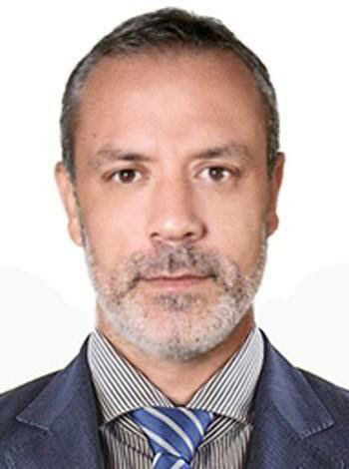

e-mail: mehmetalitokcan @gmail.com / mehmettokcan@yahoo.com

Date of birth: 11.06.1973 Izmir / Bornova
Personal status: Single
Military Service: 1995/1997 Ankara Special Pasha Protection Battalion Central Commandership

►EDUCATION

Kuşadası Hotel Management and Tourism Vocational High School Anatolian HighSchool ( 1991 _1994)

►RELATED EXPERIENCES

DerinSu Underwater Engineering

Optimus Prime ship

Chef Cook
22 May 2024 / 22.08.2024 end of businesss

Atlantik Group ship company Turkey

22 Marc 2021 --- end of businesss 20 April 2024

Altan and Hakan İlhan,Kutsi İlhan PSV 2 ship Cook

Altan Psv 2 ship
22.03.2021/17.05.2021

Hakan İlhan Psv 2 Hakan İlhan Psv 2 Hakan İlhan Psv 2 Hakan İlhan Psv 2
01.08.2021/12.09.2021 24.10.2021/05.12.2021 16.01.2022/01.03.2022 13.04.2022/25.05.2022

Hakan İlhan Psv 2 Kutsi İlhan Psv 2 Kutsi İlhan Psv 2 Kutsi İlhan Psv 2
06.07.2022/13.08.2022 30.09.2022/20.11.2022 03.04.2022/16.05.2022 29.06.2023/08.08.2023

Kutsi İlhan Psv 2
15.12.2023/16.01.2024

Cenk Group Shipping Ro ro Ropax transportation

September 2020/February 2021 contract expiry

Chef Cook
İstanbul Odessa Ukraine line
Preparing and serving three meals a day for passengers and crew, tracking kitchen and food and beverage orders (Panama flag Ship)

G&P Group Cruise Hotel Management GMBH BAAR Luzern Cruise Ship, Switzerland

Nov 2019 - Feb. 2020

Seniour Cheff de partie
- Responsible of whole salat Buffet including appetizers and salad dressings.
- Due to the echnomical reasons of the market, the company is announced bankruptcy.

Serkoc Turizm LUJO Hotel, Bodrum Turkey
(Nov 2017 – Nov 2019)

Senior Cheff de Partie
- Responsible of All day hot buffe menü lm.

Istanbul Restaurant, Kazan, Tatarstan Russia

Oct 2017 – Dec 2017

Resteraunt Cheff

- Inıtiating and deveoping all the restaurant & kitchen design in term of endustrial equipments
- Manageing order process management for company wide perspective.
- Create barbecue menu & to be a special chef.

Bodrum Lux Resort Residences, Turkey

Feb 2017 – Sep 2017 Staff Chef

- In charge of team selection & management during the opening period of the hotel.
- Closely followed up the target consumer range of the hotel and all portfolio creation of the the beach bar kitchen menus, demo and tutorial show to the other team employees

İzmir Doubletree Hilton

Mar 2016 – Feb 2017

Chef Party
- I have a place in the main team of the hotel staff and took responsibility during the team creation period.
- Managing Hotel Staff Kitchen Bangent and the mass food buffet.

Bornova Forum Begendik Abi Osmanlı

Oct 2015 – Mar 2016
Chef

Moscow Dedeman Park Hotel Izmalova, Russia

Oct 2014 – Oct 2015
Section Turkish Alacart chief

- As a part of the main hotel team, managing hotel staff kitchen
- Main responsibilities: Bangent buffet, Turkish Alacart cooked menus as an inteior design.

Güler Group Catering Catering Company, Moscow, Russia

July 2002- July 2014

Delphi Automotive Human Resources Personnel Staff Resteraunt

2002-2012

Intership

Kusadasi Kismet Hotel, Turkey 1997-2001

Kitchen Comi cheff (During the summer periods)
Kusadasi kismet hotel summer International student kitchen section 1991-1994

Ankara Pasa Guardian Officer Casinos Kitchen. 1995-1997

►RELATED KNOWLEDGE

Seamans Certificate, 2020

- Designated Security Duties. kod:1181225
- Personal Survival Techniques Trainning Kod:11481226
- Document of Compliance for Ship Cooks Kod:11481227
- Security Awareness Kod: 11481228
- Security Related Familiarization Kod: 11481229
- Personal Safety and Social Resonsibility training Kod: 11481230
- Certificate of Profciency in Basic Trainig for Oill and Chemical Tanker Cargo Operations
Kod:11481231
- Elementary Fırat and Trainning kod 11481232
- Prevention and Fire Fighting Training Kod:11481233
- Training and Qualifications of Personnel on Passenger Ship's Kod:11481234
- Medical Examination Certificate for Seafarers

Language: English (Average)

Computer Information: Microsoft programs excel, word

►REFERENCES
Fatma Cağalar (Coship company) +90 543 529 22 95
Salih Benli (Human resources Manager) +90 532 521 33 94

