Personal information
Position: |  | Deck cadet |  |  |  |  | Photo
Desired Type of Ship: |  | Any ship |  |  |  |  | 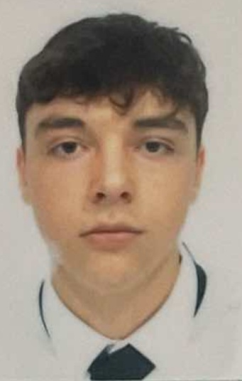
Minimum salary: |  | 500
Surname: |  | Lukas
Name: |  | Kyrylo
Patronymic: |  | Nikolaevich
Citizenship: |  | Ukrainian
Date of birth: |  | 30.08.2006
Place of birth: |  | Ukraine
Gender: |  | male
Languages | English level: |  | Ukraunian,Russian,English,Italian,Deutsch;English-A2-B1
Computer user: |  | Intermediate level of proficiency
Contact Information
Address: |  | Flughagen Tegel 1
Mobile phone: |  | +491711594021 |  | Phone: |  | +491711594021
E-mail: |  | Kirill.18519211@gmail.com |  | Additional phone: |  | No
Skype: |  | live:.cid.495a292a7ae28163;+491711594021 |  | Airport: |  | Tempelhof Airoport
Biometrical Data
Color Hair: | Brown | Color Eyes: | Brown | Shoes: | 44
Height: | 178 | Weight: | 70 | Boiler suit: | L

Seagoing Experience
Rank | Company | Vessel Name | Y.O.B./  Flag | Type | DWT GRT | BHP KW | Engine Model | Sign on | Sign off

Passports/Visas

Title | Document № | Place of issue | Date of issue | Date of expiry
Seaman’s Book: | AC 009053 | Ukraine | 10.07.2023 | 10.07.2028
Travel Passport: | GF709931 | Ukraine | 05.05.2023 | 05.05.2033
USA Visa: | no
Other RB: | NO

CERTIFICATE of COMPETENCY (DIPLOMA)

Title | Rank | Document № | Place of issue | Date of issue | Date of expiry
Certificate of Competency:
Endorsement:
Other:

flagged CERTIFICATE of competency

Title | Document № | Country | Place of issue | Date of expiry

Basic Certificates STCW 95 / Additional Certificates
Title | Certificate № | Place of issue | Date of issue | Date of expiry
GMDSS GeneralOperatorCertificate
GMDSS GeneralOperatorEndorsement
Basic Safety Training and Instruction | 1571556 | Ukraine | 19.06.2023 | 19.06.2028
AdvancedFireFighting | 624/24 | Ukraine | 08.07.2024 | 08.07.2029
Ship’s Medical Care
Medical First Aid
Prof. in Survival Craft and rescue boats other than fast rescue boats | 686/24 | Ukraine | 06.07.2024 | 06.07.2029
Proficiency in Survival Craft, Rescue Boats & Fast Rescue Boats
Proficiency in Fast Rescue Boats
Security Awareness Training | 32334224 | Ukraine | 15.09.2023 | 15.09.2028
Designated security duties
Ship Security Officer
Safety Officer Certificate (ISM Code)
Ship Maneuvering and Handling
Radar Observation and Plotting (RADAR)
Automatic Radar Plotting Aids (ARPA)
ECDIS certificate
Dangerous and Hazardous Cargoes (HAZMAT)
Bridge team management
Familiarization course on ship and port facility security for crew
Security-Related Training and Instruction for all Seafarers
Ro-Ro passenger ships
Ship handling arrangements
Advanced Training for cargo operation on Tanker
Technology of Inert Gas System Operation
Basic Training for Liquefied Gas Tanker
Refresher and updating courses
Other
Other

Name of Medical Organization | № | Place of issue | Date of issue | Date of expiry
Medical Book: | 950393939 | Ukraine | 24.07.2024 | 24.07.2025
Medical Examination: |  | Germany | 06.04.2024
Yellow Fever: |  | Ukraine | 24.07.2024 | 24.07.2024
Polio: | no
MedicalExamination

Education

Name of Maritime School / Institution | Place | From/To | Specialty / Degree of Diploma
Odessa Maritime Vocational College of the Maritime and Fishing Fleet named Oleksiy Solyanyk | Ukraine | 01.10.2021/01.08.2025 | Navigator

Additional information
Maritalstatus: | no | Children under 18: | no

Next of Kin: | Grandfather | Date of Birth: | 18.12.1961
Phones: | +380972659105 | Address: | Flughafen Tegel 1

