APPLICATION FORM |  |  |  | 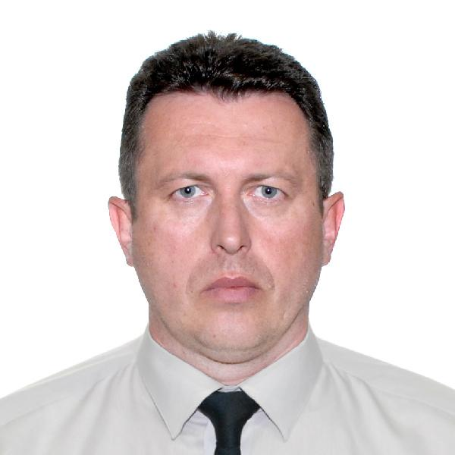
Main information
Position: | Ch. Engineer | Desired Type of Ship: | Container, Bulker….
Desired salary: | 10500 $ | Available from: | 15.09.2024
Full Name: | Stanislav Mishchenko | Date of birth: | 30.12.1976
Citizenship: | Ukrainian | Place of birth: | Karaganda, Kazakhstan
Phones: | +380674191160 | Country of residence: | Ukraine
E-mail address: | stanislav.mi.sm@gmail.com | City/ Address: | Izmail, Odessa reg., Ukraine
Skype: | Stasson4ik | USA visa valid up: | 08.11.2029
English level: | Good | Schengen visa valid up: | no

Passports / Smbk | # | Date of issue | Place of issue | Date of expire
Seaman's book | AB 667534 | 27.10.2020 | Chornomorsk | 27.10.2025
International passport | FM 191146 | 12.03.2018 | Izmail | 12.03.2028
Diplomas | # | Date of issue | Place of issue | Valid up
Rank | 1-st class engineer
Professional license | 13270/2015/01 | 15.12.2015 | Izmail
Endorsement | 13270/2015/01 | 24.11.2020 | Izmail | 17.11.2025
Certificates | # | Date of issue | Place of issue | Valid up
Basic Safety Training | 219548 | 09.11.2020 | Odessa | 09.11.2025
Advanced Fire Fighting | 219550 | 09.11.2020 | Odessa | 09.11.2025
Medical care
Medical First aid | 219551 | 09.11.2020 | Odessa | 09.11.2025
Proficiency in Survival craft | 219549 | 09.11.2020 | Odessa | 09.11.2025
Security -related training and instruction for all seafarers
Security training for seafarers with designated security duties
Designated security duties of shipboard personnel | 1372 | 08.02.2019 | Kherson | 08.02.2024
Training of Passenger ships personnel
Ship handling arrangements
Ship security officer | 219552 | 09.11.2020 | Odessa | 09.11.2025

Medicine | # |  | Date of issue | Valid up
Medical fitness certificate:
Alco-drug certificate:
Yellow fever: |  |  | 03.11.2014

Sea experience (reverse order)
Position | Name | Type | DWT/GTN | ME Type/kW | From - Till | Employer
Ch.Engineer | ZIM YANTIAN | Container | 109149 | MAN B&W 12K98MC/74757 | 27.11.2023-  12.05.2024 | V-SHIP GREECE
Ch.Engineer | BALTIMORE STAR | Container | 41358 | SULZER 8RTA82C/36160 | 01.04.2023-09.08.2023 | V-SHIP GREECE
Ch.Engineer | ARIES | Container | 75519 | SULZER 12RTA96C/61350 | 17.10.2022-07.02.2023 | V-SHIP GREECE
2nd engineer | COSCO GUANGZHOU | Container | 109149 | MAN B&W 12K98MC/74757 | 10.11.2021-  03.05.2022 | V-SHIP GREECE
2nd engineer | MSC METHONI | Container | 77000 | MAN B&W 10K98MC-C | 09.02.2021-31.05.2021 | V-SHIP GREECE
2nd engineer | KOKURA | Container | 81488 | B&W 12K90MC-C | 09.02.2020-08.07.2020 | V-SHIPS
2nd engineer | APL CHINA | Container | 64502 | B&W 11K90MC-C | 27.04.2019-06.09.2019 | CMA Ships

Additional info
Education: Odessa National Maritime Academy, 2013 |  | Knowledge of other languages:.ENGLISH,RUSSIAN,UKRAINIAN
Specialty: ships engineer |  | Lathe machine skills:
Second (relative) specialty: |  | Welding skills:
Next of Kin
Next of kin: wife |  | Phone: +380685395609
Name, Surname: Oksana Mishchenko |  | Address: app.54, 10a Mykhailivska str.,Izmail city, Odessa reg., Ukraine
Biometric Data
Sex: male | Height: 188 |  | Overall size: 58 (XXL)
Eyes color: grey | Weight: 98 |  | Shoe size: 44

