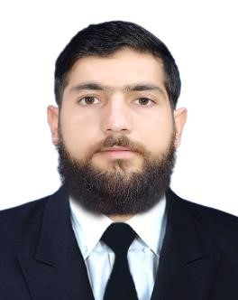
Curriculum Vitae
RAHIM ULLAH
Rank: GP III”
PERSONAL INFORMATION:
- Full Name: Rahim Ullah
- Father’s Name: Mian Khaliq Jan
- Date of Birth: 07-02-1999
- CNIC No: 15601-02357151-1
- Nationality: Pakistani
- Religion: Islam
- Marital Status: Single
- Address: Village Giga P/O Gurra Postal code 19040 Tehsil Matta District Swat
- Mobile No: +923401932852
- E-mail: rahimullah.farooqi05@gmail.com
S.No | Certificate Name | Cert. No | Issue Place | Date Of Issue
01
Personal Survival Techniques
2436/2023
AMI
25 May 2023
02
Elementary First Aid
0429/2023
AMI
25 May 2023
03
Fire Prevention & Fire Fighting
4436/2023
AMI
25 May 2023

Education | School/institude | Place | Passing year
GP course | Androse Marine Institute | Karachi | 2023
F.sc pre engineering | Gov PG Jahanzeb College | Saidu Sharif Swat | 2017
Matric | Abdali School and college | Matta Swat | 2015

DOCUMENTS:
DOCUMENTS | NUMBER | PLACE OF ISSUE | DATE OF ISSUE | DATE OF EXPIRY
Passport No | KU2747152 | Swat Pakistan | 12 May 2023 | 10 May2033
S.S.B No | 032301-S | Karachi Pakistan | 23 October 2023 | 23 October 2033
SID Card | PAK102387 | Karachi Pakistan | 25 October 2023 | 25 October 2028
Yellow Fever | AN7505665127 | Karachi Pakistan | 31 October 2023 | Life Time

SAFETY MANDATORY COURSE:
- Personal Safety & Social Responsibility 6440/2023 AMI 25 May 2023
- Oil and Chemical Tanker Cargo 8817/2023 AMI 22-Dec 2023
operations
07 Designated security duties 0901/2023 AMI 29-Dec-2023

SEA SERVICE EXPERIENCE:
S.NO | Vessel Name | Company Name | GRT | Type | Rank | Form | To
01

