RESUME

APPLIEDFOR : WIPER
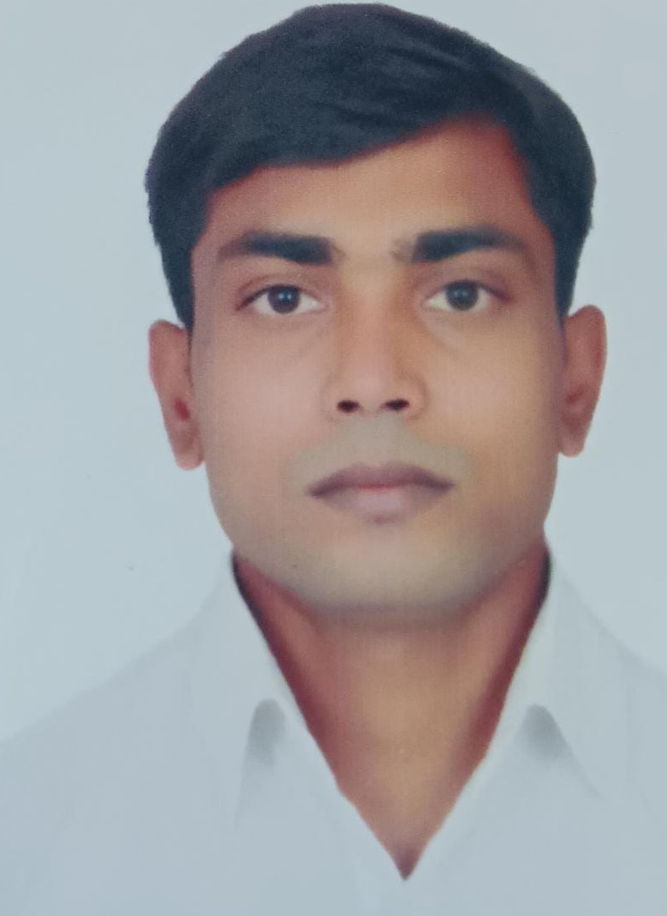
NAME : RAVI KUMAR
FATHER NAME : BARUN KUMAR
DATE OF BIRTH : 21/12/1997
GENDER : MALE
NATIONALITY : INDIAN
LANGUAGE KNOWN : HINDI, ENGLISH
EMAIL ID : ravi93887@gmail.com
CONTACT NO : 7631230020
ADDRESS : AT/POST-PANDARAK, VILLAGE-PANDARAK, HARIJAN TOLA,
SUBDIVISIONBARH, DIST-PATNA, BIHAR – 803221.
EDUCATION & TRAINING:
SCHOOL COLLEGE / INSTITUTE ATTENDED | PERIOD | CERTIFICATE OBTAINED
B.P MARINE(NAVI MUMBAI) | FROM 01-07-2019 TO 31-12-2019 | G P RATING

TRAVEL DOCUMENTS AND COMPETENCY CERTIFICATE

DOCUMENTS | NUMBER | DATE OF ISSUE | DATE OF EXPIRY | PLACE OF ISSUE
PASSPORT | N2093931 | 13/08/2015 | 12/08/2025 | PATNA
INDIAN CDC | MUM 414046 | 28/02/2020 | 27/02/2030 | MUMBAI
INDOS | 19GL0457 | 10/06/2019 | UNLIMITED | MUMBAI
YELLOW FEVER | SR.NO.1573 | 19/11/2020 | UNLIMITED | MUMBAI
COVID 19 VACCINATION | 35202672141110

BASIC STCW COURSE:-
TYPE | CERTIFICATE NO | DATE OF ISSUE | DATE OF EXPIRY | PLACE OF ISSUE
BASIC TRAINING  OCTO | 20301051112004415 | 19-DEC-2020 | NA | MUMBAI
BASIC STCW TRAINING | 201001307191974 | 11-SEP-2019 | 5 YEAR | MUMBAI
SSDS | 201001148191869 | 08-AUG-2019 | UNLIMITED | MUMBAI
GENERAL PURPOSE RATINGS | 201002810119002120 | 24-JAN-2020 | UNLIMITED | MUMBAI
OIL AND CHEMICAL DC ENDORSEMENT | COPDGSOAC2131727 | 11/01/2021 | UNLIMITED | MUMBAI
LR (WPQ) | SPM/WPS6G/1 | 29/12/2021 | 22/12/2024 | MUMBAI

SEA EXPERIENCE
SR NO. | COMPANY NAME | NAME OF VESSEL | RANK | GRT/HP | TYPE OF  VESSEL | PERIODE OF SERVICE | SIGN ON | SIGN OFF
1. | GOODWOOD SHIP MANAGEME NT PVT. LTD. | MV NN TENACITY | TR ENGINE RATING | 93684 MT/18600 KW | BULK CARRIER | 9 MONTH 6 DAY | 25/3/2022 | 31/1/2022
2 | GOODWOOD SHIP MANAGEME NT PVT. LTD. | MT DHT BAUHINIA | TR ENGINE RATING | 159,158 MT/23,258 KW | TANKER | 2 MONTH 11 DAYS | 20/6/2023 | 31/8/2023
3 | GOODWOOD SHIP MANAGEME NT PVT. LTD. | MT DHT PEONY | TR ENGINE RATING | 167054 MT/29,400 KW | TANKER | 21 DAYS | 31/10/2023 | 21/11/2023

DECLARATION:-
I HEREBY DECLARED THAT ABOVE MENTIONED INFORMATION IS CORRECT TO BEST OF MY KNOWLEDGE,

DATE :-

PLACE:-MUMBAI SIGNATURE
RAVI KUMAR

