PERSONNAL INFORMATION
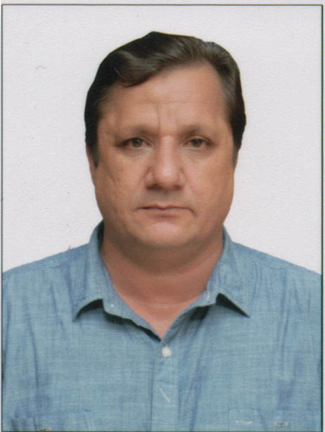
ETO/EE
NAME: MUHAMMAD IQBAL FATHER NAME: ABDUL NABI
DATE OF BIRTH: 13 MARCH 1971 NATIONALITY: PAKISTANI
ADDRESS: HOUSE NO 92 BLOCK – C– CANTT BAZAR MALIR CANTT KARACHI PAKISTAN
PHONE #: +92-333-2319554
Email: ask4iqbal@gmail.com
TYPE OF  DOCUMENTS | NUMBER OF DOCUMENTS | PLACE OF  ISSUE | DATE OF ISSUE | DATE OF EXPIRY
ELECTRICAL ENGINEER CERTIFICATE | 232/EE/19 | KAR PK | 18.4.2019 | N/A
COC PANAMA | 203058022 | DUBAI | 25.10.2021 | 22.09.2024
C O C ELECTRO TECHNICAL OFFICER | 145 | 03-09-2019 | KARACHI | 01.05.2029
SEAMAN SERVICE BOOK | 024898.EO | KAR PK | 07.05.2019 | 06.05.2029
COC | COE-E0176928 | SIGAPORE | 26.02.2021
PASSPORT | HB.1334653 | KA PK | 03.09.2020 | 02.09.2025
YELLOW FEVER | 706 | KARACHI PK | 22.07.2019 | LIFE TIME
DANGEROUS CARGO ENDORSEMENT | 1669/TE/13 | KAR PK | 02.05.2024 | 01.05.2029
US VISA | 20221089980001 | KA PK | 25.04.2022 | 19.04.2027
STCW-95 COURSES
COURSE  NAME | CERTIFICATE NUMBER | ISSUE DATE | ISSUING  AUTHORITY
ME-ENGINE FAMILIRIZATION/OPERATION/  TROUBLE SHOOTING | MEC/18-21/246/OL | 03.09.2021 | INTERNATIONAL MARITIME TRAINING CENTRE MUMBAI INDIA
FRAMO HYD CARGO PUMPING SYS | FRM-017/2021 | 10.02.2021 | Maritime Training Institute
ADV ELECTRONICS | AELS-059/2021 | 06.02.2021 | MTI Maritime Training Institute
BWTS | ALFA LAVAL & PANASIA | 15.02.2022 | ALFA LAVAL/PANASIA
P.S.S.R | PSSR-13841/2020 | 11.07.2020 | Maritime Training Institute
ADVANCE FIRE FIGHTING | .AFF-7989/2020 | 27.08.2020 | Maritime Training Institute
EFA | EFA-1171/2020 | 13.03.2020 | Maritime Training Institute
P.S.T | PST-13841/2020 | 09.07.2020 | Maritime Training Institute
P.S.C & R.B | PSCRB-5556/2023 | 27.01.2023 | Maritime Training Institute
HIGH VOLTAGE SAFETY | HVT.658/2019 | 17.05.2019 | S T C
RECORD OF SEA SERVICE
NAME OF SHIP | RANK | TYPE OF SHIP | COMPANY NAME | DWT | ENGINE NAME |  | ENG  BHP | from | to
M T  POINEER SAM | ETO | TKR | WORLDWIDE MARINE | 69628 |  | MAN B&W | 13900 | 02.11.2023 | 08.04.2024
M T  TURMOIL | ETO | TKR | Wilhelmsen T/P | 50258 |  | Man B&W | 17284 | 17.02.2023 | 07.05.2023
M T  LUCTOR | ETO | TKR | Wilhelmsen T/P | 50258 |  | Man B&W | 12708 | 21.08.2022 | 06.01.2023
M T  TURMOIL | ETO | TKR | Wilhelmsen T/P | 50258 |  | Man B&W | 17284 | 17.09.2021 | 01.04.2022
M T ENDEAVOUR | ETO |  | Wilhelmsen T/P | 49999 |  | ME B&W | 7375.62 | 27.02.2021 | 10.08.2021
M T  BARWASA 1 | ETO | TKR | SHIP & SHORE | 8744 |  | SULZER | 4825.74 | 01.12.2019 | 17.06.2020
M T  BARWASA | ETO | TKR | SHIP&SHORE | 3627 |  | SULZER | 2955 | 13.09.2019 | 30.11.2019
M T  SEA PEARL | ETO | TKR | SHIP&SHORE | 35827 |  | SUILZER | 16000 | 02.08.2018 | 08.12.2018
M V KEA | ETO | BULK | SEA TRADER | 65000 |  | Man B&W | 16000 | 08.05 2017 | 05.11.2017
M V  SINARKUTAI | EO | BULK | V SHIP | 33348 |  | MAN STX | 11610 | 10.11.2016 | 10.03.2017
M V  AMIRECA | EO | CONT | MSC | 45000 |  | Man B&W | 14900 | 26.04.2016 | 12.08.2016
M V  OTTO | EO | CTR | DORIS/NAEES | 30000 |  | Man B&W | 14900 | 28.02.2016 | 28.03.2016
M V  KARIN | EO | CTR | DORIS/ NAEES | 30000 |  | Man B&W | 16980 | 05.08.2015 | 17.12.2015
MV  KARIN | EO | CTR | DORIS/NAEES | 30000 |  | Man B&W | 16980 | 21.11.2014 | 13.04.2015
M V CORREGIDORA | E O | BULK | DORIS MARITIME | 38000 |  | D-LAVAL | 15600 | 13.12.2013 | 10.09.2014
M T  SEA DRAGON | EO | TANKER | MERAMAR | 7000 |  | MITBISHI | 2850 | 25.04.2013 | 22.08.2013
FATEH 900 | ELECTN | DLB | AL-MATAF | NA |  | NA | NA | 04.08.2012 | 11.02.2013
M V  NASEER | EO | RORO | AL-THURAYA | 5900 |  | NOHAB POLAR | 3000 | 26.11.2010 | 10.05.2011

