UPDATED :July, 2024  POSITION APPLIED TO : |  |  | CURRICULUM VITAE  Master |  |  |  |  |  |  |  |  |  |  |  |  |  |  |  | 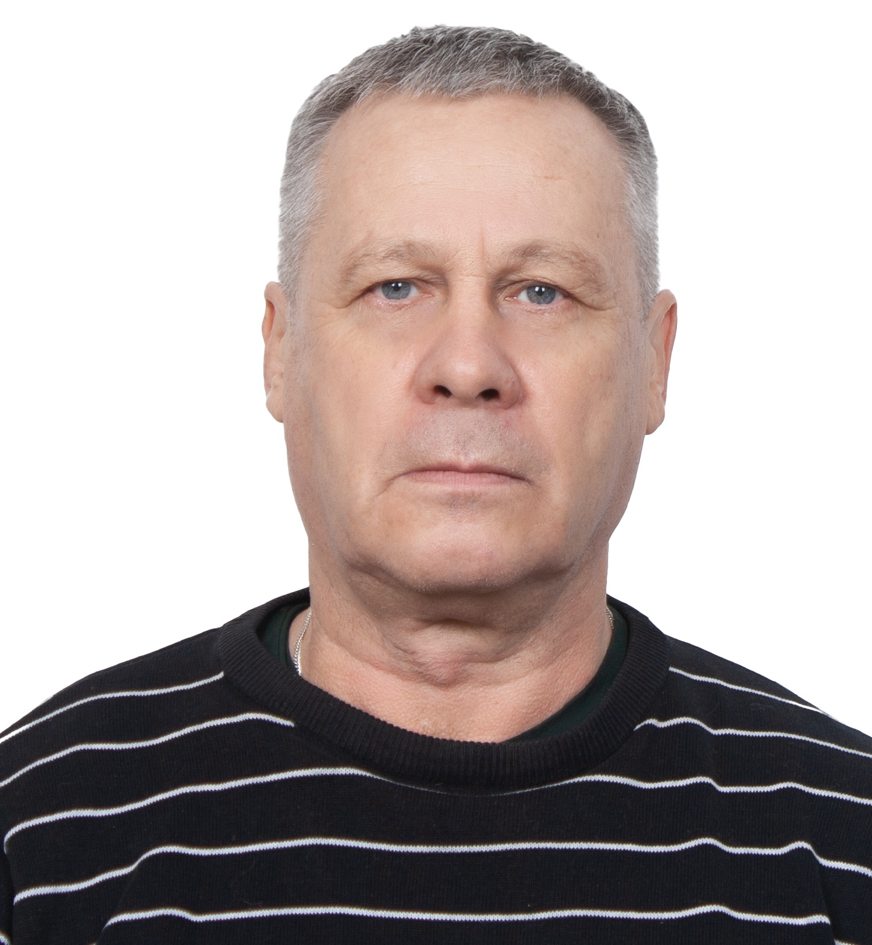

SEAFARER'S APPLICATION FORM - Page 1 of 4 - PERSONAL DATA
Rank |  |  | CAPTAIN
Personal information
Family Name |  |  | SHCHEGOLEV |  |  |  |  | First Name(s) |  |  |  |  |  |  |  | IGOR
 |  |  |  |  |  |  |  | Father's Name |  |  |  |  |  |  |  | IVANOVICH
Birth Date |  |  | 11.05.1959 |  |  |  |  | Birth Place |  |  |  |  |  |  |  | Kamchatskiy reg.
Nationality |  |  | RUSSIAN |  |  |  |  | Religion |  |  |  |  |  |  |  | ORTHODOX
Marital Status |  |  | MARRIED |  |  |  |  | Number of Children |  |  |  |  |  |  |  | ONE
Eye's Color |  |  | GRAY |  |  |  |  | Hair's Color |  |  |  |  |  |  |  | BROWN
Height |  |  | 171 cm |  |  |  |  | Weight |  |  |  |  |  |  |  | 83 kg
Safety Shoes |  |  | 42 |  |  |  |  | Boilersuit |  |  |  |  |  |  |  | 52
Nearest Airport(s) (International / Domestic) |  |  | MOSCOW - DOMODEDOVO
ADDRESS (include telephone country & area codes, advise also secondary or contact addresses if any)
Nr., Street, Apt. | h.1A, Goncharnaya str.
City | Kolomna city, Moscow reg. |  |  |  |  | Postal Code (Index) |  |  |  |  |  |  | 1404150
Country | RUSSIA |  |  |  |  | Home Phone |  |  |  |  |  |  | +7 496 6192612
Mobile Phone | +7 915 2778925 |  |  |  |  | Contact Phone |  |  |  |  |  |  | +7 915 2778925
Fax |  |  |  |  |  | E-Mail Address |  |  |  |  |  |  | schglv@rambler.ru
NEXT OF KIN INFORMATION (person-OLDER than 18 years-to contact in case of emergency & insurance beneficiary)
Surname, Name | SHCHEGOLEVA OLGA |  |  |  |  | First Name(s) |  |  |  |  |  |  | OLGA
Citizenship | RUSSIA |  |  |  |  | Relationship |  |  |  |  |  |  | WIFE
Nr., Street, Apt. | house1A, Goncharnaya str.
City | Kolomna city, Moscow reg. |  |  |  |  | Postal Code (Index) |  |  |  |  |  |  | 1404150
Country | RUSSIA |  |  |  |  | Home Phone |  |  |  |  |  |  | +7 496 6192612
Mobile Phone | +7 915 3340537 |  |  |  |  | Contact Phone |  |  |  |  |  |  | +7 915 3340537
Fax |  |  |  |  |  | E-Mail Address |  |  |  |  |  |  | olgator58@mail.ru

REMARKS:
Requested Rank: |  | Captain |  |  |  | Availability Date (Month,Year): |  |  |  |  |  |  |  |  | ASAP
Pref. Vessel Type: |  | PSV OSV AHTS |  |  |  | Salary on your last ship: |  |  |  |  |  |  |  |  | 320 $ per day
ENGLISH Language Abilities: |  |  | to Speak | GOOD |  |  | to Translate Text: |  |  |  |  | GOOD |  |  | to Write: |  |  | GOOD
SETS Test: |  |  | Marlins | Passed on: |  |  | 94 |  |  | Other Languages: |  |  |  | NO
Name of Marine (Professional) School /College/Academy: PERIOD (From - To): |  |  | 1) ASTRAKHAN COLLEGE  2) ACADEMY OF WATER TRANSPORT
 |  |  | 1) From: 1974  2) From: 1978 |  |  |  |  |  |  |  | To: 1978  To: 1992
Foreign Crew Experience (specify nationalities) |  |  | Germany, Honduras  Croatia, Polish |  | Indian |  |  |  | Filipino |  |  |  | Angolian
Other Skills  (specify details) |  |  | Towing |  | Anchor-Handling (with Pipe Layer) |  |  |  | ASD drive

I hereby affirm that all the information provided by me in this application form is the true and correct to the best of my knowledge

SEAFARER'S APPLICATION FORM - Page 2 of 4 - LIST OF DOCUMENTS

Family  Name | SHCHEGOLEV | First  Name |  | IGOR |  |  | Rank |  | MASTER
A. TRAVEL DOCUMENTS, SEAMAN'S BOOKS AND MEDICAL CERTIFICATES
Document Name (Description) |  |  | Document No. |  | Country | Issue Place |  | Issue Date |  | Exp. Date
National Seaman’s Book |  |  | MK 0339407 |  | RUSSIA | Astrakhan |  | 06.12.2011
Travel Passport (it’s mandatory to possess it) |  |  | 76 9958182 |  | RUSSIA | Moscow |  | 10.01.2023 |  | 10.01.2033
Seafarer’s Identity document |  |  | RUS 0651827 |  | RUSSIA | Astrakhan |  | 08.12.2023 |  | 07.12.2028
Medical Examination Report ( if valid) |  |  |  |  | OAE | Dubai |  | 09.07.2023 |  | 22.02.2025
Drug & Alcohol Test (optional) |  |  |  |  | OAE | Dubai |  | 09.07.2023 |  | 22.02.2025
Vaccination against Yellow Fever  Vaccination against COVID19 :  1  2  3 |  |  |  |  | RUSSIA  RUSSIA  RUSSIA  GREECE | Moscow  Moscow  Moscow  Crete |  | 17.02.2010  19.07.2021  09.08.2021  11.12.2021 |  | 17.02.2020

B. CERTIFICATES OF COMPETENCY (LICENSES) & ENDORSEMENTS, FLAG STATE CERTIFICATES
License Name (Description) |  |  | License Grade |  | License No. | Issue Place |  | Issue Date |  | Exp.Date
National License (officers) OR  Rating's Watchkeeping Certificate |  |  | MASTER |  | ASF207993184 | Astrakhan |  | 15.12.2023 |  | 07.10. 2025
Functions and Level
Limitations |  |  | Unlimited
License: Vanuatu |  |  | MASTER
National GMDSS Operator Certificate |  |  | General Operator |  | ASF207967405 | Astrakhan |  | 01.12.2023 |  | 07.10.2025
C. COURSE CERTIFICATES
Document Name (Description) |  |  | Document Number |  | Country | Issue Place |  | Issue Date |  | Exp. Date
Radar Observ. & Plotting |  |  | OBT 2057008 |  | RUSSIA | Astrakhan |  | 30.11.2023 |  | 30.11.2028
A.R.P.A. |  |  | OBT 2055689 |  | RUSSIA | Astrakhan |  | 02.12.2023 |  | 02.12.2028
Basic Safety Training (4 components) |  |  | AB 1600361 |  | RUSSIA | Astrakhan |  | 07.10.2020 |  | 07.10.2025
Proficiency in Survival Craft / Rescue Boat |  |  | AB 1600853 |  | RUSSIA | Astrakhan |  | 08.10.2020 |  | 08.10.2025
Advanced Fire Fighting |  |  | AB 1601348 |  | RUSSIA | Astrakhan |  | 09.10.2020 |  | 09.10.2025
Medical First Aid |  |  | AB 1601846 |  | RUSSIA | Astrakhan |  | 14.10.2020 |  | 14.10.2025
Medical Care |  |  | 050/2020 |  | RUSSIA | Astrakhan |  | 19.10.2020 |  | 19.10.2025
Ship Security Officer |  |  | A 20224568 |  | RUSSIA | Astrakhan |  | 03.11.2023 |  | 03.11.2028
Bridge Team Management |  |  | BTM0366/00 |  | RUSSIA | St. Petersburg |  | 22.09.2000
H2S Safety Course |  |  | 184187 |  | eTraining | www.etraintoday.com |  | 21.01.2022

SHCHEGOLEV IGOR Saudi visa valid till 2027

SEA SERVICE

Vessel Name | IMO # | Type/Service | GT-ITC | KW | DP Class | Company | Area of Operation | Position/Rank | Date On | Date Off | Crewing Agency, , Person in contact
Pacific Phoenix |  | AHTS | 1329 | 3785 | 1 | TIDE WATER | Saudi Arabia | Maste | 10-jul-23 | 17-sep-23 | Fratelli Cosulich S.p.A. - Crew Dept.  Office +390406797192  gbabich@cosulich.it
Lacoste Tide | 9586954 | AHTS | 1674 | 3840 | 1 | TIDE WATER | Saudi Arabia | Master | 05-mar-23 | 28-may-23
Bergeron Tide | 9555840 | AHTS | 1678 | 3840 | 1 | TIDE WATER | Saudi Arabia | Master | 26-sep-22 | 14-dec-22
Bergeron Tide | 9555840 | AHTS | 1678 | 3840 | 1 | TIDE WATER | Saudi Arabia | Master | 13-feb-22 | 15-gun-22
Tablate Tide | 9615810 | AHTS | 1678 | 3840 | 1 | TIDE WATER | Saudi Arabia | Master | 06-mar-21 | 05-lug-21
Lacoste Tide | 9586954 | AHTS | 1674 | 3840 | 1 | TIDE WATER | Saudi Arabia | Master | 19-Jan-21 | 24-Feb-21
Chayari Tide | 9589061 | AHTS | 1476 | 3840 |  | TIDE WATER | Saudi Arabia | Master | 22-Aug-20 | 15-Sep-20
Kirkconnell Tide | 9582180 | AHTS | 1678 | 3840 | 1 | TIDE WATER | Saudi Arabia | Master | 4-Mar-20 | 22-Aug-20
Kirkconnell Tide | 9582180 | AHTS | 1678 | 3840 | 1 | TIDE WATER | Saudi Arabia | Master | 27-Jun-19 | 13-Nov-19
Hanks Tide | 9551856 | AHTS | 1529 | 3676 | 1 | TIDE WATER | Saudi Arabia | Master | 9-Apr-19 | 15-May-19
Courtney Tide | 9582192 | AHTS | 1678 | 3840 | 1 | TIDE WATER | Saudi Arabia | Master | 15-Sep-18 | 26-Dec-18
Courtney Tide | 9582192 | AHTS | 1678 | 3840 | 1 | TIDE WATER | Saudi Arabia | Master | 29-Mar-18 | 2-Jul-18
Bergeron Tide | 9555840 | AHTS | 1678 | 3840 | 1 | TIDE WATER | Saudi Arabia | Master | 18-Aug-17 | 17-Nov-17
Bergeron Tide | 9555840 | AHTS | 1678 | 3840 | 1 | TIDE WATER | Saudi Arabia | Master | 16-Feb-17 | 16-May-17
Bergeron Tide | 9555840 | AHTS | 1678 | 3840 | 1 | TIDE WATER | Saudi Arabia | Master | 19-Aug-16 | 4-Dec-16
Dela Llana Tide | 9597903 | AHTS | 1678 | 3840 | 1 | TIDE WATER | Saudi Arabia | Master | 7-Mar-16 | 10-May-16
Hanks Tide | 9551856 | AHTS | 1529 | 3676 | 1 | TIDE WATER | Saudi Arabia | Master | 22-Sep-15 | 2-Dec-15
Dulaca Tide | 9578476 | AHTS | 1678 | 3840 | 1 | TIDE WATER | Saudi Arabia | Master | 22-Aug-15 | 22-Sep-15
Dela Llana Tide | 9597903 | AHTS | 1678 | 3840 | 1 | TIDE WATER | Saudi Arabia | Master | 5 -Feb-15 | 17-May-15
Lacoste Tide | 9586954 | AHTS, PSV | 1674 | 3840 | 1 | TIDE WATER | Saudi Arabia | Master | 21-Aug-14 | 17-Nov-14
Lacoste Tide | 9586954 | AHTS, PSV | 1674 | 3840 | 1 | TIDE WATER | Saudi Arabia | Master | 29-Apr-14 | 26-Jun-14
Lacoste Tide | 9586954 | AHTS, PSV | 1674 | 3840 | 1 | TIDE WATER | Saudi Arabia | Master | 7-Dec-13 | 12-Feb-14
Kirkconnell Tide | 9582180 | AHTS, PSV | 1678 | 3840 | 1 | TIDE WATER | Saudi Arabia | Master | 8-Jun-13 | 1-Sep-13
Lacoste Tide | 9586954 | AHTS | 1674 | 3840 | 1 | TIDE WATER | Saudi Arabia | Master | 17-Nov-12 | 22-Mar-13
Lacoste Tide | 9586954 | AHTS | 1674 | 3840 | 1 | TIDE WATER | Saudi Arabia | Master | 17-May-12 | 4-Sep-12
Lacoste Tide | 9586954 | AHTS | 1674 | 3840 | 1 | TIDE WATER | Saudi Arabia | Master | 24-Nov-11 | 2-Mar-12
Dela Llana Tide | 9597903 | AHTS | 1678 | 3840 | 1 | TIDE WATER | Saudi Arabia | Master | 26-Jun-11 | 11-Oct-11

Date: July, 2024 | 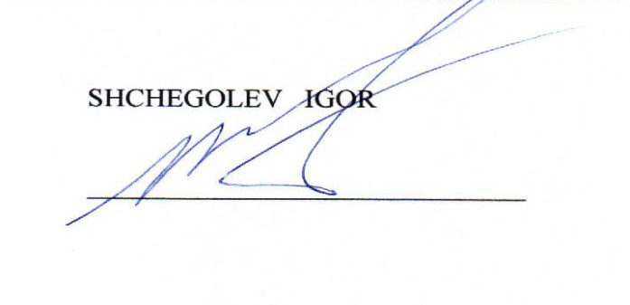  Signature:
I hereby affirm the information provided by me in this application
is true and correct to the best my knowledge and belief.

