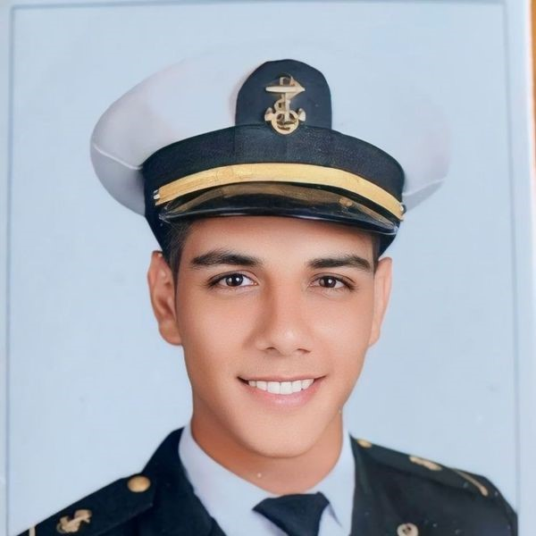
Mohamed
SAWKY _{Deck CADET}

Seeking a Marine Deck Cadet position where I can apply my theoretical knowledge and practical skills obtained through my academic career. Eager to learn and contribute to a dynamic maritime environment while working towards becoming a competent Master
PERSONAL INFORMATION  Address  Port Saed, Egypt  Date of Birth  30/11/2003  Telephone Number  +201270873952  Seaman’s Book number  S000037699  Mail  benshawky3011@gmail.com  ACTIVITIES  Karate AAST.  Table Tennis  Reading  . SKILLS  Leadership  Fast learning  Team Working  Time Management  Managerial Abilities  Communication Skills  LANGUAGE  Arabic Native  English Fluent | EDUCATION  Arab Academy for Science and Technology and Maritime transport.  Finished nautical basic studies, Alexandria / Egypt.
EXPERIENCE
Academic program • TRANSAS Simulator
Voyage planning and Weather Routing
Seamanship Principles
Terrestrial Navigation
Navigational Aids
Radar and ARPA
Watch Keeping
Ship Handling

ACHIEVEMENTS
Achieved a certificate of appreciation for participation in sport activities
Achieved a certificate of appreciation for participation in social activities
CERTIFICATES
- Communications
- Basic Oil and Chemical Tanker Cargo Operation
- Elementary First Aid A-VI/ 1-3
- Designated Security Awareness
- Fire Prevention and Fire Fighting
- Personal safety and social responsibilities
- International Medical Certificate for Seafarers
- Personal Surviving Techniques & Search and Rescue

