CURICULUM VITAE 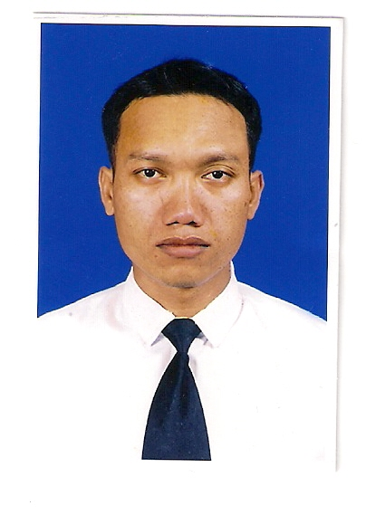

Dear Sir,
I intent to apply a job at your company for the position as deck officer and
I am ready to be planned on board with route of voyage determined by the company.
Data are as follow :

Name | : I.WAYAN SUHARTAKA
Rank | : Deck Officer Class 2
Date of Birth | : 13 SEPTEMBER 1978
Place of Birth | : KUPANG
Address | :Jl.Bumi I,block III RT04/RW02 Kelurahan Oesapa Selatan,Kelapa Lima-Kupang NTT  Indonesia
E-mail Address | : iansuta@yahoo.com
Contac Person (HP) | : +62-82225532397
Religion | : Hindu | Eyes | : Black | Hair | : Black | Civil Status | : merried
Height | : 176 cm | Waist | : 32 cm | Weight | : 75 kg | Shoes Size | : 42

Next Of Kin Emergency Contact
Name | : I Wayan Wawu Suprapta  : Mei Armiyana | Relation | : Father  : Wife
Address | :Jl.Bumi I Block III,Oesapa selatan kupang.Kelapa lima -Nusa tenggara timur Indonesia | Phone | :
 |  | Mobil Phone | : + 62-82147361057  : +62-81288054637

NATIONAL CERTIFICATES
License | Indonesia | Number | Place/Date of Issue | Expiry
Grade | Deck Officer class 2 | 6201001216N20317 | Jakarta,20-02-2017 | Permanent
Grade | ANT-2
Endorsement | Indonesia | 6201001216NB0321 | Jakarta,01-09-2021 | 01-09-2026
Passport | Indonesia | X2300018 | Kupang,,30-11-2023 | 30-11-2033
Seaman Book | Indonesia | G134403 | Kupang,27-11-2022 | 27-11-2026
GOC | Indonesia | 65870/SOU/T/II/2018 | 16-02-2023 | 16-02-2029

STCW 95 COURSES
Certificates and Qualification | Number | Expiry
Basic Safety Training | 6201001216010319 | 01-04-2029
Advance Fire Fighting | 6201001216060320 | 21-01-2026
Survival Craft And Rescue Boats | 6201001216040320 | 20-01-2026
Medical First Aid | 6201001216070315 | 05-11-2020
Medical Care | 6201001216080315 | 05-11-2020
Tanker Familiarization | 6201001216090310 | 05-07-2015
Oil Tanker Specialized Training Programme | 6201001216100308 | 23-04-2019
GMDSS/G.O.C | 6201001216G10319 | 01-09-2026
Ship Security Officer | 6201001216240316 | 24-11-2028
ISM-Code | 13.473/ISM/PIP.SMG/VI,/02 | Permanent
GOC | 6587SOU/T/II/2018 | 16-02-2029
RADAR Simulator | 6201001216030315 | 05-11-2020
ARPA Simulator | 6201001216020315 | 05-11-2020
TBOSIET
ECDIS | 6201001216280317 | 24-11-2028
IMDG CODE | 6201001216290323 | 30-11-2028
BRM | 6201001216230317 | 24-11-2028

SEA SERVICES

Vessel Name | Rank | GT/HP | Flag/Type | Area | Duration | Reason
SV.LIBRA 7 | 2nd Mate | 1123 | Supply | FG | 22.01.04-31.07.04 | Finish Contract
MV.AN HUI | 2nd Mate | 997 | Supply | FG | 21.02.05-21.03.06 | Finish Contract
MV.SETIA INDAH | 2nd Mate | 1365 | PSV | FG | 16.10.08-18.02.09 | Finish Contract
MV.SETIA INDAH | 2nd Mate | 1365 | PSV | FG | 14.05.09-22.08.09 | Finish Contract
MV.SETIA INDAH | 2nd Mate | ¹³⁶⁵ | PSV | FG | ^{04.02.10-24.05.10} | Finish Contract
MV.SETIA EMAS | 2nd Mate | ⁹⁶⁴ | AHTS | FG | ^{05.10.10-06.01.11} | Finish Contract
MV.SETIA INDAH | 2bd Mate | ¹³⁶⁵ | PSV | FG | ^{21.04.11-21.09.11} | Finish Contract
MV.SETIA INDAH | 2nd Mate | ¹³⁶⁵ | PSV | FG | ^{18.01.12-22.04.12} | Finish Contract
MV.SETIA INDAH | 2nd Mate | ¹³⁶⁵ | PSV | FG | ^{28.11.12-02.03.13} | Finish Contract
MV.SETIA INDAH | 2nd Mate | ¹³⁶⁵ | PSV | FG | ^{12.07.14-11.10.14} | Finish Contract
MV.SETIA INDAH | Chief Mate | ¹³⁶⁵ | PSV | FG | ^{07.01.15-21.04.2015} | Finish Contract
MV.SETIA INDAH | 2nd 8Mate | ¹³⁶⁵ | PSV | FG | ^{15.08.2015-20.01.2016} | Finish Contract
MV.SETIA INDAH | Chief Mate | ¹³⁶⁵ | PSV | FG | ^{05.03.2016-05.06.2016} | Finish Contract
MV.SETIA LESTARI | Chief Mate | ¹⁴⁷⁰ | AHTS | FG | ^{18.02.2017- 20.06.2017} | Finish Contract
DMS CHALLENGER | 2nd Mate | ¹³⁸⁷ | AHTS | FG | ^{09.07.2018 – 06.10.2018} | Finish Contract
DMS CHALLENGER | 2nd Mate | ¹³⁸⁷ | AHTS | FG | ^{13.12.2018 – 16.02.2019} | Finish Contract
DMS CHALLENGER | 2nd Mate | ¹³⁸⁷ | AHTS | FG | ^{24.04.2019 – 14.07.2019} | Finish Contract
DMS CHALLENGER | 2nd Mate | ¹³⁸⁷ | AHTS | FG | ^{20.09.2019 – 01.12.2019} | Finish Contract
DMS CHALLENGER | 2nd Mate | ¹³⁸⁷ | AHTS | FG | ^{07.02.2020 – 09.08.2020} | Finish Contract
MV JUZOR | 2nd Mate | ¹³⁸⁷ | AHTS | FG | ^{23.02.2021 – 08.08.2021} | Finish Contract
MV JUZOR | 2nd Mate | ¹³⁸⁷ | AHTS | FG | ^{15.03.2022 – 10.08.2022} | Finish Contract
MV.DMS CHALLENGEE | 2nd Mate | ¹³⁸⁷ | AHTS | FG | ^{10.05.2023 – 07.10.2023} | Finish Contract

^{Best Regards,}

^{I Wayan Suhartaka}

