First Name  SHERON | Middle Name (s)  CRISHANTHA FERNANDO | Last Name / Surname  COLAMBAGE

- Personal Data

APPLICATION
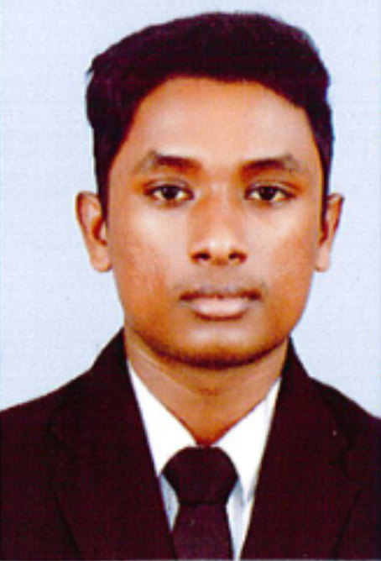
[PLEASE USE CAPITAL OR UPPERCASE LETTERS TO COMPLETE THIS FORM]

¹Select from: ●Single ●Married ●Divorced ●Common Law Partner ●Widowed ●Separated
Nationality (or current Citizenship )  SRI LANKAN | Country of Origin  SRI LANKA | Date of Birth:  31/12/2000 | Place / City of Birth  MARAVILA

Marital Status¹:  UNMARRIED | Gender : Male  Female | Religion:  CATHOLIC

Rank applied for:  TR.OS (DEACK HAND) | Willing to accept lower rank? Yes  No | Available From (date):  11.09.2024

Primary / Permanent Address:  NO 65,MADAGODA,NATHTHANDIYA,SRI LANKA |  | Alternative / Temporary Address: Until: / /
City:NATHTHANDIYA | Post Code:61190 | City: | Post Code:
State:NORTH WESTERN PROVINCE | Country : SRI LANKA | State: | Country:
Nearest Airport :KATUNAYAKE | Home Tel:+94788121770 | Phone:
Contact Method : Email sheroncrishantha431@gmail.com Mobile Phone +94781579361
Boiler suit size:M Shoe Size:7
Sweater size:M
:M
Specify size as S, M, L, XL, XXL for
Collar: 15.5 Chest:22 Waist: 21 Inside Leg: Cap:

- Personal ID / Documents / Visa

Type of Document / ID ¹ | Country of Issue | No. | Date of Issue  (DD / MM / YY) | Issued at (Place) | Valid Until  (DD / MM / YY)
Seaman’s Book (National) | SRI LANKA | C057876 | 20/06/2023 | MSS | 19/06/2028
Passport | SRI LANKA | N10385539 | 03/03/2023 | COLOMBO | 03/03/2033
SID | SRI LANKA | 367081G24 | 21.08.2024 | MSS | 21.08.2029
YELLOW FEWER | SRI LANKA | 464850 | 30.07.2024 | MINISTRY OF HEALTH COLOMBO | LIFE LONG VALIDITY
¹Select as applicable: ●Passport ●Seaman’s Book ●Seaman Passport ●Seafarers’ Identity Document ●Registration Book ●National ID Card ●PAG-IBIG Housing Insurance ●Health Insurance ●Overseas Emp Cert ●PHL Card ●Pension Fund ●Provident Trust ●Professional Organisation ●Driving Licence ●Visa
- Vaccination ●Yellow Fever

Nominee / Next of Kin & Family Details

Full Name of Nominee for compensation in case of fatality:  S.A.P.SENANAYAKA |  | Relationship¹  MOTHER | Gender : Male  Female | Nationality :SRI LANKAN
Address:65,MADAGODA,NATHTHANDIYA,SRI LANKA
City: NATHTHANDIYA | Post Code:61196 |  |  | Country:SRI LANKA
¹ Select From: ●Spouse ●Partner ●Child ●Parent ●Grand Parent ●Other Relative (Please Specify)

Reg VI / 1 – Basic Safety Training
Elementary First Aid | SRI LANKA | LATS-EFA-26897 | 10-MAY-2023 |  | PANADURA | LANKA ACADEMY
Fire Fighting & Fire  Prevention | SRI LANKA | LATS-FPFF-22199 | 10-MAY-2023 |  | PANADURA | LANKA ACADEMY
Personal Safety & Social Resp. | SRI LANKA | LATS-PSSR1-3570 | 10-MAY-2023 |  | PANADURA | LANKA ACADEMY
Personal Survival Techniques | SRI LANKA | LATS-PST-22082 | 10-MAY-2023 |  | PANADURA | LANKA ACADEMY

- Reg II / 1-4, III / 1-4 Officers Certificate of Competency & Ratings Watch-keeping Certificate (including flag state endorsements)
⁴ Certificate of competency | Country of Issue | No. | Date of Issue  (DD / MM / YY) | Issued at (Place) | Valid Until  (DD / MM / YY)
Watch Keeping
Endorsement (Oil-chem) | SRILANKA | MSS/TAN/OIL-CHE/FAM/011105 | 16.08.2024 | MSS | 13.08.2029
⁴Enter here actual description given in the Competency Certificate / Watchkeeping Certificate held by you

Reg V / 1 – Special Requirement for Tankers

Description | Level1:Incharge Level2: Asst. | Country of Issue | Number | Date of Issue | Place of Issue | Issuing Authority / Body
Endorsement – Oil
Endorsement – Chemical
Endorsement – Gas
Basic Training for Oil & Chemical Tanker Cargo Operations
Advance Training for Oil & Chemical Tanker Cargo Operations
Tanker Familiarisation (Oil) Para 1
Tanker Familiarisation (Chemical) Para 1
Tanker Familiarisation (Gas) Para 1
- Sea Experience:(Last 5 years; start the listing below with the most recent experience)

Company | Flag & Vessel Name | Type ⁽¹⁾ | GRT | DWT | Main Engine ⁽²⁾ | Rank | Date From  dd/mm/yy | Date To  dd/mm/yy

Use only the following abbreviations for vsl types:

TYPE OF VSL | ABRVTN | TYPE OF VSL | ABRVTN | TYPE OF VSL | ABRVTN | TYPE OF VSL | ABRVTN
GENERAL CARGO | GC | CHEMICAL TANKER | CT | OIL & BULK | OBO | ULTRA LARGE CRUDE CARRIER | ULCC
MULTI PURPOSE | MP | PRODUCT TANKER | PT | ANCHOR HANDLING | AHTS | STORAGE TANKER | ST
CONTAINER | CN | OIL TANKER | OT | DYNAMIC POSITION | DP | FIXED STORAGE | FSO
BULK CARRIER | BC | VERY LARGE CRUDE CARRIER | VLCC | SURVEY VESSEL | SV | BUNKER BARGE | BB
SUPPLY BOAT | SB | SELF PROPELLED BARGE | SPB | TUG | TG | CREW BOAT | CB
TUG & BARGE | TB | HARBOUR TUG | HT | PASSENGER VESSEL | PV | CRUISE VESSEL | CV

Medical History:

- All previous illnesses other than minor afflictions should be stated below or updated. If not previously disclosed, the Company is entitled to refuse any reimbursement of medical costs, claim for treatment or for any other insured benefits.
Blood Type: O+
  - Have you ever signed off a ship due to medical reasons? Yes No
If yes, please provide following details (If space is insufficient, attach additional sheets) :

Name of vessel | Date of occurrence | Place of occurrence
Brief description of illness/injury/accident
  - Have you undergone any operation in the past? Yes No
If yes, please provide following details:

Details of operation | Date | Period of disability | Present condition

  - For what illnesses or accidents have you consulted a doctor during the last 12 months?

Details of illness / accident | Date | Therapy/Treatment
NIL
  - Please give details of any health or disability problem

Details:
NIL
- Bank/Pension Scheme Details:
Bank Name: BANK OF CEYLON | M.N.O.P.F.
Address : DUMMALASURIYA BRANCH | Membership No.:
 | National Ins.No.:
Account Name: C.S.C.FERNANDO | A.V.C.:
Account No.: 5406662
Sort Code: 580

- Give details below of two recent employers who we may contact for references:
 | Reference 1 | Reference 2
Name of Company
Name of person to contact
Address
Country
Telephone /mail
I hereby declare that the above, including Medical History, is true.I further consent to the holding and processing by you and any of your direct or indirect parent or subsidiary or associated or affiliated companies of WWSMSand your principals of personal data about me (including where appropriate data concerning racial or ethnic origin, religious beliefs, membership of a trade union, physical or mental health or condition, commission or alleged commission of an offence and the proceedings and the outcome of any proceedings relating thereto) for all purposes related to my application for employment on board vessels managed by WWSMS or vessels owned or operated by third parties for whom WWSMSShips is engaged to provide crew. I understand that this data will be stored in your databases in relation to my actual or potential employment by or through WWSMS Ships. Further, I confirm that the above may involve the transfer of my personal data within WWSMS Ships or to third parties worldwide.

Place : NATHTHANDIYA Date :11.09.2024 Signature : C.S.C.FERNANDO

