RESUME
POST APPLIED FOR : CHEEF. COOK
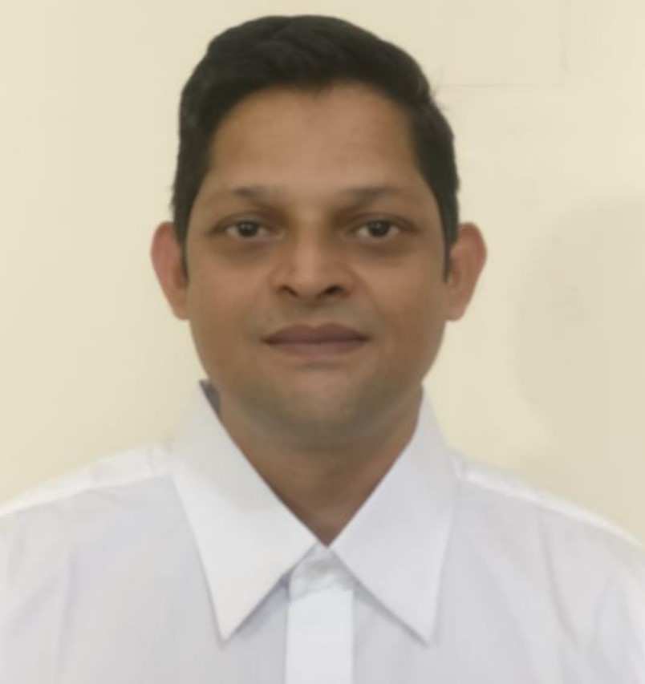
NAME : RAMESH SANWAL
FATHER’S NAME : NARAYAN DATT SANWAL
GENDER/MARITAL STATUS : MALE/MARRIED
DATE OF BIRTH : 15/07/85
NATIONALITY/RELIGION : INDIAN
LANGUARGE KNOWN : HINDI, ENGLISH, MARATHI,KUMAONI ।
CONTACT NO. :6395069220/ +971545160904
QUALIFICATION : 10thPASS
EMIL ID sanwalramesh89@gmail.com

PRESENT ADDRESS: | PERMANENT ADDRESS
SHIVALIK VIHAR BISHTDHARA BITHORIA NO 1 HALDWANI, NAINITAL PIN. 263139, UTTARKHAND, INDIA | SHIVALIK VIHAR BISHTDHARA BITHORIA NO 1 HALDWANI, NAINITAL PIN. 263139, UTTARKHAND, INDIA

DOCUMENT DETAILS:
DOCUMENT | NUMBER | DATE OFISSUE | DATE OF EXP. | PALCE OF ISSUE
PASSPORT | Z5407605 | 11/11/2019 | 10/11/2029 | DEHRADUN
CDC | MUM 502678 | 23/03/2023 | 22/03/2033 | MUMBAI
Sid | M338488220 | 25/07/2023 | 24/07/2033 | MUMBAI
YELLOW FEVER
Indos | 00ZL1047
COVID,19 | Z5407605 | 25/01/2021 | 15/02/2021 | 25/10/2021

COURSES DETAILS:
COURSE | CERTIFICATE NO | DATE OF ISSUE | DARE OF EXP. | PLACE OF ISSUE
EFA | 10501666212300814 | 17/02/2023 | N.A | DEHRADUN
PST | 10501666212300814 | 17/02/2023 | N.A | DEHRADUN
FPFF | 10501666212300814 | 17/02/2023 | N.A | DEHRADUN
PSSR | 10501666212300814 | 17/02/2023 | N.A | DEHRADUN
STSDSD | 10501661012300414 | 17/02/2023 | N.A | DEHRADUN
OPITO | 52515858090323504820 | 09/03/2023 | 15/02/2027 | ABU.DHABI

COMPANY | VESSEL | TYPE |  | RANK | SIGN ON | SIGN OFF
GREAT OFFSHORE | GOAL OFFSHORE | BARGE |  | COOK | 16/06/14 | 16/10/2015
ONGC | SAGAR KIRAN RIG | JACK UP RIG |  | COOK | 05/12/2016 | 27/05/2018
GREAT OFFSHORE | SCKANIL 1 | BARGE |  | COOK | 05/07/2018 | 01/08/2019
SEA FOX | SEA FOX TRIDENT 1 | JACK UP RIG |  | CHIEF COOK | 15/12/2019 | 08/03/2021
ADNOG | SEP JOPETWIL 300 | BARGE |  | CHIEF COOK | 26/09/2022 | 22/03/2023
ADNOG | SEP JOPETWIL 300 | BARGE |  | CHIEF | 26/05/2023 | 28/08/2023
ONGC | RKHS | PLATEFORM SHP |  | COOK | 12/5/2009 | 12/10/2009
ABAN6 | KELIVEN SODEXO | RIG |  | COOK | SEP/2011 | 2012
DD2 | KELIVEN SODEXO | RIG |  | COOK | 2012 | 2013
ABAN5 | KELIVEN SODEXO | RIG |  | CHEF COOK | 17/02/2015 | 06/11/2015

PLACE:
DATE :

RAMESH SANWAL

