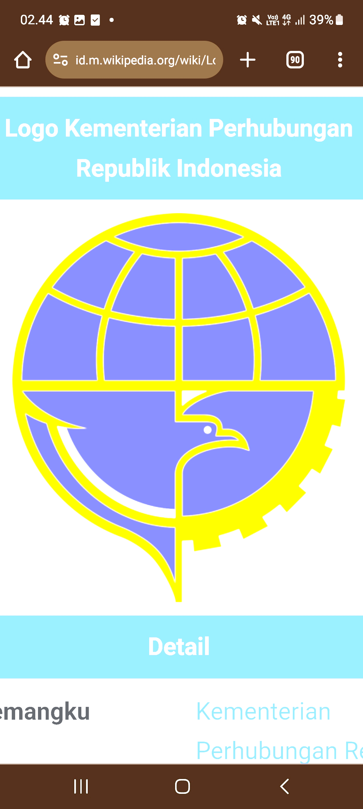

Full Name : Muhamad Raffi Pratama
Rank : Engineer
Date of Birth : July 16st , 1995
Place of Birth : DKI Jakarta
Address : Lontar Luar NO 40 RT.05 RW .04 Koja ,North Jakarta DKI Jakarta 14260
Contact Number : 0852 1575 4299
E-mail : raffipratamaa9517@gmail.com ID Number : 3172031607951002
Nationality : Indonesia Religion : Moslem Civil Status : Married
Eyes : Brown Hair : Black Coverall : M
Weight : 60 ^{kg} Height : 165 ^{cm} Shoe Size : 40 ^{cm}
Next of Kind Emergency | Name | Address | Relation : Wife
Next of Kind Emergency | Mega Tamara Masias | Lontar Luar NO 40 RT.05 RW .04 Koja,  North Jakarta DKI Jakarta 14260 | phone : 0895 6129 63086
⌂
Nationality Certificate | Grade | Number | place, Date of Issued
Licence | Engine Officer Management Class III | 6211809715T30122 | Jakarta, 04 Feb 2022
Licence | Endorsment Certificate | 6211809715T30122 | Jakarta, 04 Feb 2022
⌂
 | Number | Place, Date of Issued | Date of Expiry
Passport | F 178019 | Jakarta, Aug 05th 2019 | Aug 05th 2024
Seaman Book | C 4441956 | Jakarta, Oct 02nd 2018 | Oct 02nd 2025
Passport K3LL PHE OSES | 92002075 | Jakarta, Feb 08th 2021 | Aug 08th 2021
Passport K3LL PHE ONWJ | 117067 | Jakarta, Dec 16th 2020 | Jun 16th 2021

⌂ SHORT COURSE TRAINING CERTIVICATE
 | Number | Date of Issued | Place of Issued
Basic Safety Training | 6211809715010122 | March 2022 | STIP Jakarta
Proficiency Survival Craft and Rescue Boats | 6211809715041822 | May 2022 | Sinar Poseidon
Advance Fire Fighting | 6211809715010118 | Oct 2018 | STIP Jakarta
Medical First Aid | 6211809715070118 | Life Time | STIP Jakarta
Basic Training for Oil and Chemical Tanker | 6211809715390119 | July 2019 | STIP Jakarta
Medical Care | 6211809715080222 | Life Time | BP3IP Jakarta
Ship Security Officer | 6211809715240222 | Life Time | BP3IP Jakarta
Engine Room Resource Managment | 6211809715270222 | Life Time | BP3IP Jakarta

⌂ SEA SERVICE RECORD IN SEAMAN BOOK
Vessel name | Engine Type | GT / HP | Rank | Sign On | Sign Off | Company
AHTS PETEKA 5401 | YANMAR | 1371 / 2 X 2700 | Cadet | 20 Jan 2020 | 16 Jul 2020 | Pertamina Trans Koninental
AHTS PETEKA 5402 | YANMAR | 1371 / 2 X 2700 | Cadet | 17 Jul 2020 | 16 Jan 2021 | Pertamina Trans Koninental
AHTS PETEKA 5401 | YANMAR | 1371 / 2 X 2700 | Cadet | 07 Jan 2021 | 08 Mar 2021 | Pertamina Trans Koninental
KOLAKA I | MITSUBISHI | 267 / 2 X 1000 | 3rd Eng | 13 Nov 2022 | 24 Jul 2023 | BSML
AMPENAN I | MITSUBISHI | 267 / 2 X 1000 | 3rd Eng | 14 Dec 2023 | 15 Jun 2024 | BSML
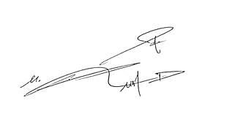
By

Muhamad Raffi Pratama

