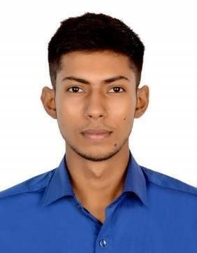
SHAIKH MOHD AZEEM ISHA
SS-1/386, Sector-D1, LDA Colony, Kanpur Road, Lucknow, Uttar Pradesh-226012 Email:mohdazeemshaikh3378@gmail.com
Contact No.: +91 8355079867/ 8948851954

Positive attitude towards career life in professional approach to get the best result in the interest of organization ability to meet all sort of challenges during the course of responsibility.

DOCUMENT DETAILS

Particulars | Documents Number | Date of Issue | Date of Expiry | Place of Issue
Passport | S1322447 | 19/06/2018 | 18/06/2028 | LUCKNOW
CDC | MUM386428 | 28/06/2019 | 27/06/2029 | MUMBAI
INDos No. | 18NL1883 | 07/08/2018 | LIFTIME | MUMBAI
Yellow Fever | 088 | 29/07/2019 | LIFETIME | LUCKNOW
SID | M31138342 | 22/10/2019 | LIFETIME | MUMBAI
Panama  Watchkeeping | C-MACC/GIRIK-WDR-2020-00587 | 28/11/2020 | 28/11/2025 | MAHARASTRA

COURSES DETAILS

COURSES | Certificate No. | Date of Issue | Place of Issue
DNS | 20805411218DNS/11/201856 | 31-07-2019 | YAK EDUCATION TRUST, MUMBAI
PSSR | 2080543071900252 | 19-01-2019 | YAK EDUCATION TRUST,MUMBAI
RPST | 1010036112230613 | 08-08-2023 | CMET, LUCKNOW
RFPFF | 1010036122230613 | 07-08-2023 | CMET, LUCKNOW
EFA | 2080543071900252 | 19-01-2019 | YAK EDUCATION TRUST, MUMBAI
STSDSD | 20805414819104 | 05-01-2019 | YAK EDUCATION TRUST, MUMBAI

BTOCTCO | 203016076193520 | 16/09/2019 | YAK EDUCATION TRUST, MUMBAI
OIL &  CHEMICAL | COPDGSOAC191778 | 08/10/2019 | MMD MUMBAI

SEA SERVICE DETAILS

Ran k | Vessel Name/  Flag | Vess el  Type | Dead  weig ht | GRT | NR T | Sign-On | Sign- Off | Company Name
Deck  Cadet | MV Trang An 06/  Mongolia | Gener al Cargo | 7547 | 6448 | 3114 | 30/11/2020 | 02/07/2021 | Indocean Maritime  P VT. LTD.
Deck Cadet | Lucy  Borchard /  Antigua & Barbuda | Container | 8238 | 6701 | 3557 | 15/12/2023 | 24/05/2024 | Confidence  Shipping  PVT. LTD.

PERSONAL SKILLS
- Good Communication.
- Hard Work and Dedication.
- Leadership and Team management.

PERSONAL DOSSIER

Name : Mr. Mohd Isha Shaikh
DOB : 23rd October 1998
Marital Status : Unmarried
Languages : English, Hindi, Marathi.
Nationality : Indian
Gender : Male

I here by finish all relevant information for your kind consideration and is true and correct.
Thanking You.
Shaikh Mohd Azeem Isha Date:

