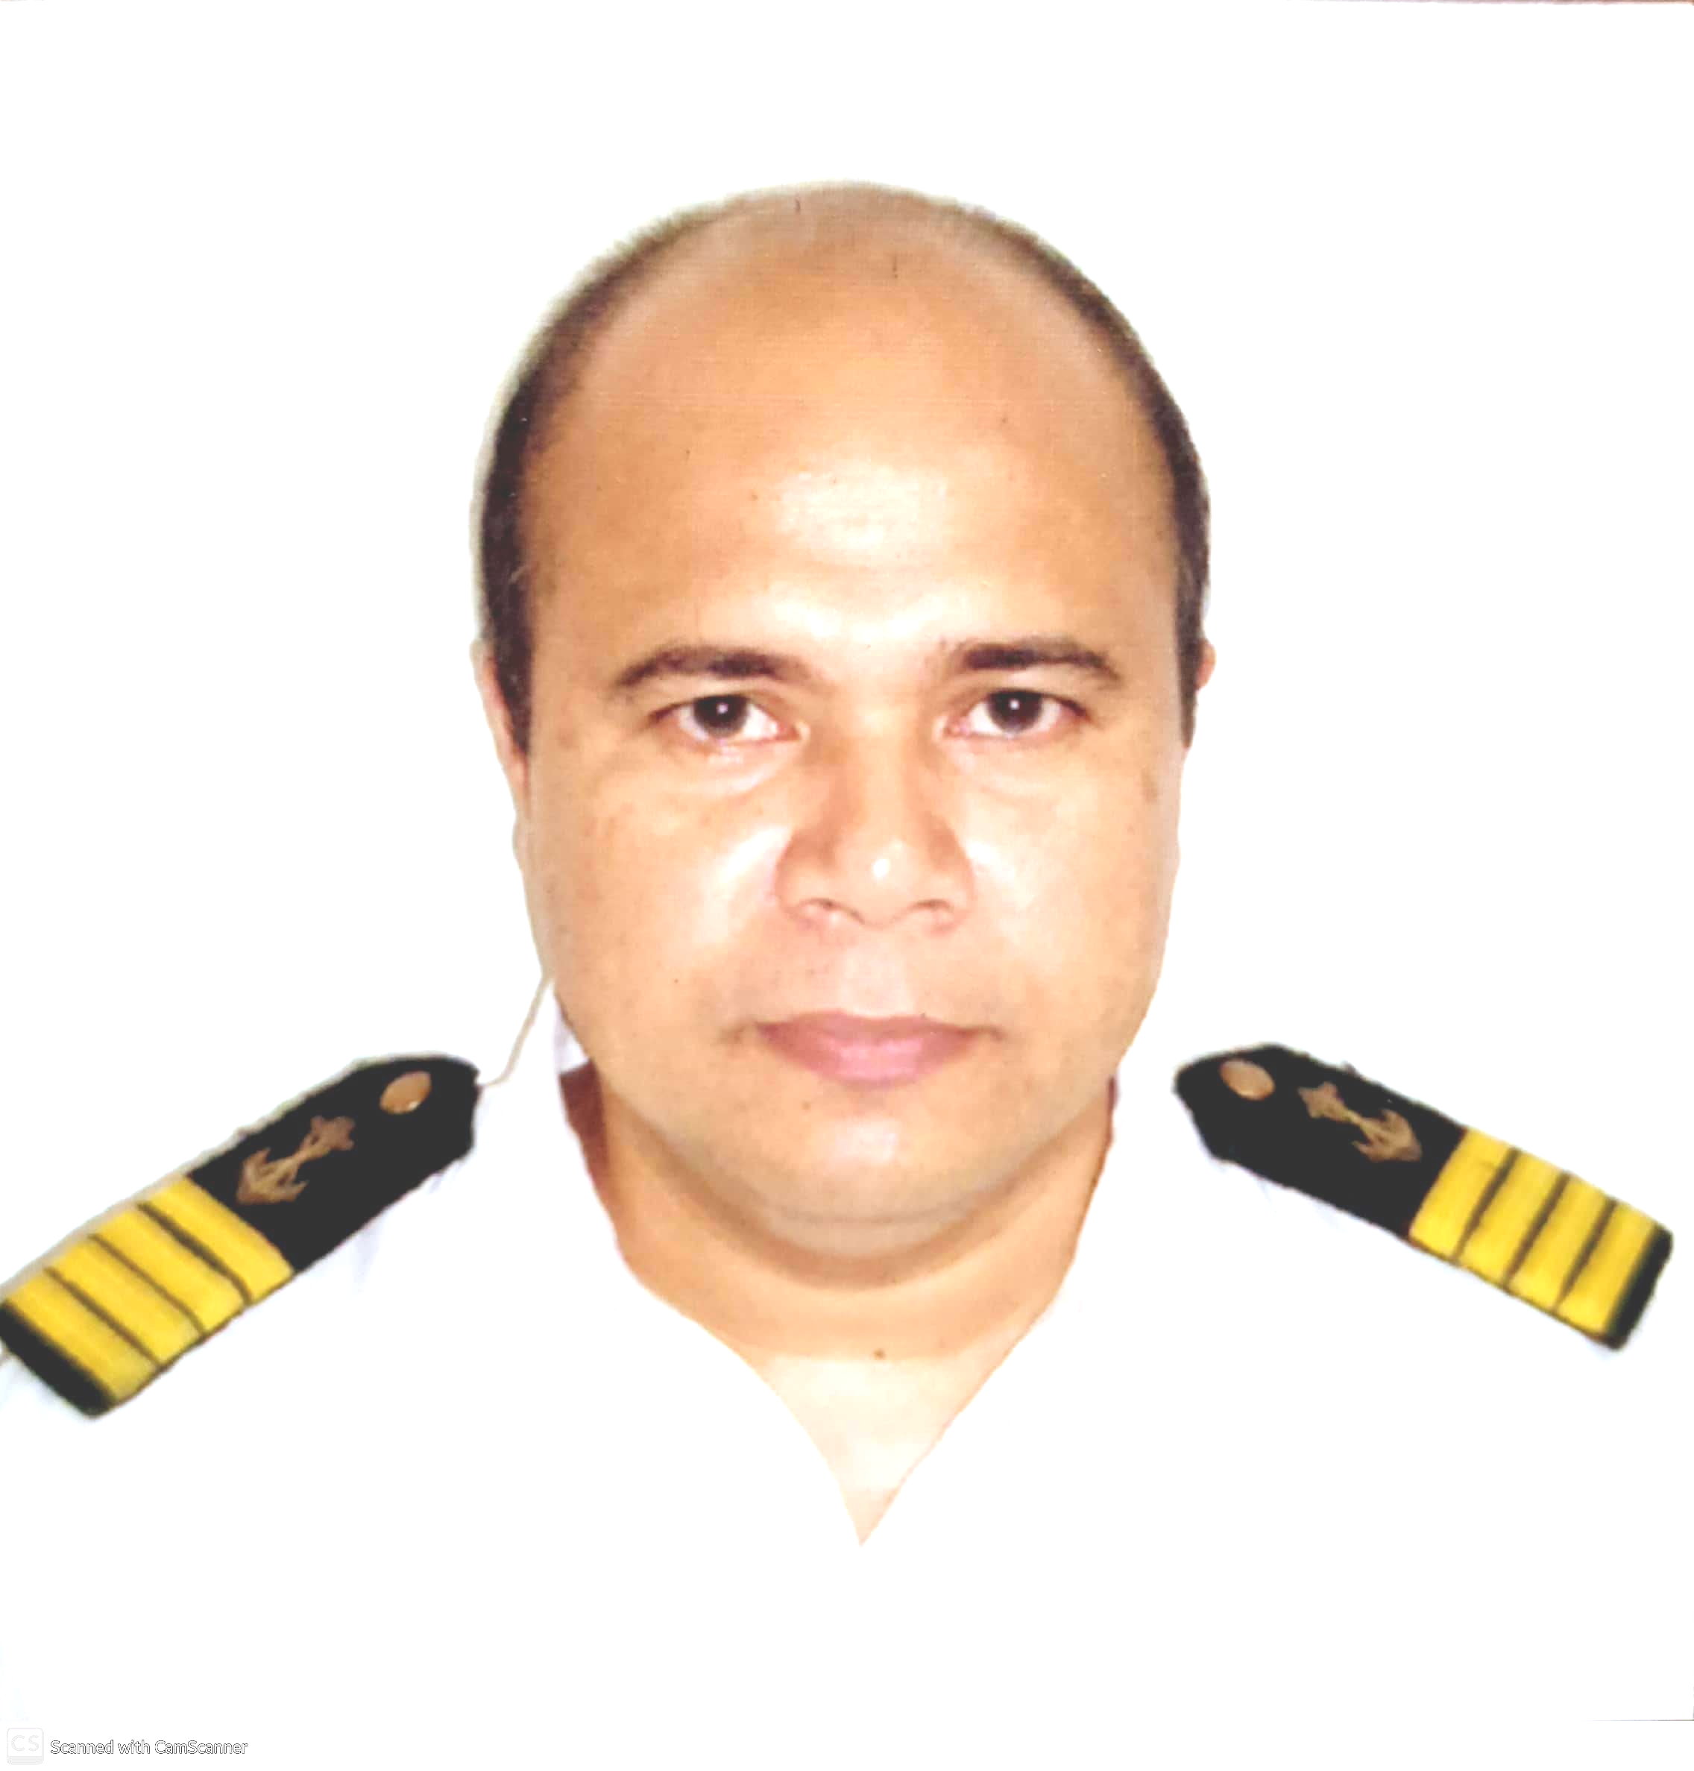
Blk 9 Lot 9 Juana 1 Complex,
Brgy. San Francisco, Binan City, Laguna
Tel: +63-2-8405-9058/ Mobile: 0956-872-9864
E-mail: carmelo.ragas@gmail.com

CAPT. CARMELO R. RAGAS

Master Mariner:

- Superintended the vessel, managed shipboard team, and spearheaded strategic planning and execution.
- Implemented and maintained shipboard Safety and Quality Management Systems.
- Enforced strict adherence to Health, Safety & Environment policies.
- Management of all operations including Navigation, Cargo Loading & Discharging, Maintenance of the Vessels, Engine Department, Accounting, Public Relations, Administration and Human Resources.
- Lead a team of Multi-national Officers and operation staff in conducting vessel operations safely and efficiently on complexed vessel worldwide.
- Maximized revenue with safe & efficient cargo handling operation. Maintained the vessels standards to ensure acceptance in Port State inspectors.

PERSONAL:

Date of Birth: 15 July 1964
Place of Birth: Guinobatan, Albay, Philippines
Status: Married
Spouse: Judy B. Ragas
Children: One (1) / Daughter
Religion: Roman Catholic
SSS : 03-7819725-0
TIN : 117-018-977
Pag-IBIG : 1210-8270-9886
PhilHealth : 02-025026559-0
SIRB : C0915203 / Issued 30 Sep 2016 / Valid 28 Sep 2026
PASSPORT : P2787523B / Issued 15 August 2019 / Valid 14 Aug 2029
SRC : 0020725-93 / Issued 5 May 2004
Yellow Fever : Issued 21 Dec 2015 / Valid Lifetime
COVID-19: 1st Dose 24 Sep 2021 / 2nd Dose 22 Oct 2021 / 1st Booster 24 Jan 2022 / 2nd Booster 16 Nov 2022

SHIPBOARD EXPERIENCES:

Flag | Vessel’s Name | Type | GRT | Rank | Date From | Date To | Agency/  Principal
PAN | TELI | Crude/ Product/ FSO | 94729 | Mstr/ OIM | 21/03/22 | 16/10/22 | Elwin
LIB | CAP DIAMANT | Crude/ Product | 94729 | Mstr | 15/10/20 | 08/09/21 | Elwin
HKG | PHOENIX HILL | Product | 28882 | Mstr | 15/01/19 | 04/08/19 | Fleet
HKG | PEACE HILL | Crude | 38862 | Mstr | 22/03/18 | 03/07/18 | Fleet
MI | PACIFIC PIONEER | Oil / Tanker | 57148 | Mstr | 26/01/18 | 06/03/18 | Fleet
HKG | LIME GALAXY | Oil / Chem | 11623 | Mstr | 02/01/17 | 13/08/17 | Fleet
MI | SILVER AMANDA | Oil / Chem | 29460 | Mstr | 03/01/16 | 05/08/16 | Fleet
PAN | GAMMA II | Crude | 53724 | Mstr | 12/03/14 | 05/04/15 | Seaguardian
LIB | PACIFIC ENERGY | Product / Crude | 57949 | Mstr | 14/03/13 | 27/07/13 | BMC
LIB | VERMILION ENERGY | Product / Crude | 56245 | Mstr | 30/10/12 | 22/02/13 | BMC
MI | FR8 REGINAMAR | Product / Crude | 42307 | Mstr | 14/02/11 | 26/07/11 | MST
MI | FR8 REGINAMAR | Product / Crude | 42307 | Mstr | 18/01/10 | 27/08/10 | MST

EDUCATIONAL ATTAINMENT:

1982 – 1986 Philippine Merchant Marine Academy BSMT – NS
1977 – 1981 St. Benedict’s Academy High School

CERTIFICATES:

Panama License : Endorsement No. 203339070 / Document No. 001301752 / CT No. CT - 033673/22 - PGR / Issued 13 May 2022 / Expiry 29 Oct 2024

Panama Seaman’s Book : PA0249414 / Issued 24 Apr 2022 / Expiry 29 Oct 2024

Panama GMDSS License : Endorsement No. 203339075 / Document No. 001301753 / CT No. CT – 0333674/22 – PGR / Issued 13 May 2022 / Expiry 29 Oct 2024

Panama GMDSS Book : PA0249415 / Issued 24 May 2022 / Expiry 29 Oct 2024

Liberia License : Endorsement No. 1182018 / Issued 06 Nov 2020 / FIN 730520 / Expiry 29 Oct 2024

Liberia Seaman’s Book: 1557875 / FIN 730520 / Issued 06 Nov 2020 / Expiry 06 Nov 2025

P.R.C Board Cert (Master) : Cert. # D1-0021246 / Issued 11 Feb 2000

C.O.C. II/2 : Cert. # CMM200000378119 / Issued 29 Oct 2019 / Expiry 29 Oct 2024

C.O.E. II/2 : Cert. # EMM200000380019 / Issued 29 Oct 2019 / Expiry 29 Oct 2024

G.O.C 1V/2 : Cert. # GOC200001059419 / Issued 29 Oct 2019 / Expiry 29 Oct 2024

Refresher on Basic Training: Cert. # BTR-W38-2019-B70BPM-MA153893-66952 / Issued 18 Sep 2019

BT COP : Cert. # BT200014755519 / Issued 29 Oct 2019 / Expiry 29 Oct 2024

Refresher on Advance Fire Fighting: Cert. # RATF-W38-2019-B34AM-MA153894-66952 / Issued 21 Sep 2019

AFF COP : Cert.# AFF200003334319 / Issued 29 Oct 2019 / Expiry 29 Oct 2024

Refresher on Proficiency in Survival Craft & Rescue Boats Other Than Fast Rescue Boats ; Cert # PSCRB-R-19-0077226 / Issued 19 Sep 2019

PSCRB COP : Cert. # PSCRB200006563119 / Issued 29 Oct 2019 / Expiry 29 Oct 2024

Medical Emergency First Aid : Cert. # MEFA-01-090051 / Issued 15 Sep 2001

MEFA COP : Cert. # 18-187298 / Issued 19 Jun 2015

Refresher Medical Care : Cert. # RMECA025/1210/01 / 27 Oct 2012.

MECA COP : Cert. # 19-54031 / Issued 19 Jun 2015

Specialized Training in Oil Tanker : Cert. # AOTO98-060019 / Issued 08 Jun 1998

ATOT COP : Cert. # ATOT200000477819 / Issued 29 Oct 2019 / Expiry 29 Oct 2024

Specialized Training in Chemical Tanker : Cert. # ACTO098-050004 / Issued 14 May 1998

ATCT COP : Cert. # ATCT200000325719 / Issued 29 Oct 2019 / Expiry 29 Oct 2024

BTOC COP : Cert. # BTOC200004154219 / Issued 29 Oct 2019 / Expiry 29 Oct 2024

Specialized Training in Liquified Gas Tanker : Cert. # ALT098-040005 / Issued 30 Apr 1998

Inert Gas System / Crude Oil Washing : Cert. # CI98-060034 / Issued 25 Jun 1998

Gas Measurement Course : Cert. # GMC 99-097 / Issued 17 Sep 1999

Marpol 73/78 Annex I : Cert. # MP98-050338 / Issued 25 May 1998

Marpol 73/78 Annex II : Cert. # MP98-050338 / Issued 28 May 1998

Marpol 73/78 Annex III, IV, V & VI : Cert. # M3/6-110044PM / Issued 21 Jan 2011

Ship Security Officer : Cert. # SSO070/1210/09 / Issued 25 Oct 2012

SSO COP : Cert. # 22-2262 / Issued 19 Jun 2015

Radar Observance Course : Cert. # 004 Series of 1986 / Issued 18 Aug 1986

Radar Simulator Course : Cert. # 476 Series of 1990 / Issued 23 Feb 19890

Automatic Radar Plotting Aid : Cert. # ARPA 425-92 / Series of 1992 / Issued 11 Jun 1992

Ships Restricted Radiotelephone Operators Course : Cert # 23221 / Issued 15 Jun 1991

Satellite Communication Course : Cert. # 2621 / Issued 01 May 1992

Global Maritime Distress & Safety System : Cert. # 494 / Issued 08 May 1992

Maneuvering, Ship Handling & Collision Avoidance : Cert. # PG MSCA 0153 98 / Issued 30 Jan 1998

Refresher on Ship Simulator & Bridge Teamwork with Bridge Resource Management: Cert. # RSSBT/BRM047/1512/02 / Issued 23 Dec 2015

Bridge Resource Management : Cert. # BRM-05244PM / Issued 18 Feb 2005

Updating Course for Management Level Marine Deck Officer (Function 1) : Cert. # 2015-UMLC-DF1-018 / Issued 17 July 2015

Updating Course for Management Level Marine Deck Officer (Function 3) : Cert. # 2015-UMLC-DF3-017 / Issued 23 July 2015

Electronic Chart Display & Information System (ECDIS) with Automatic Identification System : Cert. # ECDS/0912-696 / Issued 18 Dec 2009

Navmaster ECDIS : Cert. # 74502 / Issued 03 Apr 2018

Furuno ECDIS, model FMD-3100/FMD-3200/FMD-3200-BB/FMD-3300 : Cert. # TE28867 / Issued 17 Dec 2016

JRC ECDIS, model JAN-901B/701B/2000/901M/901/701 JRC-2015-C5065-29290 : Ref # 9c4077d6 / Issued 15 Dec 2015

JRC ECDIS, model JAN-701B/901B/2000 / Certificate No. 2020-JRC-0006 / Issued 12 Oct 2020

Marine Accident Investigation & Root Cause Analysis : Cert. # AIRCA-110090PM / Issued 10 Nov 2011

Vetting : Cert. # VET-100001AM / Issued 08 Jan 2010

Anti-Piracy Awareness Training : Cert. # 9419 / Issued 18 Oct 2012

Safety Officer Course : Cert. # SO/FMTI 2015/09-65 / Issued 22 Dec 2015

Maritime Incident Investigation and Analysis : Cert .# FMTIPI/IIC/0043/2018/03-06 / Issued 23 Jan 2018

Enclosed Spaced Entry Procedure : Cert. # EES/FMTI 43/15-44 / Issued 11 Dec 2015

Shore-Based Fire Fighting : Cert. # SBFF-01-090063 / Issued 11 Sep 2001

Human Relationships Course : Cert. # HRDC98-070013 / 09 Jul 1998

Prevention of Alcohol and Drug Abuse in the Maritime Sector : Cert. # PDMS98-070072 / Issued 14 July 1998

Personal Safety and Social Responsibility : Cert # PSSR98-070036 / Issued 04 July 1998

Risk Assessment and Hazard Identification : Cert. # FMPIPI/RA/0139/2018/04-26 / Issued 23 Jan 2018

____________________________________________________________

