 | 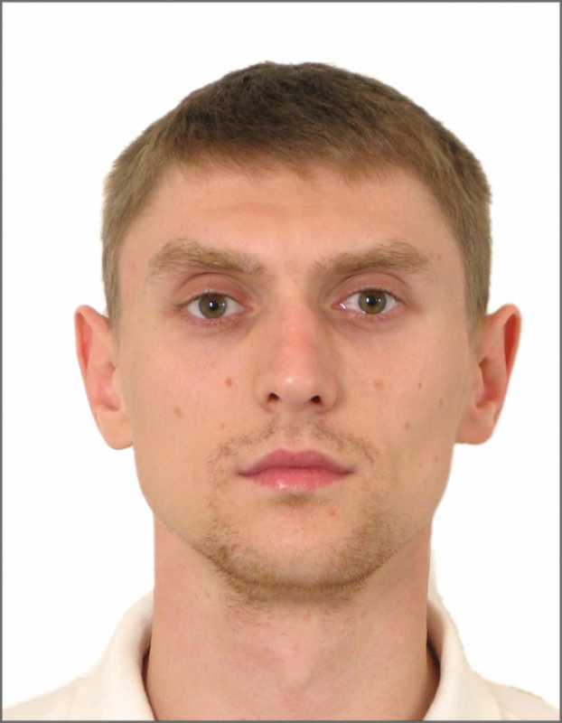
  SEAFARER'S APPLICATION FORM
  Position: | FITTER or welder or Pumpman | Readiness: | 27. 09.2022
  Position: | FITTER or welder or Pumpman | Citizenship: | Russia
  Last name: | Kapranov | Marital status | married
  First name: | Sergei | Children: | 2
  Middle name: | Andreevich | Nationality: | Russian
  Birth date: | 03.07.1986 | Birth place: | Russia, Kaliningrad
  Home address: | Kaliningrad, Russia, 236022 | Phone mobile: | 8(952)7903000
  Home address: | Kaliningrad, Russia, 236022 | Phone home:
  Home address: | Kaliningrad, Russia, 236022 | Email: | Sergeikapranov49@gmail.com
  English level: | Good

Salary | Minimum: 2500 | Expected: 2700-3600 | Last: 2500-3200 | $/month

Passports, Licenses & Certificates
Title | Class | Number | Place of issue |  | Issued | Valid
Passports & Visas
Civil passport |  | 2705046615 | Kaliningrad, RUS |  | 31.08.2006
Seaman's book |  | MK0230839 | Kaliningrad, RUS |  | 15.08.2014
Travel passport |  | 731595855 | Kaliningrad, RUS |  | 15.11.2013 | 15.11.2023
USA Visa C1/D

Schengen Visa MULT C
Diplomas & Endorsements
Electric and Gas Welder |  | 39-15-41096 | Kaliningrad, RUS |  | 09.12.2015
Certificate of Competency | III/5 | KGD201039047 | Kaliningrad, RUS |  | 25.05.2017
Certificates & Licenses
Proficiency in Survival Craft (VI/2) |  | AB 1375290 | Maritimetraining center FSBEI HE KSTU  Kaliningrad, RUS |  | 19.09.2019 | 19.09.2024
Training of seafers with designated security duties(Section A-VI/6, table A-VI/6-2) |  | AB 1232311 | Maritimetraining center FSBEI HE KSTU  Kaliningrad, RUS |  | 25.02.2019 | 25.02.2024
Basic Training for cargo operations  on oil and chemical tanker |  | 3.01.0087/2022 | Maritimetraining center FSBEI HE KSTU  Kaliningrad, RUS |  | 05.08.2022 | 05.08.2023
Basic Safety Training (VI/1.1-4) |  | AB 1228414 | Maritimetraining center FSBEI HE KSTU  Kaliningrad, RUS |  | 05.03.2019 | 05.03.2024
Medical Certificates
Medical Fitness Certificate |  | №017781 | Kaliningrad, RUS |  | 18.08.2022 | 18.08.2023
Yellow Fever Vaccination |  | Lat466 d-0,5 |  | Kaliningrad, RUS | 30.07.2014
Drug/alcohol test |  | №772 |  | Kaliningrad, RUS | 15.08.2022 | 15.

Sea-going experience
1 | Batm Zamoskvorechye | RUS | Fishing vessel | Pielstic  6C40/46 |  | Wiper | 01.10.2014 | Westrybflot
1 | Batm Zamoskvorechye | 1987 | GRT 4407 | 2*3500 KW |  | Wiper | 12.02.2015 | ZAO Westrybflot Kaliningrad
2 | Countess Anna | Ant&Brb | Dry Cargo | Deutz  SBV6M628 |  | Motorman-welder | 11.05.2015 | Krey Schiffahrts GmbH
2 | Countess Anna | 1992 | GRT 1589 | 1015 KW |  | Motorman-welder | 22.10.2015 | Skov Shiping Ltd.
3 | Countess Anna | ATG | Dry Cargo | Deutz  SBV6M628 |  | Fitter | 17.02.2016 | Triton Schiffahrts GmbH
3 | Countess Anna | 1992 | GRT 1589 | 1015 KW |  | Fitter | 15.08.2016 | Avior Kaliningrad
4 | Atlantic Marmaid | LBR | Refrigerator | HITACHI/B&W  7S50MC |  | Fitter | 13.09.2016 | Triton Schiffahrts GmbH
4 | Atlantic Marmaid | 1991 | GRT 9829 | 9170 KW |  | Fitter | 15.11.2016 | Avior Kaliningrad.
5 | Countess Anna | ATG | Dry Cargo | Deutz  SBV6M628 |  |  | 06.02.2017 | Krey Schiffahrts GmbH
5 | Countess Anna | 1992 | GRT 1589 | 1015 KW |  |  | 30.04.2017 | Skov Shiping Ltd.
6 | m/v Fuji Bay | LBR | Refrigerator | Mitsubishi  6UEC52LA |  | Fitter | 04.07.2017 | Seatrade Groningen B.V.
6 | m/v Fuji Bay | 1990 | GRT 9070 | 6765 KW |  | Fitter | 01.12.2017 | Avior Kaliningrad
7 | m/v Green Bodo | Bagamas | Refrigerator | Wartsila  12V32D |  | Fitter | 31.03.2018 | Green Management Klg.
 |  | 1990 | GRT 5084 | 4405 KW |  |  | 27.08.2018 | Green Reefers
8 | m/v Green Karmoy | Bagamas | Refrigerator | Wartsila  12V32D |  | Fitter | 09.03.2019 | Green Management Klg.
 |  | 1988 | GRT 5084 | 4405 KW |  |  | 06.09.2019 | Green Reefers
9 | m/v Johanna C | UK | Dry Cargo Multiporpose | Mak  6M43C |  | Fitter | 14.12.2019 | Carisbrooke shipping company
 |  | 2009 | GRT 9590 | 5400 KW |  |  | 02.07.2020 | Carisbrooke shipping company
10 | m/v Triumph | Curacao | Heavy Lift | Man B&W |  | Fitter | 28.08.2020 | Anglo-EASTERN SHIP  Management
 |  | 1992 | GRT 42515 | 13369 KW |  |  | 22.01.2021 | Boskalis
11 | m/v Mighty Servant 3 | Curacao  1984 | GRT 23123 | Wartsila  12000 KW |  | Fitter | 29.03.2021  09.07.2021 | Anglo-EASTERN SHIP  Management
12 | m/v Hafnia Sea | UK | GRT 25609 | Man B&W 8L48/608 |  | Fitter | 03.08.2021 | Anglo-EASTERN SHIP  Management
 |  | 2012 |  | 19200 KW |  |  | 14.09.2021
13 | m/v Boka Vanguard | Curacao  2013 | GRT 91784 | Wartsila 4ME  24000KW |  | Fitter | 15.11.2021  19.04.2022 |  | Anglo-EASTERN SHIP  Management

14 m/v Boka Vanguard | Curacao  2013 | GRT 91784 | Wartsila 4ME  24000KW |  | Fitter | 17.06.2022  14.07.2022 |  | Anglo-EASTERN SHIP  Management

Anglo-Eastern Ship Management | Tel. +85239407000

General Physical State
Height (cm) | Weight (kg) | Shoes | Clothes | Hair color | Eye color
191 | 85 | 44 | XL(50-54) | brown | Green-brown

Date applied: | 30.09.2022 |  | Signature: | Kapranov S.

