SEAMAN’S PRE-EMPLOYMENT CHECK LIST
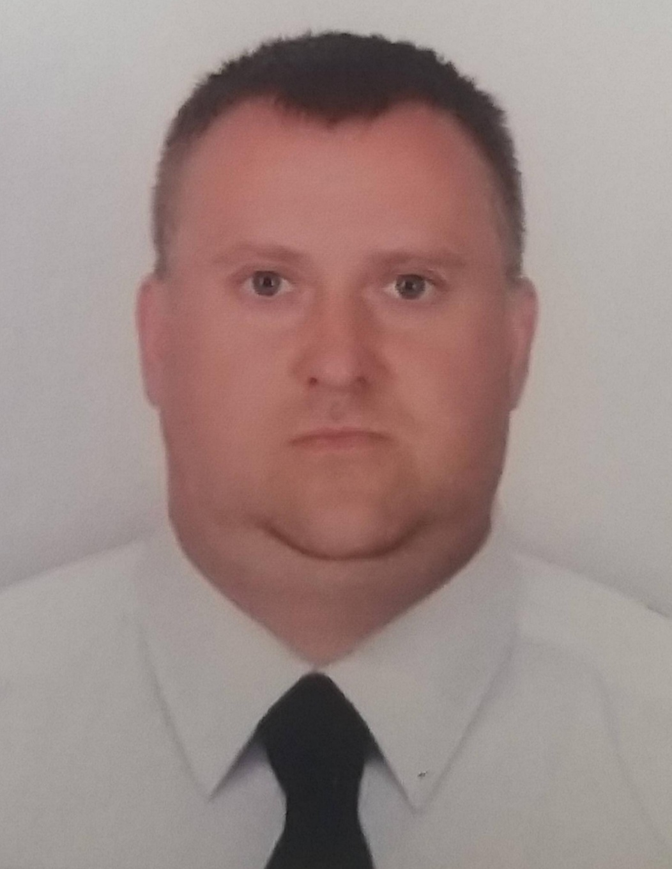

A. PERSONAL DETAILS

Name | MITIANIN OLEKSANDR

Surname First name Father’s name
Date and place of birth | 28 JUN 1982

Nationality | Ukrainian | FamilyState | MARRIED

Home Address | Odessa region, village Alexandrovka
(Permanent residence)
E-mail, tel. /mob | +380633921755 , alex1982mityanin@gmail.com

Trade Education | SER/SHIP'S COOK #03623/2022/08

( College / university / academy, date of graduation )
Marital status (married/single/divorced) | MARRIED
WifeFull Name MITIANINA NATALIIA
Beneficiary Full Name
Beneficiary Full Name relation
Beneficiary Address and tel.
Children names/age
ROSTYSLAV 5 YEAR,
ILONA 12 YEAR

Position applied for | CHIEF COOK
B. NATIONAL AND FLAG CERTIFICATES
Title of the seafarer’s National documents | Number | Date of issue | Place of issue | Valid till
Seaman’s book | AB 693910 | 08.07.2022 | PORT IZMAIL | 08/07/2027
Travel passport | FB 349441 | 02.04.2015 | ODESSA | 02.04.2025
Ukrainian domestic passport | ЕЕ 321548 | 08.08.2000 | Ukraine
Certificate of competency (Capacity_________________)
Endorsement of Certificate (Limitations ,if any_________)
Flag Endorsement of Certificate(Flag _______________ ) _______________
GMDSS certificate (Capacity ______________________)
Endorsement of GMDSS (Limitation, if any___________)
Flag endorsement of GMDSS (Flag__________________)
Basic safety training Certificate | 1457200 | 08.06.2022 | IZMAIL | 08.06.2027
Proficiency in Survival craft
Proficiency in Survival craft and rescue Boat Certificate | 1489925 | 01.09.2022 | ODESSA | 01.09.2027
Advanced fire fighting Certificate | 1490475 | 02.09.2022 | ODESSA | 02.09.2027
Carriage of dangerous cargo Certificate
Medical first aid / Medical care Certificate
Radar navigation Certificate
ARPA Certificate
ECDIS Certificate
Ships Safety Officer Certificate
Ship Security Officer Certificate(A –VI/6-2 STCW) | 1485290 | 19.08.2022 | ODESSA | 19.08.2027
Designated Security Duties
Security Related Training | 1457447 | 08.06.2022 | IZMAIL | 08.06.2027
Security Awareness Training
Engine Room
Bridge team management Certificate
Oil tanker Familiarization
Crude Oil Washing
Inert Gas System
Oil Tanker Special
Chem.tanker Special
Liquified gas tanker

Medical certificate
Yellow fever vaccination Certificate
Drug and alcohol test Certificate

English language knowledge: POOR  (verygood/good/poor) |  |  |  |  | Marlin’s test (%)
Working clothes size 58 | Shoes size 42 |  | Height 185 | Weight 105 |  | Eyes color BLUE | Hair ColorBLOND

C. SEA SERVICE ( last ten contracts)
Vessel’s name | Type | Flag | DWT | M/E  maker power |  | Rank | Signed  on off |  | Company
TUG FELIX | Pusher Tug/Other | Portugal | 297 t | Cummins KTA 50-M2 |  | Cook | 09.10.2022  Port IZMAIL | 06.03.2023 Burgas | Stoutridge International LTD
BBC Amethyst | Cargo | Antigua Barbuda | General Cargo  14452 | Briese Shiffahrts GmbH | IMO 9504724 | Chief Cook | 01.05.2023 Tianjin,China | 09.11.2023  Yokohama, Japan | Stella Marine Company Ltd
BBC Mercury | Bulk cartter | Liberia | 39869 | Briese shiffahrts gmbh | IMO 9965588 | Chief cook | 13.12.2023 Conchan Peru | 20.04.2024  Arica Chile | Stella Marine Company Ltd
D. OTHER INFORMATION
Previous Employment (please indicate the companies that he worked the two last contracts)

Company name | Address | Phone | Rank | From | To

Other countries visits(USA, SHENGEN)
NO

(Specify the country and year of each visit for last 5 tears)

USA, Australia, Schengen VISA(Specify Country and validity date)
NO

Are any Liabilities in progress?(Alimony, judicial claims and etc.)

NO

All above-stated is true. The present I allow to store and use the information received from me with a view of my employment.

Date and applicant signature_______________

- INTERVIEWER CONCLUSION

When available for Employment

Reference (from Whom, details)

Great work experience,on the shore

February 2021- August 2022 – OOO.Kopeyka Center Confectionery production manager

Ability
Character |  | January 2020 – February 2021 --- Cook 4 categories --PAT USRZ

Qualification
Motivation |  | 2014-2016-Chef-Restaurant of the hotel complex «Pavlovs House"
Punctual, responsible, no bad habits.  I cook, serve banks, make bakery and confectionery products.  I know food recipes  I know how to work with technological maps.  I'm conserving for the winter |  | 2016-2020 Confectioner of the confectionery shop LTD «Seven Seas» Gustomarket
Found | Suitable____________ |  | Hold for possible reconsideration __________ | Not suitable _____________

Interviewer’s Name and signature

Date and place of Interview

