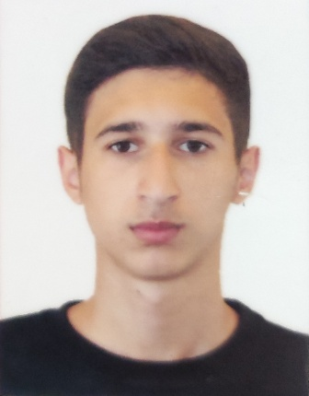
APPLICATION FORM

Position Applied for: Rating Forming Part of a Navigational Watch
Date of readiness for joining: Any moment and any time

1. Personal Data
Family Name: Rzayev | First Name: Jafar | Middle Name: Gurbanali
Date of Birth: 01.10.2003 |  | Citizenship: Azerbaijani
Permanent Address: Azerbaijan , Astara , Sahagaci village |  | Phone number: +994507805203  E-mail:  rzayevcafar0@gmail.com

2. Maritime Education
Name of school | Town | Country | From | To | Type of degree or diploma
“Kaspian Education Center” LLC | Baku | Azerbaijan | 07.2022 | 12.2022 | Rating forming part of a navigational watch.

3. Family Details
Civil Status (Single, Married, Separated, Divorced, Widowed): Single

Next of Kin (the first emergency contact): Rzayev Gurbanali Jafar | Relationship: Father
Address of Residence Russia. Saint-Petersburg | Phone: +79992118017

4. Identity Documents
Document | Country | Number | Place of Issue | Issue Date | Expiry Date
Seaman's Book | Azerbaijan | DQK 022744 | Azerbaijan state Maritime Agency | 17.02.2023 | 17.02.2028
Travel Passport | Azerbaijan | С03359235 | Ministry of internal affairs | 12.08. 2023 | 11.08.2033
Civil Passport | Azerbaijan | AA2062286 | Ministry of internal affairs | 21.08.2020 | 21.08.2030

5. Courses Attended and Certificates Obtained
Document | Number | Dates |  | Place
Document | Number | Issue | Expiry | Place

Rating forming part of a Navigational Watch Certificate of Competency | 0402/23 | 09.02.2023 | 09.02.2028 | Azerbaijan State Maritime Agency
Certificate of Competency Endorsement | 0402/23 | 09.02.2023 | 09.02.2028 | Azerbaijan State Maritime Agency
Proficiency in Survival Craft and Rescue Boats | SL-3448-22 | 25.10.2022 | 24.10.2027 | Azerbaijan State Maritime Administration
Ship Security-related training and instruction | SI-2325-22 | 22.09.2022 | 22.09.2027 | Azerbaijan State Maritime Agency
International Safety Management Code | SP-3237-22 | 25.10.2022 | 25.10.2027 | Azerbaijan State Maritime Agency
Training for seafarers with designated security duties | SH-2183-22 | 26.10.2022 | 26.10.2027 | Azerbaijan State Maritime Agency
personal survival techniques –fire prevention avdfire fighting –elementary first aid –personal safety and social responsibilities | SO-4319-22 | 21.09.2022 | 21.09.2027 | Azerbaijan State Maritime Agency

6. Physical Data
Height | 178cm
Weight | 60 kg
Colour of Hair | Brown
Colour of Eyes | Brown
Boilersuit Size | M
Shoes Size | 41

7. Medical History | Yes | No
Have you ever signed off a ship due to medical reasons? |  | ✓
Did you undergo any medical operation in the past? |  | ✓
Have you consulted a doctor during the last 12 months for an illness/accident? |  | ✓
Do you have any health or disability problems now? |  | ✓

 | Passed: | Valid till:
International Medical Examination | 18.08.2022 | 18.08.2024

8. Seagoing Experience

Name of vessel | Flag | Vessel’s Type | DWT | Manager or Owner | Rank | From d/m/y | To  d/m/y | Total  m/d
MORION | Azerbaijan | PTS | 70 | Azerbaijan Caspian Shipping Company | Cadet | 11.02.2022 | 12.05.2022 | 3/1
SERENITY AC | NIUE | GENERAL CARGO | 1750 | NEW MOON SHIPPING CO.LTD. | AB | 15.10.2023 | 23.05.2024 | 7/9

