CV APPLICANT’S PERSONAL DATA
POSITION APPLIED FOR: | READY TO WORK (DATE):
FIRST / LAST NAME: Aleksandr Kriuchek | CITIZENSHIP: Russia
FATHER’S NAME: Aleksandr | ADDRESS (incl. post code): 197349
DATE OF BIRTH: 19.05.1959 | Russia, Saint Petersburg,Fermskoe Shosse Str.20/1
RELIGION: Orthodox | Fl.49
PLACE OF BIRTH: USSR, Arkhangelsk region | Fl.49
PHONE:+7 812 602 11 75  MOBILE:+7 911 906 28 96 | E-MAIL: a.kryuchek@mail.ru  SKYPE: Aleksandr Kriuchek

MARITAL STATUS: SINGLE / MARRIED / DEVORSED | NEXT OF KIN: (if not married) | 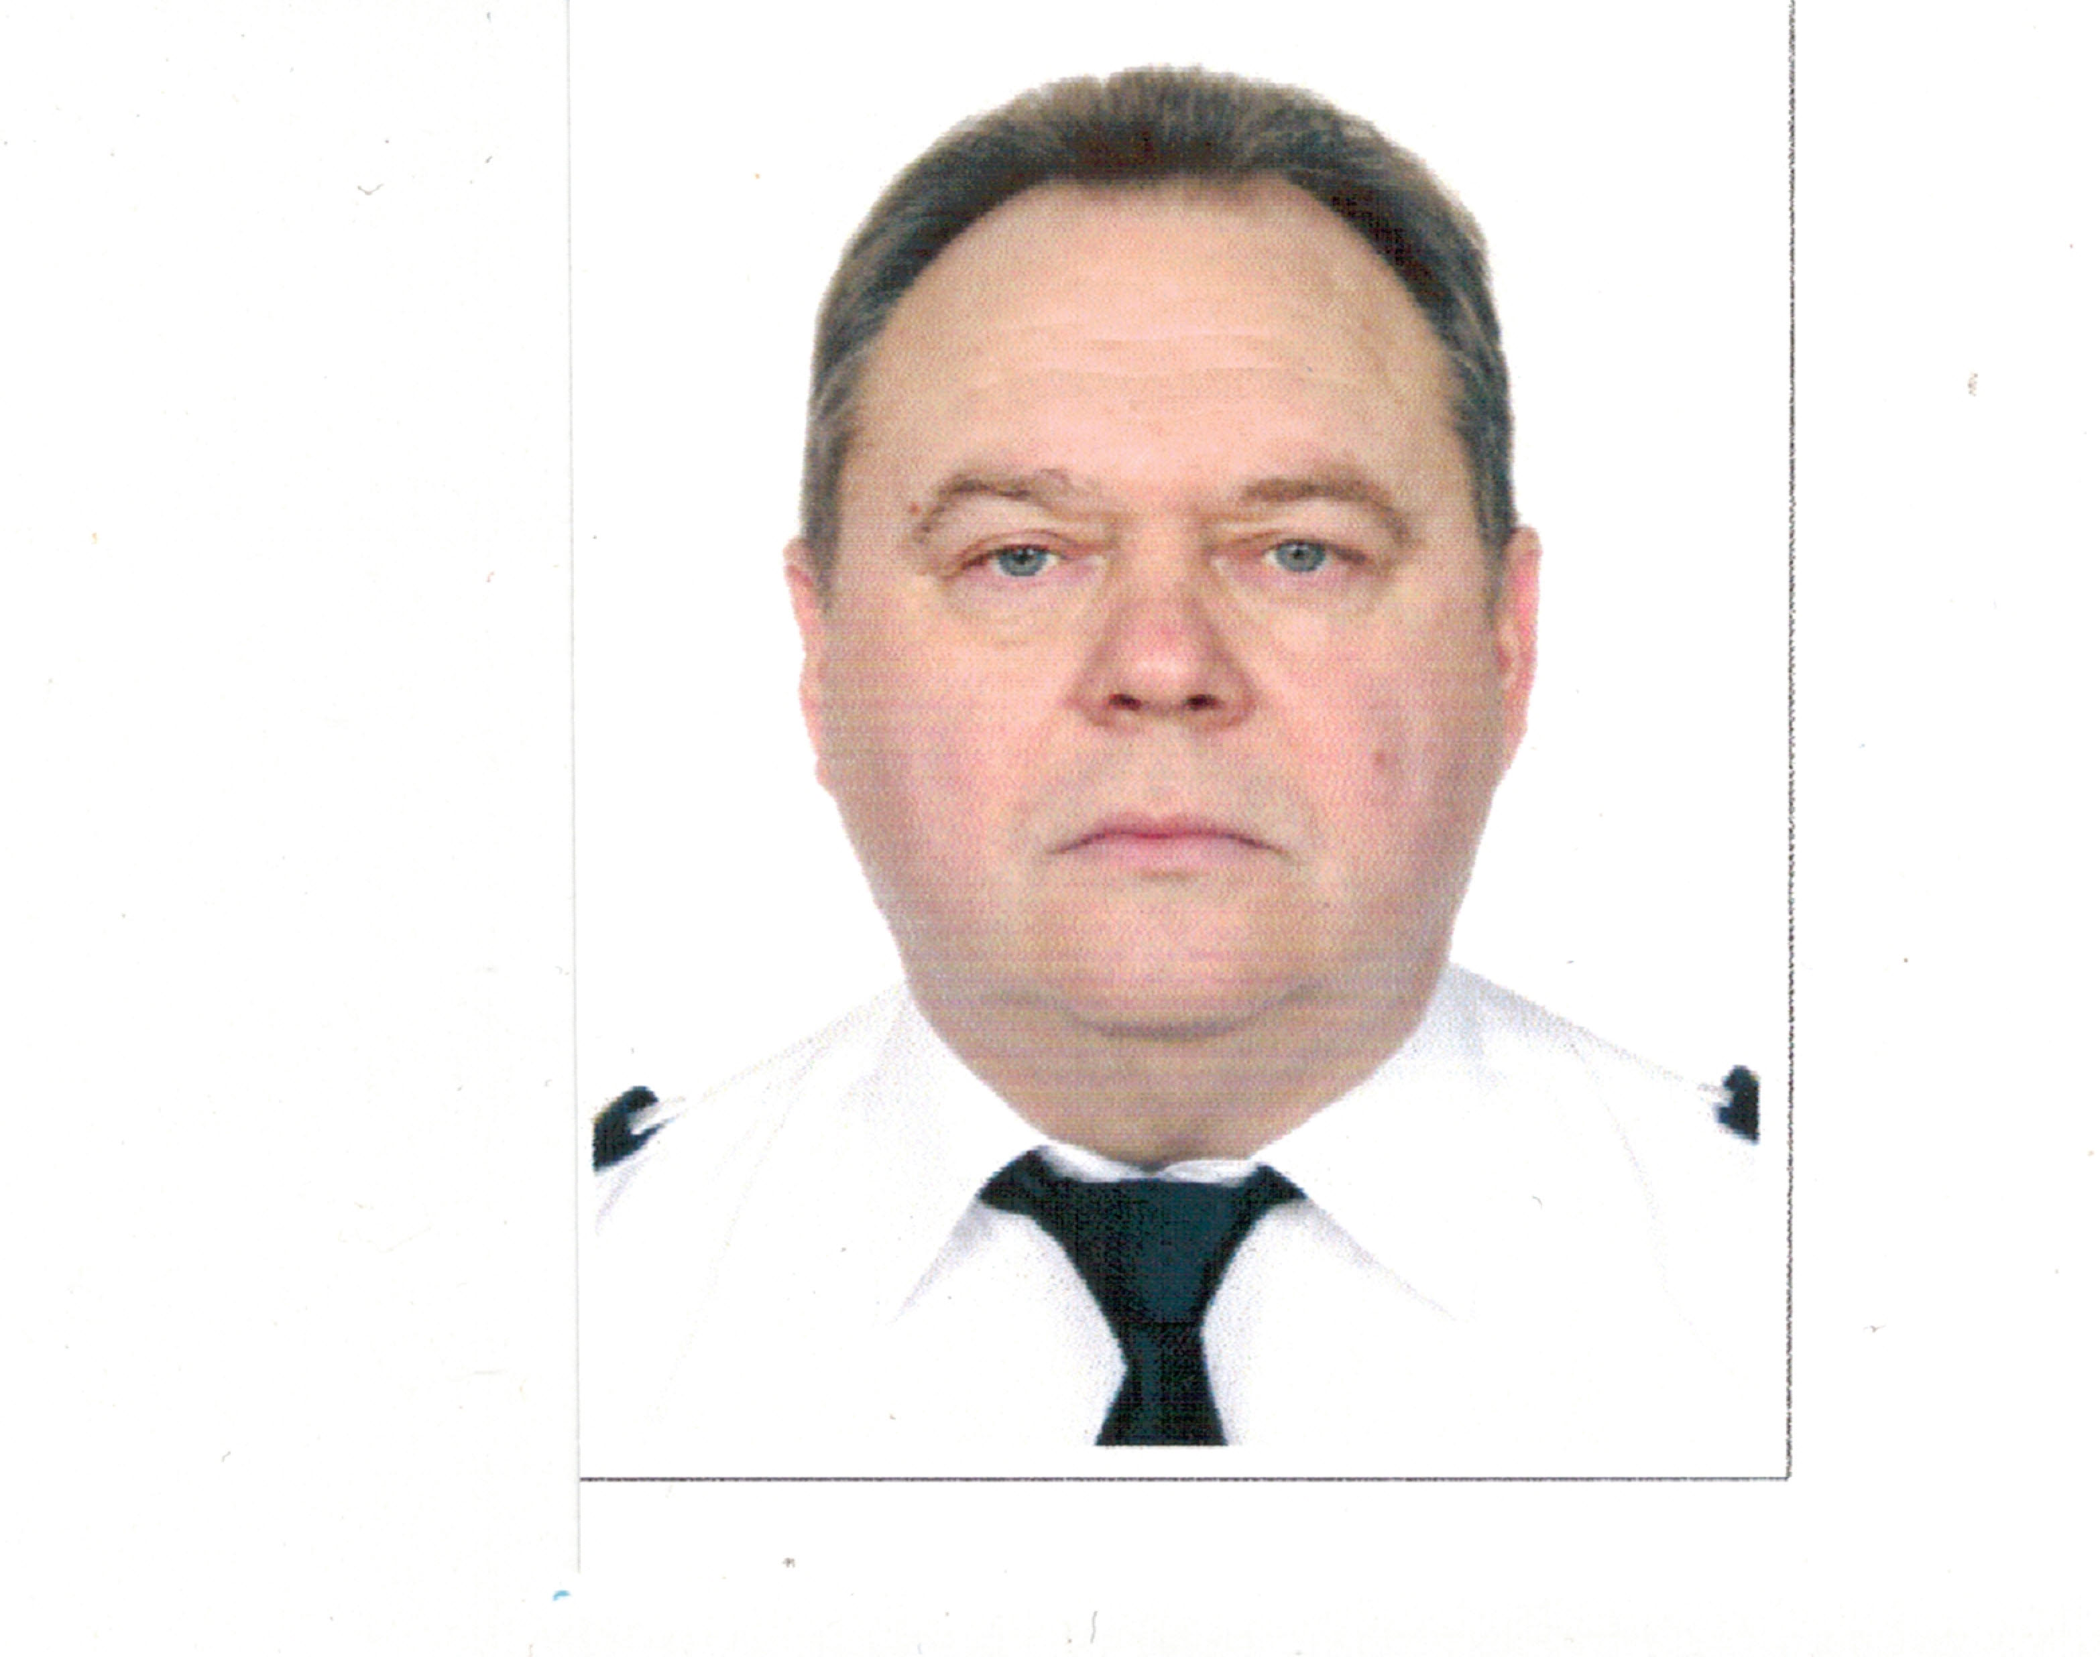  photo
DATE OF MARRIAGE: 20.09.1980
WIFE’S FIRST / LAST NAME: Zinaida Kriuchek | RELATION:
FATHER’S NAME: Anatoliy | FIRST / LAST NAME :
WIFE’S DATE& PLACE OF BIRTH: 17.04.1959,Crimea region | FATHER’S NAME:
ADDRESS: Russia, St . Petersburg,Parashyutnaya Str.23/1 ,Fl 18 | ADDRESS:
PHONE: +7 812 602 11 75  MOBILE:+7 911 251 06 59 | PHONE:  MOBILE: +7 911 906 28 96

CHILDREN (IF APPLICABLE):
FIRST/ LAST NAME : | DATE OF BIRTH :
FIRST/LAST /MIDDLE NAME of MOTHER | FIRST/LAST /MIDDLE NAME of FATHER

CLOTHES: | SIZES: | HEIGHT |  |  | VISA | PLACE OF ISSUE (CITY) | TYPE OF VISA | FROM | VALID TILL
OVERALL | 54 | WEIGHT | 95 |  | USA
SAFETY SHOES | 42 | COLOR OF EYES | grey |  | SCHENGEN | St.Petersburg | Greece | 15.03.20 | 14.03.21
TROUSERS | 54 | COLOR OF HAIR | brown
SWEATER | 54 | CHEST (Cms) | 100
SHIRT | 42 | WAIST (Cms) | 104

MARINE EDUCATION RECEIVED
NAME OF SCHOOL | FROM | TILL | TYPE OF DEGREE RECEIVED
Arkhangels Marine College | 01.09.1976 | 31.12.1980 | Navigator

NATIONAL DOCUMENTS (RUSSIAN): |  | NO. |  | ISSUED | VALID
SEAFARER’S IDENTITY DOCUMENT |  | RUS 0415536 |  | 30.10.18 | 29.10.23
SEAMAN’S BOOK |  | МК 0224288 |  | 23.04.14 | unlimit
TRAVELLING PASSPORT |  | 71 5081533 |  | 24.06.11 | 24.06.21
CIVIL PASSOPRT |  | 46 06 912695 |  | 17.06.05 | unlimit
 |  | GRADE | NO. | ISSUED | VALID
NAT.LICENCE: STCW II/2 |  | Master | LED203925580 | 28.01.20 | 04.12.24
ENDORSEMENT : Oil Chem LPG  x x |  | Management | LED203925580 | 28.01.20 | 04.12.24
GMDSS: |  | General operator | LED203925572 | 28.01.20 | 04.12.24
ENDORSEMENT: |  | Operational
RADAR OBSERVER: |  | IMO RES. A483 (XII) | 603-353/19-02C | 20.12.19 | 20.12.24
ARPA : |  | IMO RES. A482 (XII) | 602-009/20-02C | 10.01.20 | 10.01.25

 | CERTIFICATES: |  |  |  |  |  | STCW CODE |  |  | NO |  | ISSUED |  |  | VAILD TILL
 | BASIC SAFETY STCW ‘95 |  |  |  |  |  | A-VI/1 |  |  | 620-013/20-07C |  | 14.01.20 |  |  | 14.01.25
 | SURVIVAL CRAFT, RESCUE BOATS: |  |  |  |  |  | A-V1/2-1 |  |  | 622-015/20-06C |  | 15.01.20 |  |  | 15.01.25
 | ADVANCED FIRE FIGHTING : |  |  |  |  |  | A-V1/3 |  |  | 625-016/20-02C |  | 16.01.20 |  |  | 16.01.25
 | MEDICAL EMERGENCY FIRST AID |  |  |  |  |  | A-V1/4-1 |  |  | 628-343/19-12c |  | 11.12.19 |  |  | 11.12.24
 | MEDICAL CARE CERTIF. |  |  |  |  |  | A-V1/4-2 |  |  | 629-346/19-07c |  | 13.12.19 |  |  | 13.12.24
 | DESIGNATED SECURITY DUTIES (SSD) |  |  |  |  |  | A-VI/6, A-VI/6-2
 | SHIP SECURITY OFFICER (SSO) |  |  |  |  |  | A-VI/5, A-VI/5 |  |  | AB 0911318 |  | 06.12.19 |  |  | 06.12.24
 | BRIDGE TEAM MANAGEMENT / ERM |  |  |  |  |  |  |  |  |  |  | 13.02.16 |  |  | 13.02.25
 | BRIDGE TEAM MANAGEMENT IMO 1.22 |  |  |  |  |  |  |  |  | 599-329/19-02C |  | 29.11.19 |  |  | 29.11.24
 | ECDIS |  |  |  |  |  |  |  |  | AA0991095 |  | 18.12.19 |  |  | 18.12.24
 | ECDIS SPECIFIC |  |  |  |  |  | TRANSAS 4000 |  |  | 46/2013 |  | 18.03.16 |  |  | 18.03.25
 | OIL TANKER / FAMILIARIZATION /PROG. |  |  |  |  |  | A-V/1, P.2-7
 | OIL TANKER / SPECIALIZED / PROG. |  |  |  |  |  | A-V/1, P.9-14 |  |  | 34/2016 |  | 28.10.16 |  |  | 28.10.25
 | CHEM TANKER / FAMILIARIZATION/ PROGR. |  |  |  |  |  | A-V/1, P.2-7
 | CHEM TANKER /SPECIALIZED/ PROGR. |  |  |  |  |  | A-V/1, P.16-21 |  |  | 36/2016 |  | 03.11.16 |  |  | 03.11.25
 | LIQUID GAS TANK/FAMILIARIZATION/ PROGR. |  |  |  |  |  | A-V/1, P.2-7
 | LIQUID GAS TANK/SPECIALIZED / PROGR. |  |  |  |  |  | A-V/1, P.23-34
 | HAZMAT |  |  |  |  |  | B-V/4, B-V/5
 | HAZMAT (USA-TITLE 49)
 | CRUDE OIL WASHING OPERATIONS/ INERT GAS SYSTEM
 | YELLOW FEVER |  |  |  |  |  |  |  |  | 319 |  | 26.03.10 |  |  | Valid for life
FLAGS DOCUMENTS:
LIBERIAN |  |  |  | GRADE | NBR | ISSUED |  | TILL | PANAMANIAN |  | GRADE |  | NBR | ISSUED |  | TILL
SBK |  |  |  | MASTER | 1444628 | 08.02.19 |  | 08.02.24 | SBK |  | MASTER
END. TO LIC |  |  |  | MASTER | 1119416 | 08.02.19 |  | 08.02.24 | END. TO LIC |  | MASTER
END. TO GMDSS |  |  |  | GO | 1119416 | 08.02.19 |  | 08.02.24 | END. TO GMDSS |  | GO |  | CTC299923 | 31.05.16 |  | 31.05.21
GMDSS |  |  |  | GO | 1119416 | 08.02.19 |  | 08.02.24 | GMDSS
SPECIAL QUALIFICATION  CERTIFICATES |  |  |  | As per STCW |  |  |  |  | SPECIAL QUALIFICATION  CERTIFICATES
GERMAN |  |  |  |  |  |  |  |  | ANT&BARBUDA
SBK |  |  |  |  |  |  |  |  | SBK
END. TO LIC |  |  |  |  |  |  |  |  | END. TO LIC
END. TO GMDSS |  |  |  |  |  |  |  |  | END. TO GMDSS

DUTCH
SBK |  |  |  |  |  |  |  |  | MARSH. ISLAND
END. TO LIC |  |  |  |  |  |  |  |  | SBK |  | Master |  | MH0552799 | 03.11.17 |  | 03.11.22
END. TO GMDSS |  |  |  |  |  |  |  |  | END. TO LIC |  |  |  | 1100501 | 03.11.17 |  | 03.02.21
GMDSS |  |  |  |  |  |  |  |  | END. TO GMDSS |  |  |  | 542399 | 03.11.17 |  | 03.02.21
SPECIAL QUALIFICATION  CERTIFICATES |  |  |  |  |  |  |  |  | SPECIAL QUALIFICATION  CERTIFICATES
CYPRUS |  |  |  |  |  |  |  |  | MALTA
SBK |  |  |  |  |  |  |  |  | END. TO LIC
END. TO LIC |  |  |  |  |  |  |  |  | END. TO GMDSS
END. TO GMDSS |  |  |  |  |  |  |  |  | BAHAMAS
NIS |  |  |  |  |  |  |  |  | END. TO LIC
SBK |  |  |  |  |  |  |  |  | END. TO GMDSS
END. TO GMDSS |  |  |  |  |  |  |  |  | SINGAPORE/ HONG KONG
END. TO LIC |  |  |  |  |  |  |  |  | END. TO LIC
GMDSS |  |  |  |  |  |  |  |  | END. TO GMDSS
SPECIAL QUALIFICATION
CERTIFICATES

OTHER DOCUMENTS (NOT MENTIONED BEFORE)
DOCUMENT | GRADE | NO. | ISSUED | VALID

SEA SERVICE LAST 5 YEARS (10 FOR MASTERS AND CHIEF ENGINEERS)
VESSEL’S NAME | COMPANY (SHIP’S OWNER/ CREWING) | FLAG | VSL’S  TYPE | TEU/  CARGO | GRT/ | ENG.TYPE | /  KW | RANK | EMPLOYMENT  (M/Y) |  | TOTAL
 |  |  |  |  |  |  |  |  | FROM | TO | TOTAL
China Spirit | Alison | Liberia | o/chem tanker |  | 7687 | MAK | 6060 | master | 20.10.22 | 09.03.23 | 5m
Curacao Trader | Alison | Liberia | o/chem tanker |  | 7687 | MAK | 4850 | master | 20.04.21 | 09.09.22 | 5m
Saronic Bay | Alison | Liberia | o/chem tanker |  | 6952 | MAK | 4320 | master | 20.01.20 | 09.06.21 | 6m
Bonaire Trader | Alison | Liberia | o/chem tanker |  | 7687 | MAK | 4850 | master | 20.03.19 | 09.10.19 | 7m
Anuket Ivory | NORBULK | Panama | o/chem  tanker |  | 6952 | MAK | 4320 | master | 19.07.18 | 12.10.18 | 3m
River Oak | NORBULK | Marsh.Isl | o/chem tanker |  | 8530 | MAK | 5500 | master | 27.10.17 | 22.01.18 | 3m
Anuket Ivory | NORBULK | Panama | o/chem tanker |  | 6952 | MAK | 4320 | master | 04.09.17 | 27.10.17 | 1.5 m
Anuket Ivory | NORBULK | Panama | o/chem tanker |  | 6952 | MAK | 4320 | master | 16.12.16 | 21.04.17 | 4m
Anuket Amber | NORBULK | Panama | o/chem tanker |  | 6952 | MAK | 4320 | master | 07.11.16 | 12.12.17 | 1m
Anuket Sapphire | NORBULK | Panama | o/chem tanker |  | 5581 | MAK | 3120 | master | 23.04.15 | 06.10.15 | 5m
Ngol Cunene | Vships | Belize | o/tanker |  | 1000 | Hanshin | 500 | maser | 01.06.14 | 12.10.14 | 4m
Ngol Cunene | Vships | Belize | o/tanker |  | 1000 | Hanshin | 500 | maser | 20.09.13 | 02.02.14 | 4m
Bonaire Trader | Vships | Liberia | o/chem tanker |  | 7687 | MAN | 4850 | master | 07.06.13 | 19.08.13 | 2m
Bremen Trader | Vships | Malta | o/chem tanker |  | 8530 | MAK | 5500 | master | 20.07.12 | 27.01.13 | 6m
Carpe Diem II | Vships | Marsh.Isl | o/chem tanker |  | 17800 | MAK | 9300 | master | 17.08.11 | 06.02.12 | 5m
YM Venus | Vships | Malta | o/chem tanker |  | 3906 | MAK | 2850 | master | 25.06.09 | 18.05.11 | 2x4 m

SHIP OWNER’S DATA
COMPANY | TEL | CONTACT PERSON
Alison Shipmanagement Corp. | +306951951346 | Sergey Matus

CREW AGENCIES DATA
VESSEL | CREW AGENCY | TEL | CONTACT PERSON
BONIRE TRADER | Baltija & Oceanija | +371 29257839 | Elvira Antonova
С автоматической обработкой моих персональных данных, указанных в анкете, их передачей третьим лицам (включая трансграничную) и хранением в целях трудоустройства в соответствии с Федеральным законом РФ №152-ФЗ согласен. Подтверждаю, что мои персональные данные, указанные в анкете, являются общедоступными.

SIGNATURE OF SEAMAN (подпись моряка): _A.Kriuchek_______________ DATE: __11.06.2020__________________

